Recell Co., Ltd., a GIST faculty startup, was selected by the Ministry of SMEs and Startups for Deep-Tech Tips (TIPS)... 1.5 billion won support

– Recell Co., Ltd., a startup founded by Professor Kwanghee Lee, has developed mass production of organic-inorganic hybrid solar cell films... expected to accelerate the commercialization of flexible solar cells

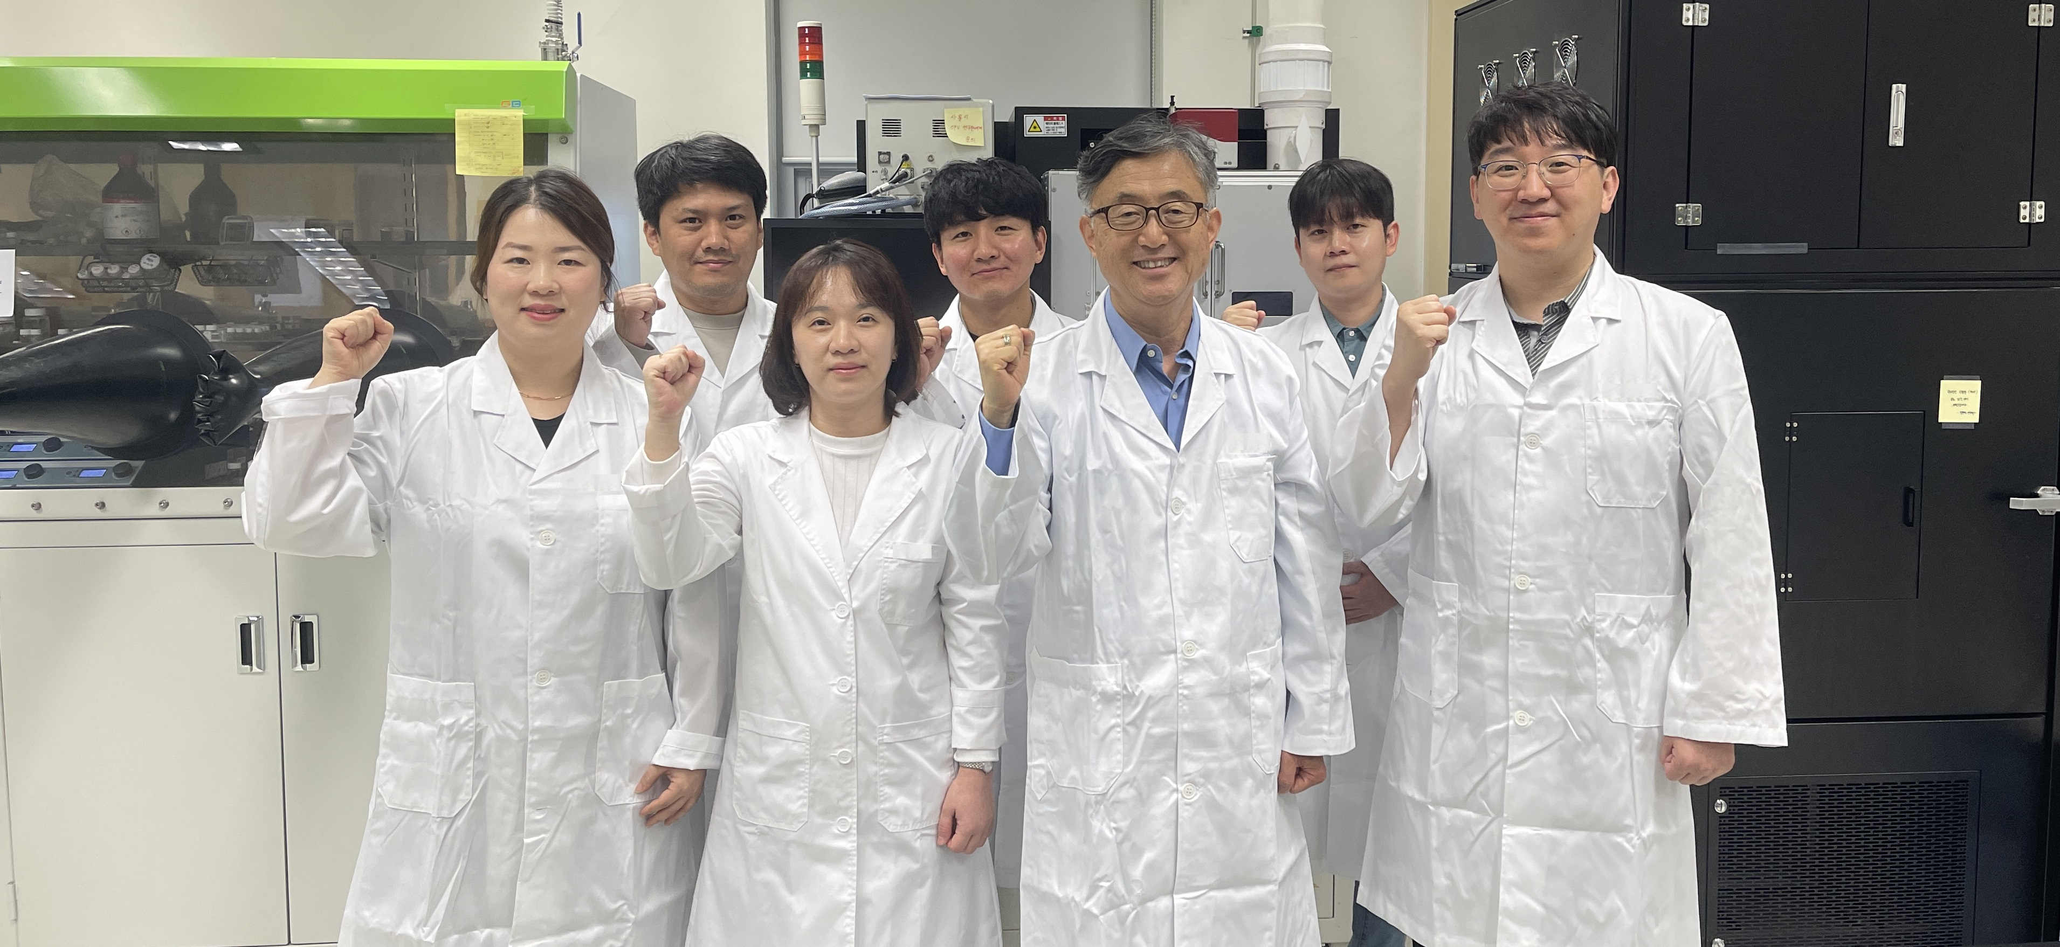▲ Researchers at Recell Co., Ltd.: (front row, clockwise from left) Senior Researcher Honggyu Kang, Professor Kwanghee Lee, Researcher Songi Jeong, Administrative Director Guieun Yang (Recell), Postdoctoral Researcher Junho Jang, Researcher Dongha Lim (Recell), Researcher Hyunseok Jeong (Recell)

Gwangju Institute of Science and Technology (GIST, President Kichul Lim) announced that Recell Co., Ltd., a faculty-founded company, was finally selected for Deep-Tech* TIPS** (eco-friendly and energy sector) and recently signed an agreement.

Deep-Tech Tips is a program that selects and fosters promising startups in 10 industrial fields selected by the government as part of the ‘Super Gap Startup 1000+ Project’ announced by the Ministry of SMEs and Startups.

* Deep-Tech: A business or industry that tends to narrowly and deeply focus on one or two specific technologies based on in-depth R&D (Research and Development) such as engineering or science.

** Tips (Tech Incubator Program for Startup): A program that intensively fosters promising future start-ups

Recell Co., Ltd., which was selected for this Deep-Tech Tips, was founded in November 2022 by Professor Kwanghee Lee of GIST's School of Materials Science and Engineering, and possesses technologies related to next-generation solar cell materials and modules. Based on existing technology, their goal is to manufacture solar cell modules that can be applied to various application fields such as low-light, building-integrated, mobility-integrated, and agricultural types and supply them to customers.

‘Deep-Tech TIPS’ is known to support technology development funds that are three times larger than existing TIPS, and has strict evaluation criteria such as technological capabilities, business feasibility, and potential for global expansion. Recell Co., Ltd. has secured R&D funding worth approximately 1.5 billion won for three years (2023 to 2026).

Recell Co., Ltd. plans to mass-produce organic-inorganic hybrid solar cell film for the first time in Korea by upgrading its roll-to-roll manufacturing technology. By installing it in places where existing silicon solar cells are difficult to apply, they aim to contribute to the development of the domestic solar energy industry and the realization of a carbon-neutral society.

The organic-inorganic hybrid solar cell film that Recell Co., Ltd. wants to develop is ultra-light and transparent. Based on its flexibility, it can be produced in a flexible film form and has the advantage of being easy to construct, so its applications are endless.

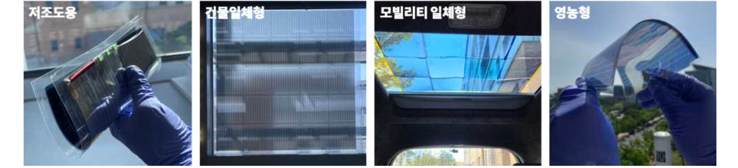▲ Representative photos of organic/inorganic hybrid film-type solar cell modules by application area

Kwanghee Lee, CEO of Recell Co., Ltd., said, "The selection as a Deep-Tech Tips winner is expected to accelerate the commercialization of film-based flexible solar cells that push the boundaries of solar cell applications. We will continue our manufacturing R&D in close cooperation with customers so that our unique solar film mass production technology can be applied to various fields such as smart home appliances and IoT sensors, buildings, vehicle sunroofs, and greenhouses."



