Professor Hong Kook Kim's research team wins the Judges' award at the International AI Sound Recognition Competition

- GIST-HanwhaVision team won the Judges' award in the indoor acoustic event detection category at the ‘DCASE Challenge 2023’ workshop
- Designed an artificial intelligence model that detects sounds occurring in everyday indoor life

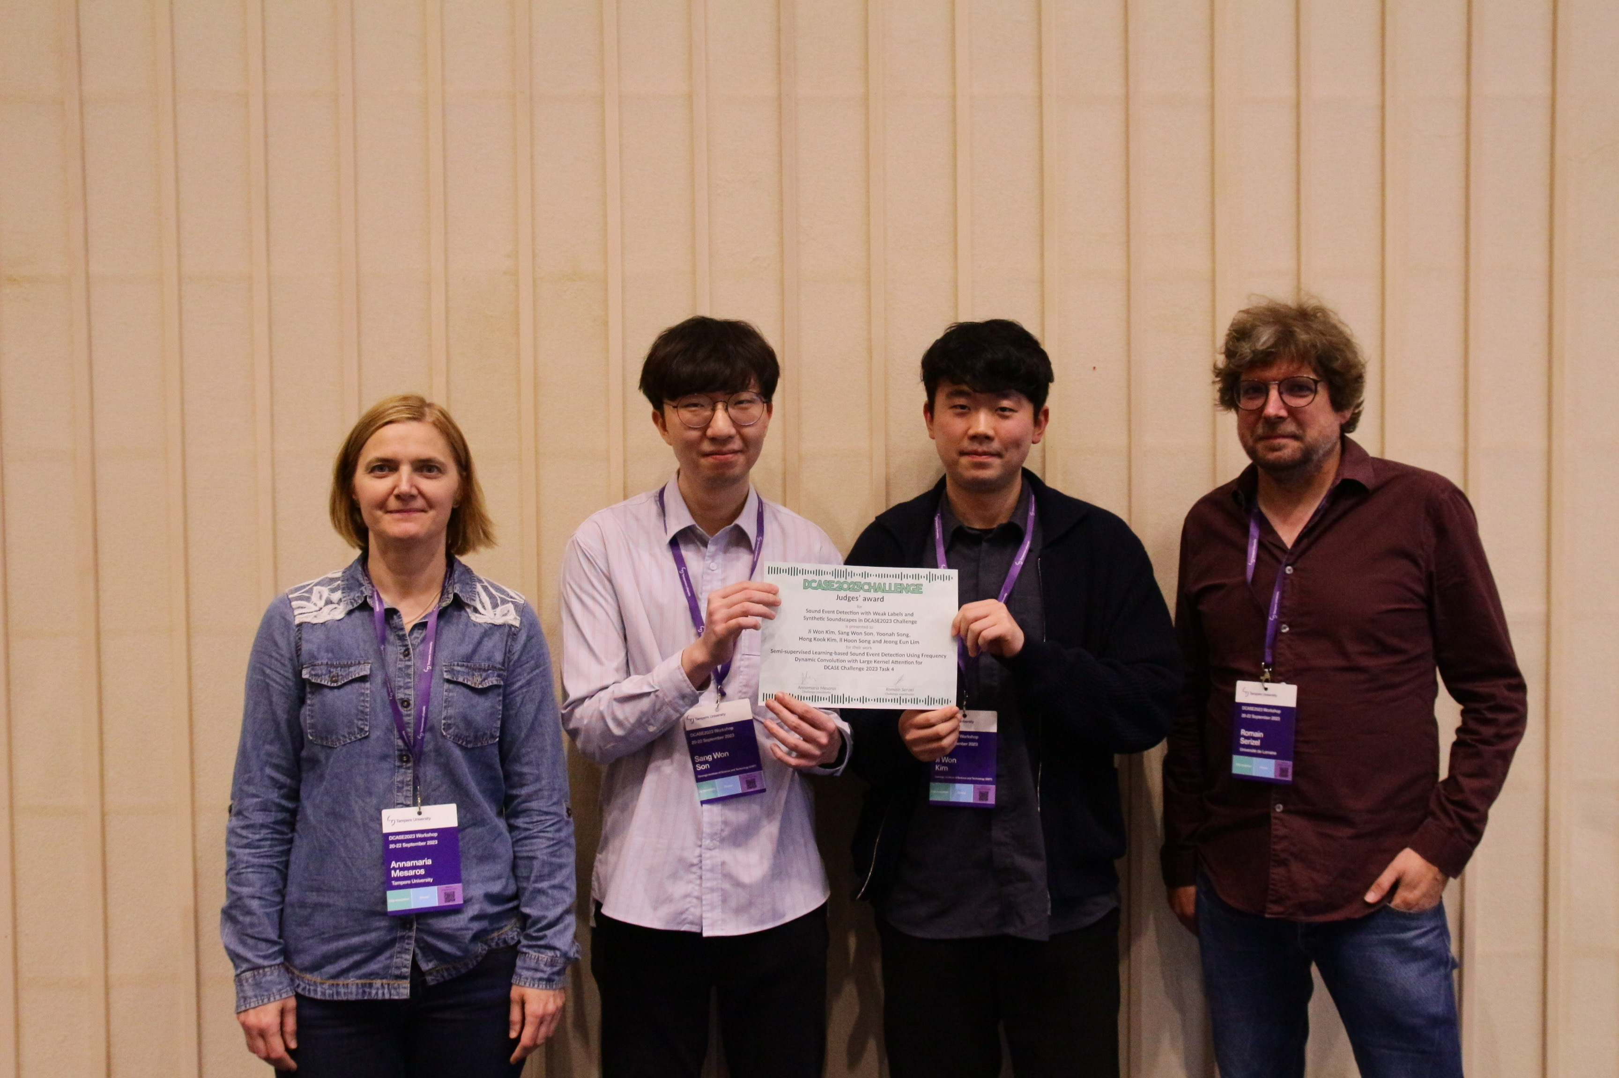▲ (From left) Judge Professor Annamaria Mesaros of Tampere University, GIST students Sang-won Son and Ji-won Kim, Judge Professor Romain Serizel of University of Lorraine

The Gwangju Institute of Science and Technology (GIST) announced that a joint research team from the Audio Intelligent Technology & Research Laboratory (AiTeR, Prof. Hong Kook) of the School of Electrical Engineering and Computer Science and Hanwha Vision (Prof. Inseon Noh, head of the AI Research Center) won the Judges' award at the "International AI Sound Recognition Contest (DCASE Challenge 2023)" workshop organized by the Signal Processing Society of the Institute of Electrical and Electronics Engineers (IEEE), the world's largest association of electrical and electronic engineers.

The GIST-HanwhaVision team, consisting of students from GIST's Audio Intelligent Lab (master's students Sang-won Son and Ji-won Kim, and integrated student Yuna Song) and Hanwha Vision researchers (chief researchers Il-hoon Song and Jeong-eun Lim), participated in the 'DCASE (IEEE AASP Challenge on Detection and Classification of Acoustic Scenes and Events) Challenge 2023' and won first place in the single model category and second place in the ensemble model category in the indoor acoustic event detection category (Task 4A). In particular, they were awarded the 'Judges' Award' at the workshop, which recognized our excellent performance in various criteria such as the innovation of the research, the completeness of the technology, and the quality of the paper.

The judges' award is given to only one team per task after reviewing the originality and excellence of the research, focusing on the technical report submitted to ‘DCASE Challenge 2023’. The GIST-HanwhaVision team won this award in the ‘Indoor Acoustic Event Detection Category (Task 4A)’, beating out 15 teams from leading institutions, including Chung-Ang University, Xiaomi, and Samsung Research China-Nanjing.

‘Indoor acoustic event detection technology’ is a technology that detects and distinguishes 10 different sounds that can occur in an indoor environment, such as the sound of a vacuum cleaner or washing dishes, through AI.

This technology monitors indoor situations through its strength in being able to detect acoustic events using only sound in situations where processing through cameras is limited, and it can be used in various applications such as AI speakers.

In this workshop, the GIST-HanwhaVision team developed a high-performance indoor acoustic event detection technology by combining AI technologies that can express various audio intelligence to solve problems. (Paper title: Label Filtering-Based Self-Learning for Sound Event Detection Using Frequency Dynamic Convolution with Large Kernel Attention)

Specifically, ▴ semi-supervised learning technology that uses pseudo-correct answers inferred by artificial intelligence for learning ▴ technology that fuses the inference results of a pre-learning training model* with the inference results of the existing model ▴ technology that refines data to improve performance. And ▴ excellent results were achieved with an artificial intelligence model incorporating ensemble technology that merges various techniques to improve artificial intelligence capabilities.

* Pre-learning training model: a large model trained on a large amount of data sets

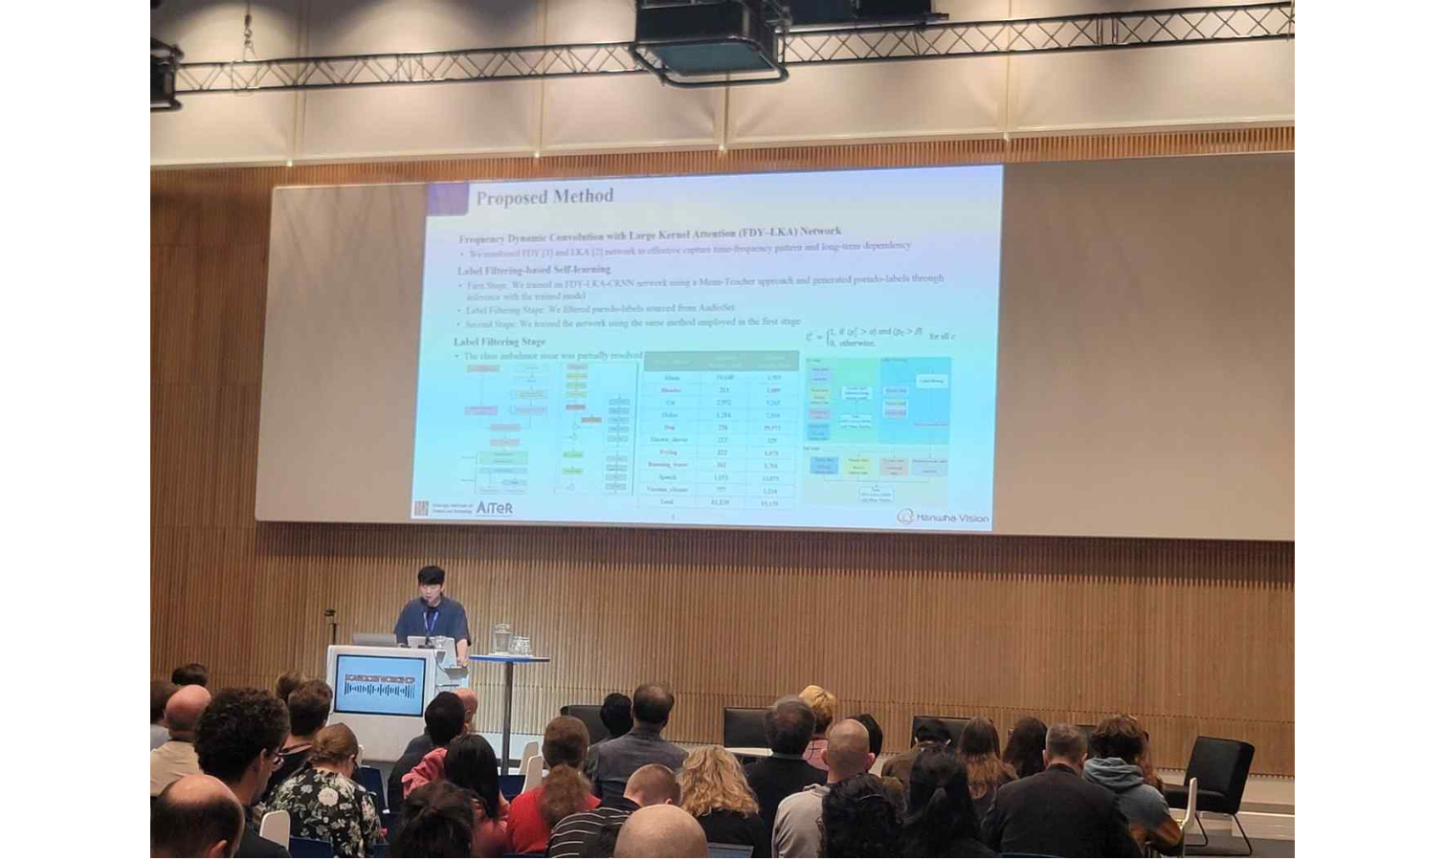▲ GIST student Ji-won Kim is presenting a paper at the ‘International AI Sound Recognition Competition (DCASE Challenge 2023)’ workshop hosted by the Signal Processing Society of the Institute of Electrical and Electronics Engineers (IEEE), the world's largest association of electrical and electronic engineers.

Professor Hong Kook Kim said, "The experience and development technology gained through this competition will be applied to the detection of sound events in Hanwha Vision's CCTV. Furthermore, we will strive to develop more efficient and user-friendly services by detecting voice segments and sound events in social media content."

Participating students of the GIST-HanwhaVision team said, "Thanks to close collaboration with Hanwha Vision researchers and professional support from Professor Hong Kook Kim, we were able to create results recognized at global competitions. Based on the current achievements, we plan to further deepen research in the field of audio artificial intelligence and contribute to the commercialization of audio intelligence technology and the creation of social value."

Meanwhile, the GIST Audio Intelligent Technology & Research Laboratory (AiTeR), of which the GIST-AiTeR team is a part, is researching AI models for speech acoustics, and is collaborating with domestic industry and research institutes such as the Massachusetts Institute of Technology (MIT) and overseas research institutes in various fields such as speech synthesis, speech noise reduction, speech recognition, abnormal situation detection, and biometric information processing, in addition to acoustic event detection.

This study was conducted with the support of △ 2023 Hanwha Vision’s deep learning-based sound source classification commercialization support project in CCTV and △ the media content audio language localization technology development project of the Ministry of Science and ICT and the Korea IT Planning and Evaluation Institute. The DCASE workshop was held in Tampere, Finland, from September 20th to 22nd, and the awards ceremony was held at Tampere Hall on the 22nd.



