GIST AI Graduate School's first doctoral graduate appointed as an assistant professor in the Department of Artificial Intelligence at Chonnam National University

- Dr. Man-Je Kim, I want to become an artificial intelligence researcher who can contribute to people’s happiness
- Gwangju Metropolitan City’s ‘AI talent development ladder’ construction policy model... A virtuous cycle of AI talent production and supply

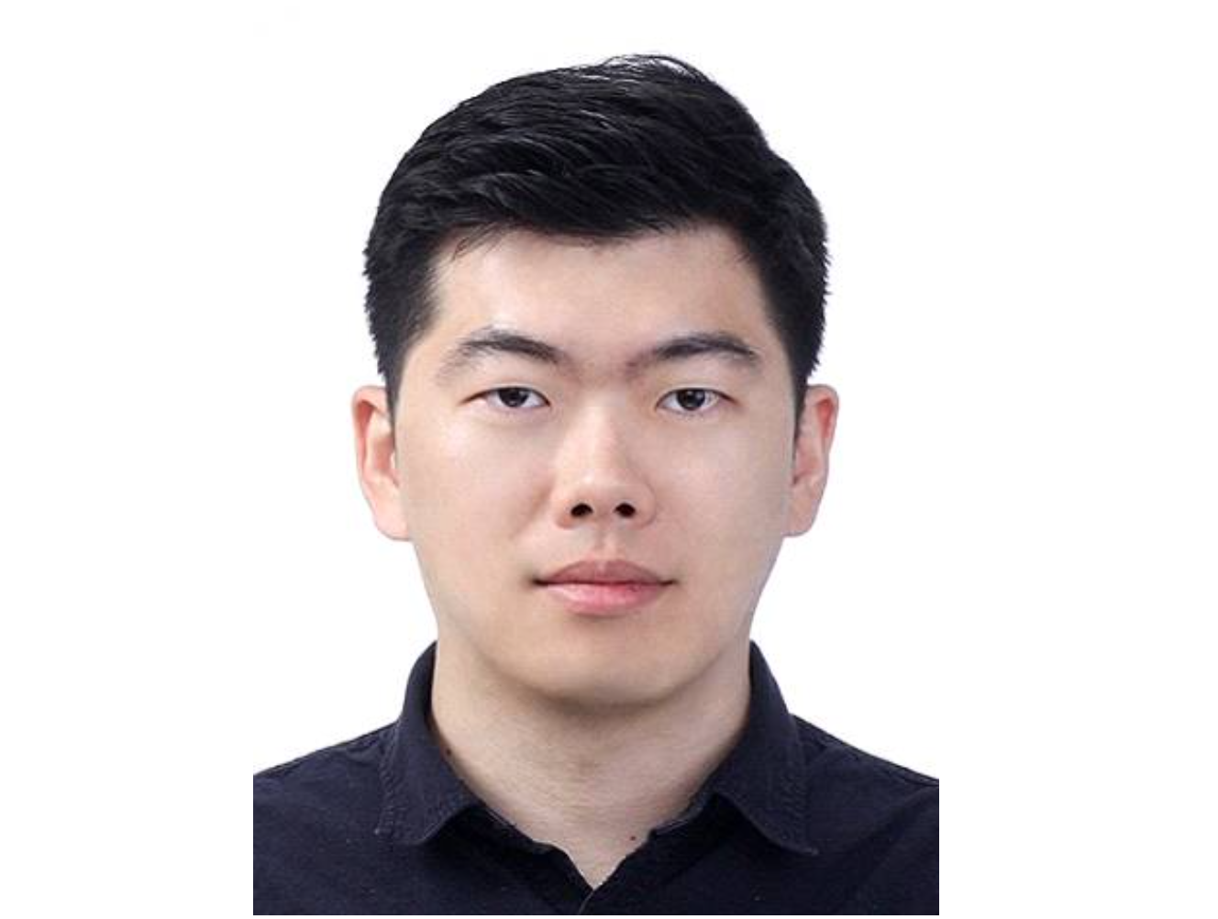▲ Man-Je Kim, the ‘first doctorate’ of GIST AI Graduate School, was appointed as an assistant professor at Chonnam National University

Gwangju Institute of Science and Technology (GIST, President Ki-Chul Lim) AI Graduate School’s ‘No. 1 Doctor’ Man-Je Kim (advisor Chang Wook Ahn, graduated in February 2023) was appointed this month as an assistant professor in the Department of Artificial Intelligence at the Chonnam National University's College of AI Convergence.

Dr. Man-Je Kim researched the latest evolutionary reinforcement learning algorithms and developed reinforcement learning AI in various fields at the Meta-Evolutionary Machine Itelligence Laboratory of Professor Chang Wook Ahn, famous for ‘artificial intelligence compositions’. He was the first graduate of the AI graduate school to receive a doctorate degree at the GIST Commencement Ceremony held in February of this year for ‘Research on Evolutionary Reinforcement Learning for Single and Multi-Optimization’.

Additionally, Dr. Kim has published and presented a total of 7 papers in international journals (SCI) and 8 papers at international conferences over the past 8 years. He won the ‘StarCraft II AI Global Battle’ and also won prizes in the international artificial intelligence competition hosted by the IEEE.

After graduation, he was selected for the National Research Foundation of Korea's Creative and Challenging Research Foundation Support Project and the GIST AI Convergence Talent Training Project and conducted human-friendly artificial intelligence research as a postdoctoral researcher at the GIST AI Graduate School from March to August of this year.

Dr. Man-Je Kim, who has been recognized for his outstanding research capabilities, is attracting attention by being appointed as an assistant professor in the Department of Artificial Intelligence at Chonnam National University's College of AI Convergence, even without any overseas postdoctoral researcher experience.

Dr. Kim's appointment as professor is significant in that the goal of establishing the GIST AI Graduate School, which opened in March 2020 to foster global AI innovative talent that connects education, research, and entrepreneurship, is beginning to bear fruit. In particular, it is expected to serve as an example for Gwangju Metropolitan City's policy of building an ‘AI talent training ladder’ that aims to become an ‘AI leading city.’

Dr. Man-Je Kim said, "The goal is to develop human-centered artificial intelligence so that future artificial intelligence can improve human happiness. I will strive to become a senior who serves as a role model for my juniors and an educator who is respected by students."



