[Personnel] GIST key positions

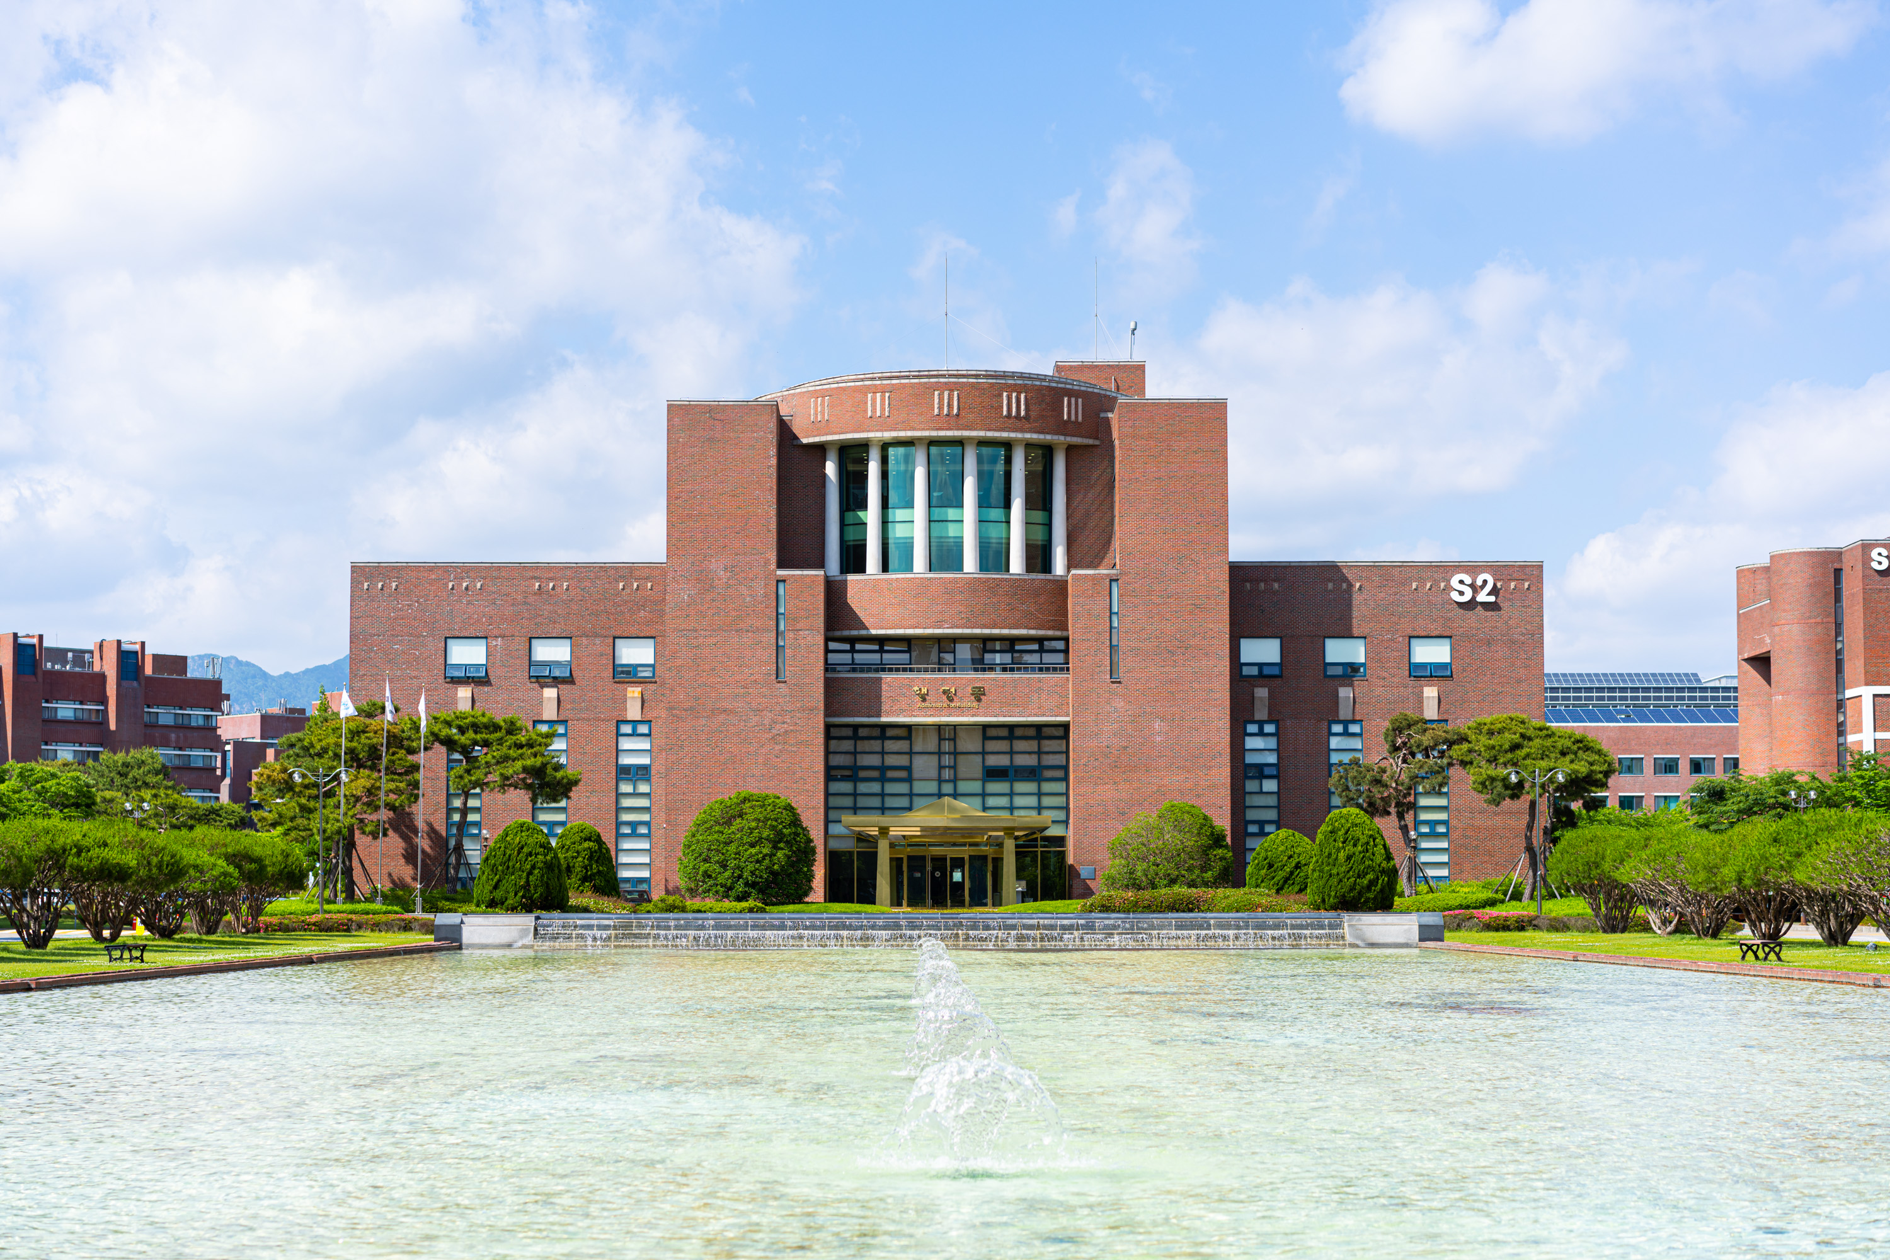▲ Panoramic view of GIST administrative building

Office/Center Director ▲ Office of Future Strategy Director Jong-sam Choi ▲ Startup Acceleration Center Director Seong-hoon Lim ▲ Technology Commercialization Center Director Young-soo Choi

Team Leader ▲ Office of Future Strategy Team Leader Seung-jae Lee (A) ▲ Future Education Team Leader Su In Choi ▲ Division of Liberal Arts and Sciences Team Leader Chul-woong Kim ▲ School of Electrical Engineering and Computer Science Team Leader Miae Kim ▲ School of Earth Sciences and Environmental Engineering Team Leader Hyo Jung Kim ▲ School of Life Sciences Team Leader Yoon-kyung Park ▲ Institute of Intergrated Technology Team Leader Seung-jae Lee (B) ▲ Department of Chemistry Team Leader In-cheol Park ▲ Artificial Intelligence Graduate School Team Leader Sijin Cho ▲ Budget Team Leader Nam-gil Hong ▲ Management Innovation Team Leader Sang-hoon Yoo ▲ Admissions Team Leader Byeong-gwan Cho ▲ General Affairs Team Leader Ki-wook Seong ▲ HR Team Leader Chang-hoon Choi ▲ Library Services Team Leader Mi-yeong Yoo ▲ Advanced Photonics Research Institute Team Leader Seong-geun Ki ▲ Research Management Team Leader Young-wook Cho ▲ Research Planning Team Leader Kwon-jin Oh ▲ Central Research Facilities Team Leader Chang-won Lee ▲ International and Public Affairs Team Leader Yong-ryeol Kim ▲ Media PR Team Leader Ji-hoon Kim ▲ Development Fund Team Leader Ga-young Cha



