[Personnel] GIST key positions

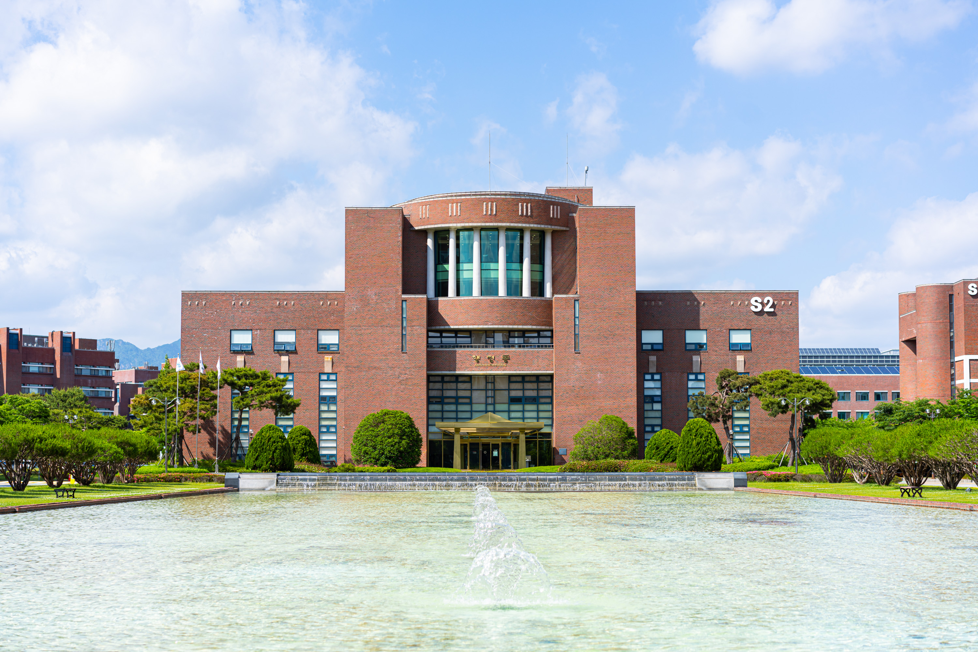▲ Panoramic view of GIST administrative building

Dean ▲ School of Materials Science and Engineering Dean Bong Joong Kim

Assistant Dean ▲ School of Materials Science and Engineering Assistant Dean Joo-Hyung Lee



