[Personnel] GIST key positions

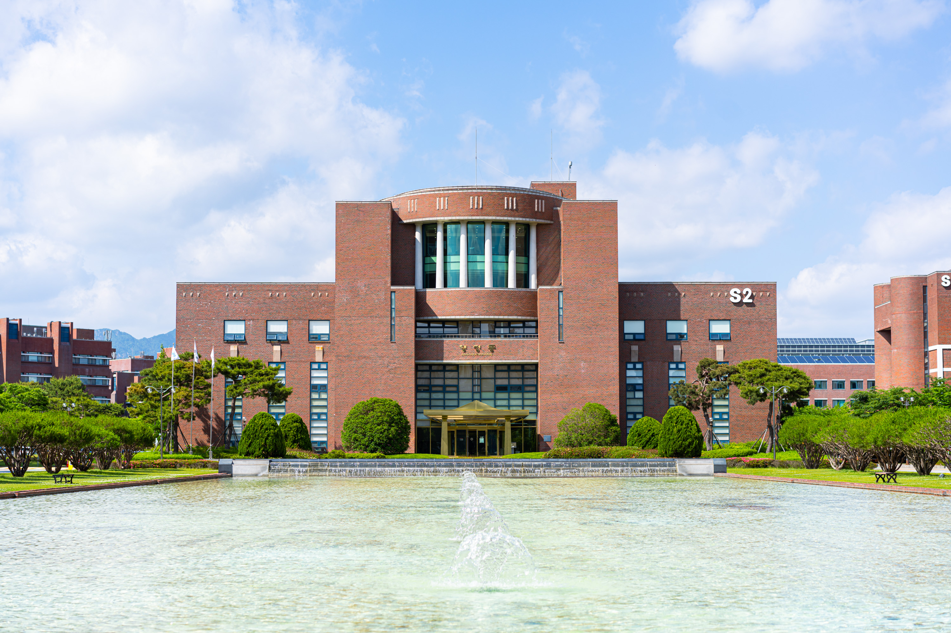▲ Panoramic view of GIST administrative building

Dean ▲ School of Life Sciences Dean Jeong-Seok Nam

Research Director ▲ Integrated Institute of Biomedical Research Director Chang-Duk Jun



