[Personnel] GIST key positions

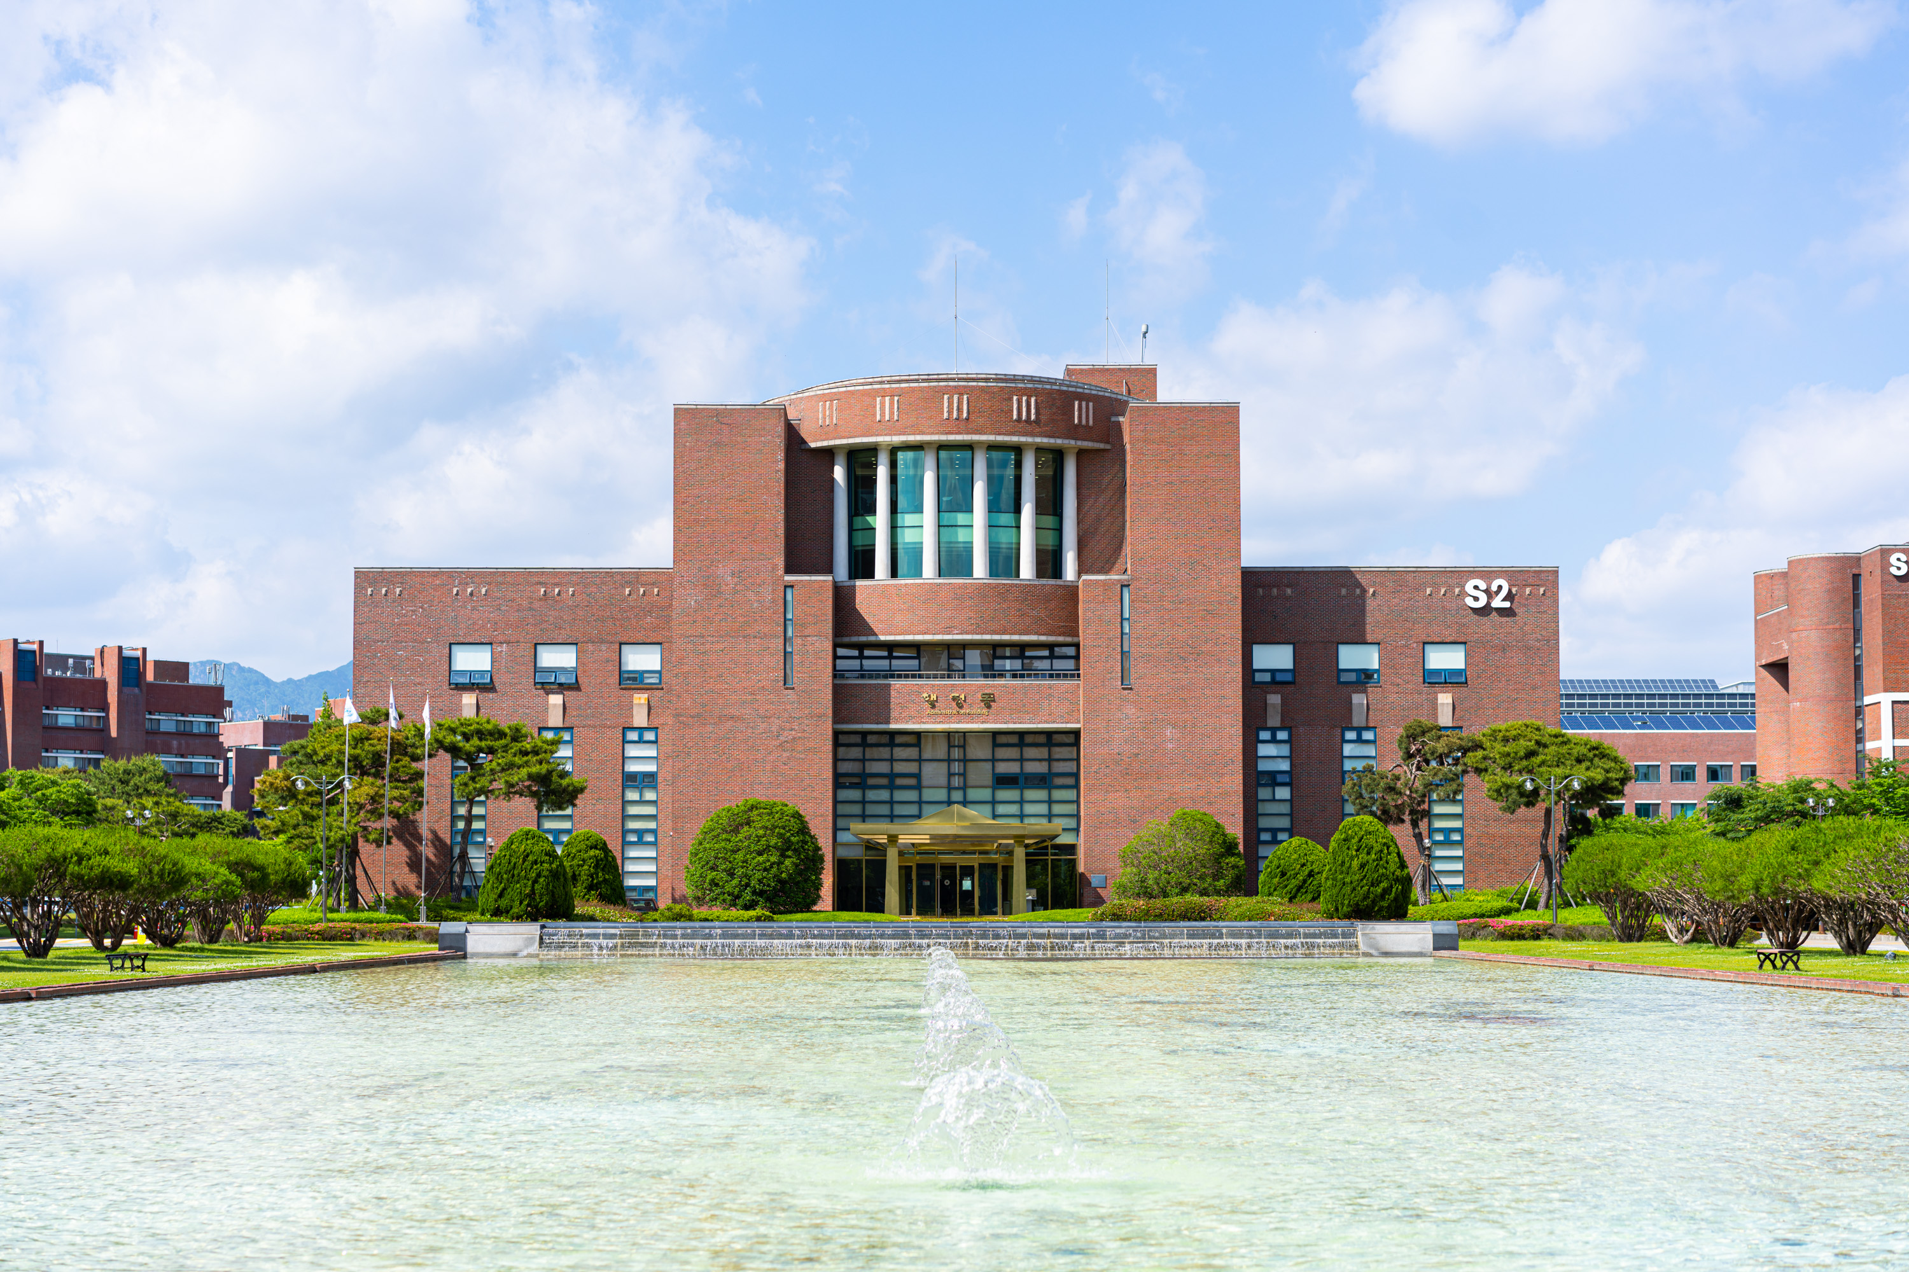▲ Panoramic view of GIST administrative building

Personnel in key positions

Deans/Assistant Deans ▲ School of Mechanical Engineering Dean Jaewook Lee ▲ School of Mechanical Engineering Assistant Dean Hyunseok Oh

Research Director/Center Director ▲ Advanced Photonics Research Institute Director Do-Kyeong Ko ▲ Research Institute For Solar And Sustainable Energies Director Sanghan Lee ▲ Korea Culture Technology Institute Director Kyung-Joong Kim ▲ International Environmental Research Institute Director Jin-Ho Yoon ▲ Institute for Artificial Intelligence Director Hojung Nam ▲ Central Research Facilities Director Tae-Young Kim ▲ Laboratory Animal Resource Center Director Jeong-Seok Nam



