Ha Tae-seong Wins Gold Medal Award
at International Invention Competition

- Taeseong Ha, a student in the Division of Liberal Arts and Sciences at GIST, invents an auxiliary apparatus that inserts water bottles in water dispensers.
- Awarded at INTARG, with 42 countries around the world participating... “I want to challenge myself for the betterment of humanity.”

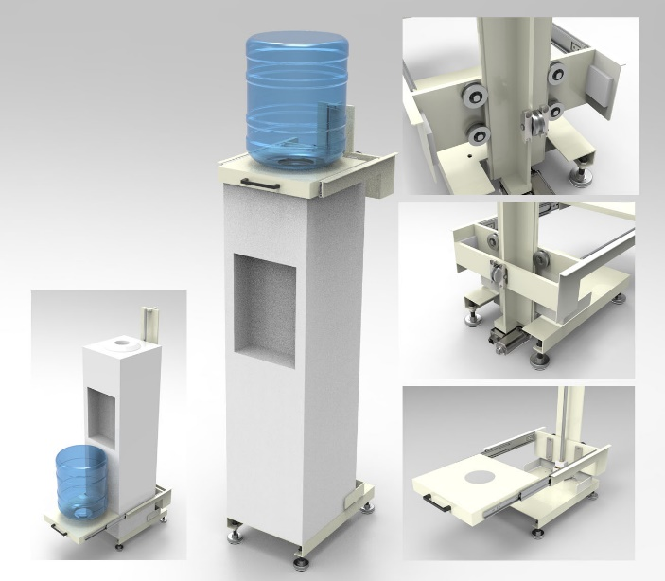
▲ (Left)Ha Tae-seong wins the gold medal award at an international invention contest,
(Right) Appearance of the auxiliary dispensing apparatus.

GIST’s (Gwangju Institute of Science and Technology) Ha Tae-seong, a student in the Division of Liberal Arts and Sciences, won the gold medal award at the 16th INTARG (International Invention and Innovation Show), an international invention competition held in Poland.

INTARG, which selects technologies that actually implement invention ideas every year, is a global competition in which 42 countries, including Canada, France, and Germany, participate. This year, it was held in Katowice, Poland, from May 24 to 25.

Ha Tae-seong, a first-year undergraduate student, devised a water bottle dispensing apparatus based on his experience of accidentally dropping a water bottle while attempting to replace one in a water dispenser. Replacing a water bottle, usually holding 20 liters, is a difficult task as the water bottle is heavy and needs to be inserted upside down on the top of the water dispenser, and poses the risk of injury from dropping one when being performed by the frail or elderly.

Ha Taeseong installed an apparatus that moves from the bottom of the water dispenser to the top. A water bottle is inserted upside down into the apparatus at the bottom of the water dispenser. The apparatus is designed to move to the top of the water dispenser, so that the water bottle can be replaced without manually lifting it high.

In particular, water bottle replacement-type water dispensers are relatively hygienic and easier to manage than those directly connected to water lines, so if this device is widely distributed and bottle-type water dispensers become more common, it is expected to have a positive impact on public health.

Ha Tae-seong stated, “I was able to get good results thanks to the habit of thinking about what solutions can be found instead of leaving the inconveniences commonly felt in daily life as they are. It is an honor,” he continued, “to receive this great award. I will continue to be a person who challenges himself for the betterment of humanity.”

