Selected as a GIST 'Innovative Startup'

- Samsung Electronics selects 5 AI-based companies as innovative startups in Gwangju
- Selected as GIST faculty start-up company ‘FOEL’ and alumni start-up company ‘intflow’

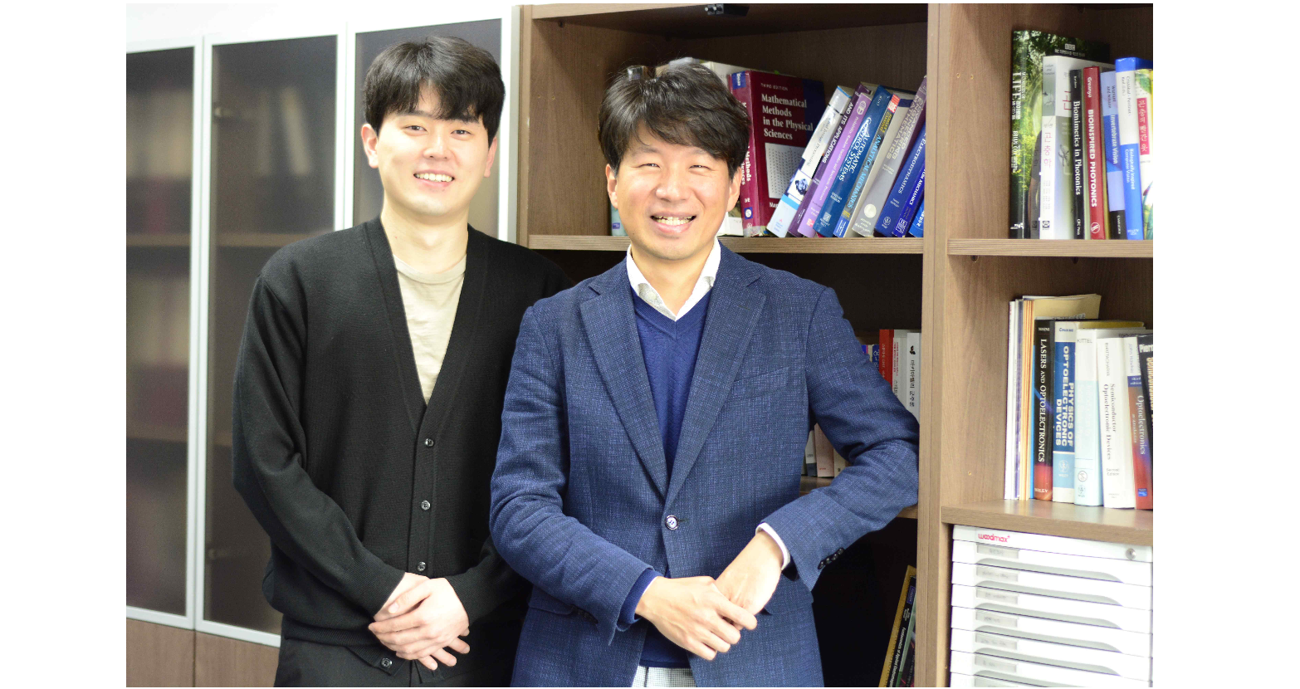▲ ‘FOEL’ (from left) CEO Jong Heon Lee and Professor Young Min Song (Co-CEO)

GIST (Gwangju Institute of Science and Technology, Acting President Raekil Park Rae-gil), a faculty start-up company, FOEL Co., Ltd. (CEO: Young Min Song and Jong Heon Lee) and alumni start-up company intflow (CEO: Kwang-myeong Jeon) were selected for Samsung Electronics C Lab Outside Gwangju.

C Lab Outside is an external startup fostering program operated by Samsung Electronics since 2018, contributing to the development of the local economy by discovering and nurturing excellent startups.

In November of last year, Samsung Electronics held a contest for startups located in Gwangju and selected five innovative startups in the region in the areas of artificial intelligence (AI), healthcare, and materials and parts. Two of these companies are start-up companies founded by GIST professors and graduates.

First, ‘FOEL’, an energy-saving cooling material development company, was founded by School of Electrical Engineering and Computer Science Professor Young Min Song of the Department of Electrical and Computer Engineering with his own radiant cooling technology. The company started a business to directly commercialize its research results and apply them to various fields, and the original technology of 'flexible color cooling radiation nanomaterials that operate without electricity', which was selected as one of the top 10 nano technologies in 2019, is the core technology of the business. It is promoting the commercialization of radiant cooling technology for the first time in Korea.

Professor Young Min Song said, "I started the business with the idea that the achievements through technology startups should help society. We are concentrating on research that can solve global warming with eco-friendly cooling materials, and we hope that radiation cooling technology can be used in the near future."

intflow, an AI-based animal bioanalysis and livestock care platform company, is a start-up founded in 2019 by GIST graduate Dr. Kwang-myeong Jeon.

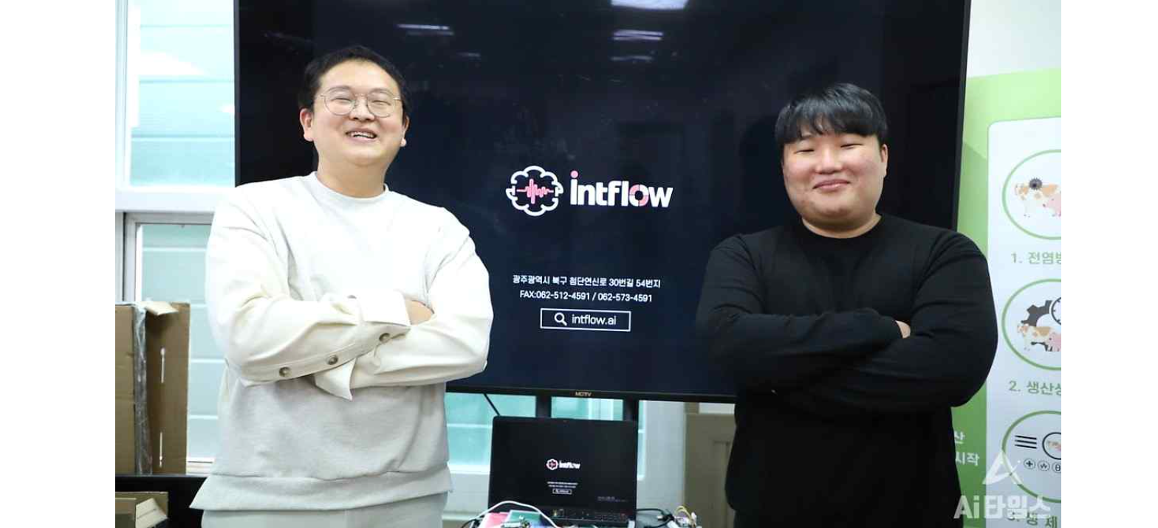▲ ‘Intflow’ (from left) CEO Kwang-myeong Jeon and senior researcher Hyung-joon Ahn

It is promoting various projects based on video/voice deep learning analysis technology, such as an AI-based customized livestock asset management intelligence model business and a pure domestic AI/non-contact body temperature measurement quarantine system business.

CEO Kwang-myeong Jeon said, "It is expected that Edge Farm, a livestock AI solution currently in operation, will be able to achieve innovative improvements in disease prevention, animal management, and environmental control in livestock farms in the next few years. In order to leap forward as a true global company, we plan to challenge the digital healthcare field in the mid- to long-term."

Meanwhile, Samsung Electronics plans to hold the opening ceremony of the "C Lab Outside Gwangju Campus" at Samsung Fire & Marine Insurance's managing office in Seo-gu, Gwangju on the 20th and intensively foster innovative startups in Gwangju to revitalize the local economy and contribute to the creation of high-quality jobs.

Executives and employees of Samsung Electronics will be matched one-on-one for each company and will receive up to 100 million won in business subsidies over the next year and customized consultations for each stage of corporate growth from executives and employees of Samsung Electronics. It will also have opportunities to cooperate with Samsung Electronics and related companies, participate in domestic and foreign IT exhibitions such as CES, and develop domestic and foreign markets.



