GIST wins Gold, Silver, and Bronze at the Samsung Human Tech Thesis Awards

– A total of 4 teams, including the team of Professor Young Min Song and Professor Kyoobin Lee, received the gold medal... 10 graduate students received awards

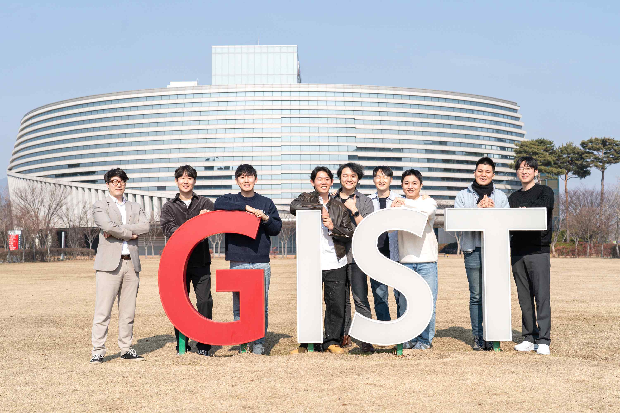
▲ GIST winners of the 29th Human Tech Thesis Awards are taking a commemorative photo on campus. (From left) Sang-Hun Han (silver prize), Dong Hyun Seo and Joo Hwan Ko (gold prize), Sang-jun Noh, Taewon Kim, Seunghyeok Back and Raeyoung Kang (gold prize), Seungjin Song, and Wonjung Lee (bronze statue)

GIST (Gwangju Institute of Science and Technology, President Kiseon Kim) had 4 teams win at the 29th 「Samsung Human Tech Paper Awards」, including 2 gold prizes, silver prizes, and bronze prizes, and 10 graduate students were awarded prizes.

The 「Samsung Human Tech Thesis Award」, hosted by Samsung Electronics and co-sponsored by the Ministry of Science and ICT and the JoongAng Ilbo, is the largest academic thesis award in Korea, has been held annually by Samsung Electronics since 1994 to discover and nurture excellent human resources in the field of science and technology. Due to the influence of Corona 19, an offline awards ceremony was held on February 20 (Mon) for the first time in 4 years.

A total of 10 categories, including basic science, materials science, and computer engineering, select winners, and this year, a total of 118 awards were received in the university and high school categories.

A total of four teams won gold, silver, and bronze awards this year from two teams: Professor Young Min Song (School of Electrical Engineering and Computer Science) had two advisee students and Professor Kyoobin Lee (School of Integrated Technology) had four advisee students.

1. Professor Young Min Song, Joo Hwan Ko (Ph.D. student, lead author), and Dong Hyun Seo (Ph.D. student), who won the gold prize, devised a switching device with high efficiency on/off ratio based on conductive polymers as optical signal modulation devices for application to optical integrated circuits. In particular, by maximizing the interaction between light and matter, it overcomes the limitation of low modulation rate of optical properties of polymers.

Unlike conventional technologies, this technology can operate at low power without generating heat, reducing the power consumption required for optical integrated circuit operation, and it is expected to be applied to next-generation optical devices such as optical memories and neuromorphic devices*.

Professor Young Min Song's research team is developing new concept devices such as futuristic semiconductors and encryption devices, and, based on active research results, it won the gold prize in the same division (Physical Devices & Processes) at the 27th Human Tech Thesis Awards.

* neuromorphic element: An element made by imitating the structure of a cranial nerve to process information in a way similar to the human thinking process.

2. Another gold prize-winning team, Professor Kyoobin Lee (School of Integrated Technology), Sang-Jun Noh (PhD course, lead author), Raeyoung Kang (Ph.D. student), Taewon Kim (Ph.D. student), and Seunghyeok Back (Ph.D. student) developed a method based on a large-scale simulation for stably placing an object that has not been learned in advance and achieved world-class performance.

The research was carried out with the support of the Ministry of Trade, Industry and Energy and the Robot Industry Core Technology Development Project and is expected that it will be used in various categories such as industrial sites and homes as it has developed source technology related to object manipulation by robots.

Professor Kyoobin Lee's research team is conducting research related to AI robot development and deep learning, and he created excellent research results and won a bronze award in the same division (Mechanical Engineering) of the 28th Samsung Human Tech Thesis Awards.

3. Professor HaeGon Jeon (AI Graduate School), Sang-Hun Han (integrated student, lead author), and Young-Jae Park (integrated student), won the silver prize for using a single image in the 'Research on High-Quality 3D Human Reproduction Using High-Resolution Images' and for developing a method for restoring high-quality human body models. It is expected that this will be applied to human modeling and rendering technology essential in the metaverse industry in the future, as it is possible to create a 3D model with delicate facial expressions and fabric wrinkles by separating high-resolution images into each part of the human body and utilizing high-efficiency memory.

4. Bronze award-winning team Professor Junhyeok Seo (Department of Chemistry), Wonjung Lee (integrated student, lead author), and Seungjin Song (integrated student), in 'Development of monoatomic cobalt catalyst for electrochemical carbon dioxide conversion and research on reactivity', focused on monoatomic cobalt, and an electrochemical catalyst that selectively produces carbon monoxide was developed by presenting a combination of clamp-type and pi-conjugated ligands.

In particular, it drew attention by identifying the relationship between structural changes caused by electrons and catalytic reactivity using spectroscopic analysis and ‘Density Functional Theory*’. It is expected to help develop efficient carbon dioxide conversion catalysts through reactivity control at the atomic level.

* density functional theory (DFT): Based on quantum mechanics, it is used for various chemical problems as a calculation method for dealing with multi-electronic electronic structures such as atoms, molecules, and condensed phases.

President Kiseon Kim said, "I sincerely congratulate the winners who have reaped good results from their efforts so far, and I will continue to provide support so that students can devote themselves to research and achieve excellent results."



