School of Electrical Engineering and Computer Science Professor Jong Won Shin was appointed to the editorial board of the world's best journal in the field of speech processing

- Member of the editorial board of IEEE/ACM Transactions on Audio, Speech, and Language Processing since February

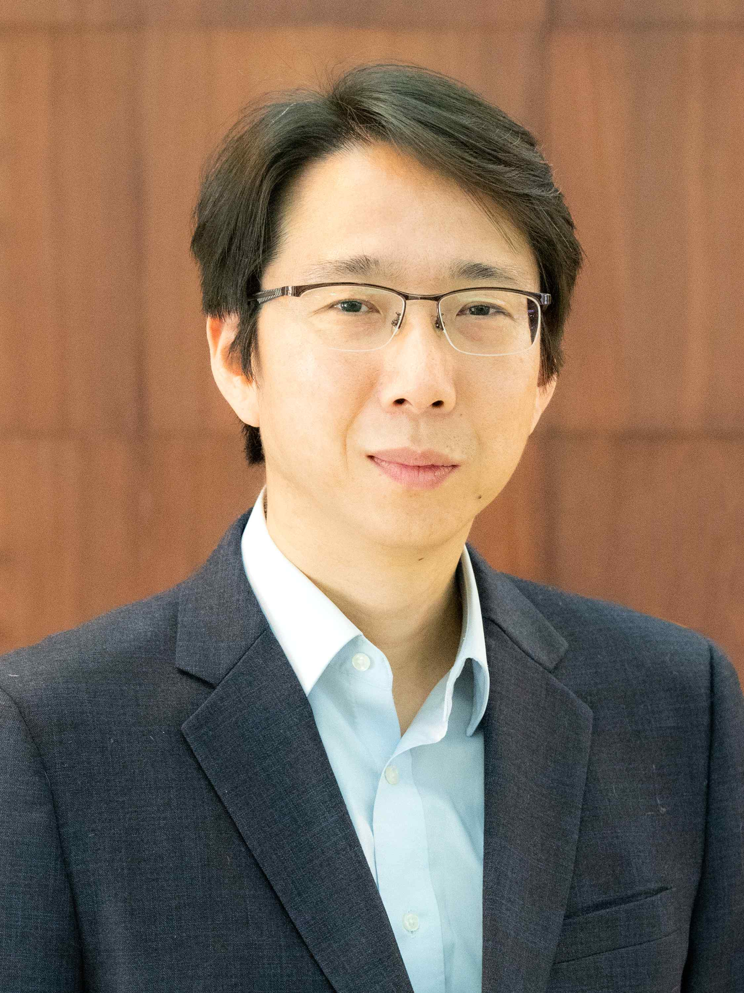
▲ GIST Professor Jong Won Shin

GIST (Gwangju Institute of Science and Technology, President Kiseon Kim) School of Electrical Engineering and Computer Science (Graduate School of AI) Professor Jong Won Shin is an editor (Associate Editor) of 「IEEE/ACM Transactions on Audio, Speech, and Language Processing* (TASLP)」, the world’s best journal in the field of voice processing.

* Sound/Voice/Language Processing Transaction

Since February of this year, Professor Jong Won Shin has been working as an editorial board member of the journal and has been working on voice and audio processing using multiple microphones. Activities such as selecting review members and deciding whether or not to publish papers in the field of audio and voice signal enhancement and sound source separation will be performed.

Professor Shin received his Ph.D. in electrical and computer engineering from Seoul National University in 2008 and worked for Qualcomm in the US from 2008 to 2012. He joined GIST in 2012 and is currently working as an Associate Professor in the School of Electrical Engineering and Computer Science.

Currently, the GIST Speech and Audio Processing Lab (SAPL) is working on various voice and audio processing, such as single-channel/multi-channel voice/audio enhancement, detection, separation, compression, echo cancellation, emotion recognition, and speaker recognition. are conducting research.

TASLP (IF: 4.364, as of 2021) began publication in 1993 under the name of IEEE Transactions on Speech and Audio Processing. ) and the Association for Computing Machinery (ACM), the world's largest academic organization in the field of computer science, and is a journal that analyzes, synthesizes, enhances, transforms, classifies, and interprets audio, speech, and natural language signals, machine learning/pattern recognition, etc. It is considered the world's best journal in the field of voice processing.



