Minhee Kim, a Ph.D. student at Harvard Medical School, is studying brain activity with "the latest medical optics research in the laboratory of Harvard Medical School" in the United States

- Selected for research foundation 'Female Science and Engineering Graduate School Student Training in the US'... Received support for accommodation and airfare
- Clinical brain signal analysis research with local faculty at Massachusetts General Hospital since last September

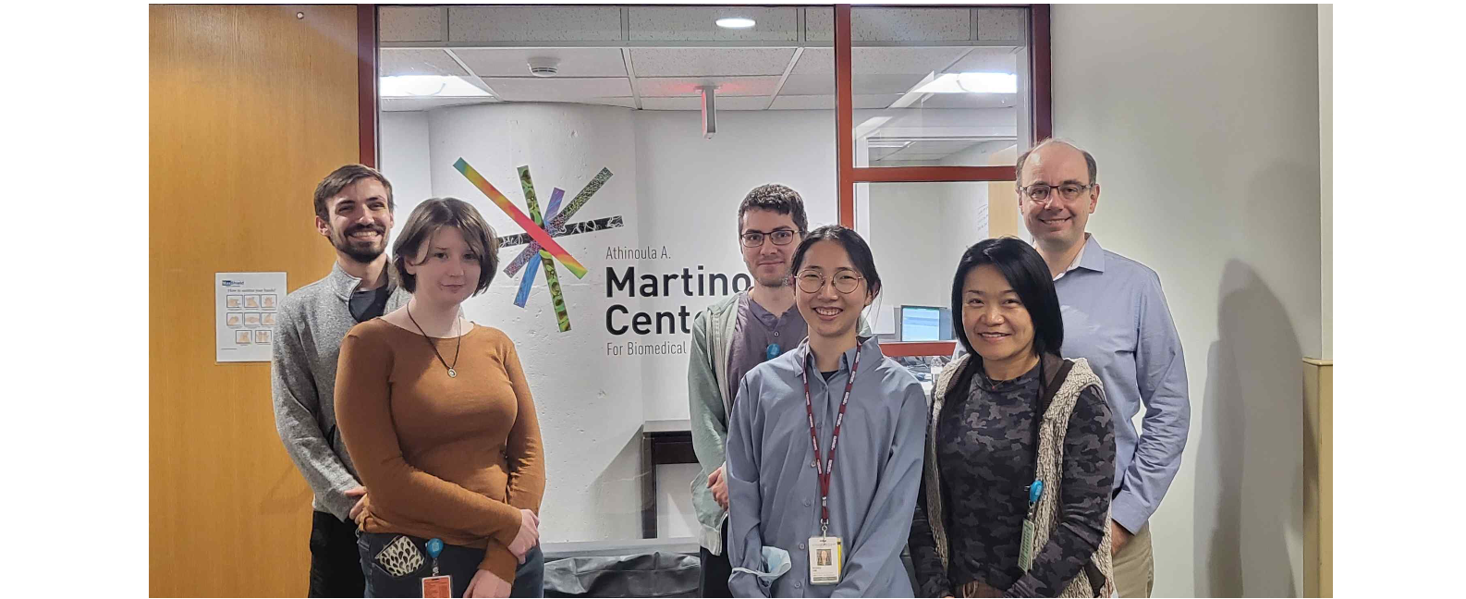▲ Ms. Minhee Kim (center of photo), a doctoral student in the Department of Biomedical Science and Engineering, who was selected for the National Research Foundation of Korea’s ‘Korean Female Science and Engineering Graduate Student Program in America’ and is conducting research at the Martinos Biomedical Imaging Center of Massachusetts General Hospital in Boston, USA in 2022.

"At Massachusetts General Hospital, a part of Harvard Medical School, top experts in optics, electronic engineering, and clinical fields are collaborating to conduct research in an environment optimized for high-level technology development and rapid clinical research."

GIST (Gwangju Institute of Science and Technology, President Kiseon Kim) doctoral student Minhee Kim (Advisor Professor Jae Gwan Kim) of the Department of Biomedical Science and Engineering was finally selected for the National Research Foundation of Korea's '2022 Korean Science and Engineering Female Graduate Student American Training Program'. She received support for accommodation and airfare, and is currently staying in Boston, USA, where she is conducting her research.

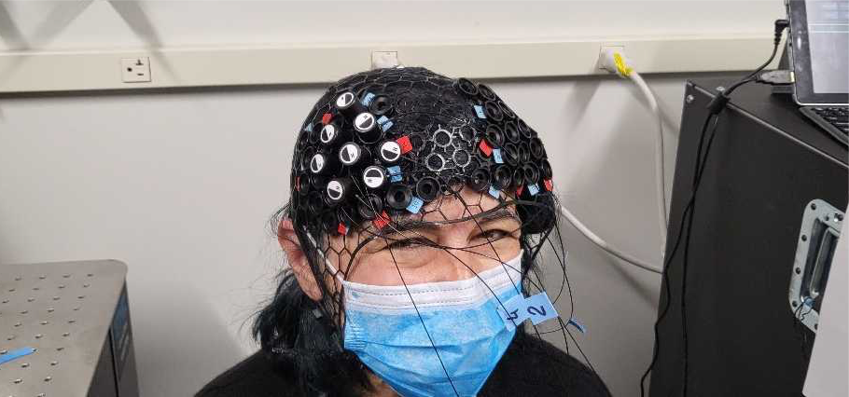
▲ A fiber optic sensor attached to the frontal lobe to measure blood flow velocity non-invasively

Ms. Kim is studying at the Athinoula A. Martinos Center, a medical imaging laboratory located inside Massachusetts General Hospital in Boston, and she arrived in Boston last September to conduct a six-month study under the theme of 'analysis of brain activity following cognitive stimulation using near-infrared spectroscopy and diffusion correlation spectroscopy.'

Martinos Biomedical Imaging Center is a hospital research institute leading the latest technology in the field of medical imaging. Professor Stefan Carp's team, to which Minhee Kim belongs, is actively conducting cerebral blood flow analysis research that applies 'diffusion correlation spectroscopy technology', which can measure blood flow information noninvasively, to clinical areas such as cardiac arrest and coma patient monitoring.

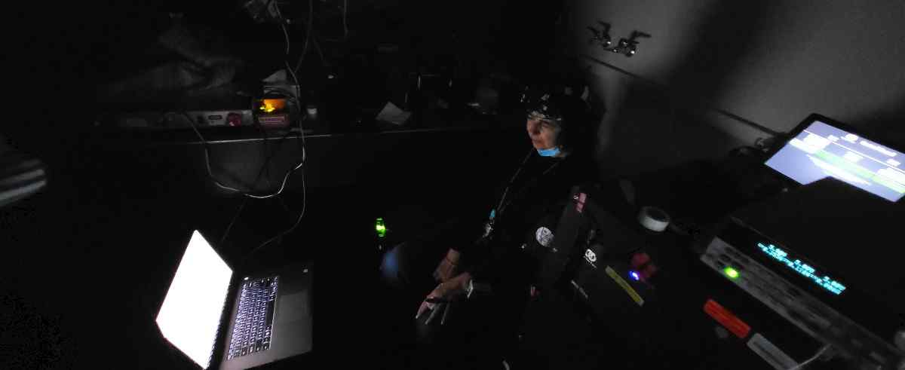
▲ A test subject attached to an optical fiber sensor conducts a brain function measurement experiment

Ms. Minhee Kim said, "The technology of non-invasively measuring the patient's cerebral blood flow is a very important technology for predicting sudden abnormal brain signals and monitoring brain function. I plan to apply various abnormal signal analysis techniques to brain cognitive function monitoring research during the research period."

The ‘Korean Science and Engineering Female Graduate Student American Training Program’, hosted by the National Research Foundation of Korea under the Ministry of Science and ICT, is a project to promote the research activities of young female researchers and their entry into the science and engineering field. For female graduate students, support is provided to institutions in the U.S. for 3-6 months of stay abroad and airfare.



