Ilhyung Choi, School of Materials Science and Engineering, awarded the Best Paper Presentation Award at the American Society of Materials Science conference

– Development of new anti-freezing peptide nanomaterials that inhibit ice growth at the ice/water interface

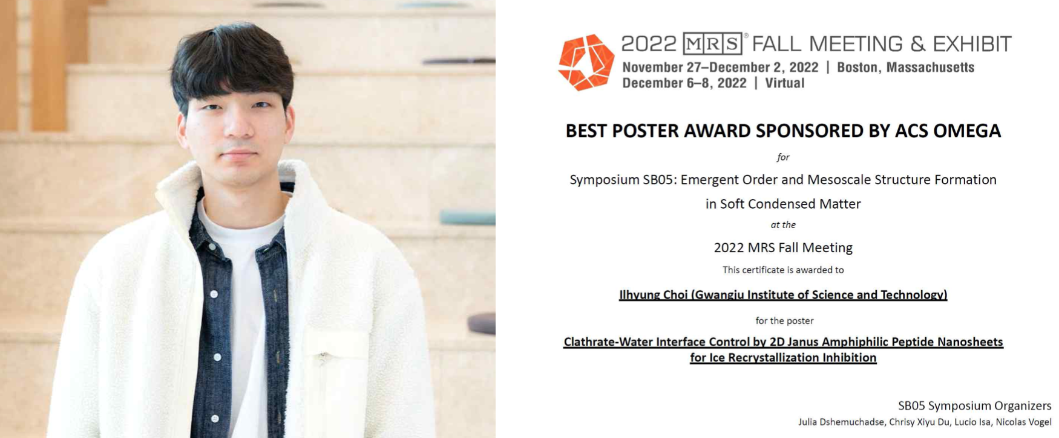▲ (Left) Ilhyung Choi, who received the award at the American Society for Materials Science (MRS) conference, (Right) the Best Paper Presentation Award from the American Society for Materials Science and Technology (MRS)

GIST (Gwangju Institute of Science and Technology, President Kiseon Kim) Ilhyung Choi (Advisor: Eunji Lee) from the School of Materials Science and Engineering won the Best Paper Presentation Award at the Fall 2022 Materials Research Society (MRS) conference held in Boston, USA.

Ilhyung Choi presented a study on the development of new materials with excellent anti-freezing effects by mimicking the chemical composition of antifreeze proteins and structural shapes of polar organisms using peptide self-assembly nanotechnology. (Paper title: Clathrate-Water Interface Control by 2D Janus Amphiphilic Peptide Nanosheets for Ice Recrystallization inhibition)

Through this research, Mr. Choi simulated the characteristics of anti-freeze proteins that exist in polar organisms to effectively preserve food, cells, organs, etc., and synthesized nanomaterials capable of self-assembly in one or two dimensions. The chemical composition and structural shape of the structure that can more effectively inhibit ice growth at the ice/water interface were proposed.

This research was conducted with support from the GIST-GTI commercialization research project and the National Research Foundation of Korea's Future Materials Discovery project.

Ilhyung Choi said, "It is my first research to be presented at an international conference, and it is a great honor to be awarded the paper presentation award at the prestigious American Society for Materials Science. I want to grow into a researcher who can give a good influence to my juniors."

Professor Eunji Lee, the advisor, said, "This award is more meaningful and gratifying in that the on-site judges awarded a special award in the field of self-assembly nanochemistry and recognized world-class research excellence even though the thesis award selection review track was not supported. I'm looking forward to becoming a more creative researcher."

Meanwhile, the American Materials Society is an academic society established in 1973 to promote the development of interdisciplinary materials research including chemistry, physics, biology, mathematics and engineering. Currently, it is a world-class academic organization with about 14,000 researchers from academia, industry and government.



