Ph.D. student Jeongmin Gu won the best thesis award at SIGGRAPH Asia 2022

- Proposal of artificial neural network-based rendering image quality improvement technology at the best computer graphics conference

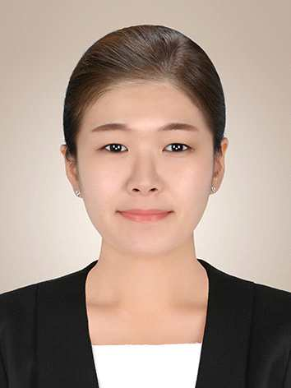
▲ Doctoral student Jeongmin Gu who won the best thesis award

A graduate student at GIST (Gwangju Institute of Science and Technology, President Kiseon Kim) won the Best Paper Award at 「ACM SIGGRAPH Asia 2022」, the best conference in the field of computer graphics.

* SIGGRAPH (Special Interest Group Graphics and Interactive Techniques): The world's largest international conference in the field of computer graphics, where you can see the world's best CG works and the latest cutting-edge technologies as well as the development know-how of world-famous cultural technologies in one place. Since 1974, it is held every year. SIGGRAPH ASIA is an event held in Asia sponsored by ACM (Association for Computing Machinery), the world's largest computer science association.

At 「ACM SIGGRAPH Asia 2022」 held in Daegu from December 6th to 9th, GIST School of Integrated Technology Ph.D. student Jeongmin Koo (Advisor: Prof. Bochang Moon) presented a proposal to dramatically improve the quality of ray tracing-based rendering images. It was selected as one of the four best papers out of a total of 155 papers presented at conferences. (Paper Title: James-Stein Combiner for Unbiased and Biased Renderings)

* rendering: A technology that creates CG images to make virtual objects look real. CG images created by rendering technology are often referred to as ‘rendered images’.

One of the rendering technologies, ‘ray tracing’, has the advantage of generating high-quality CG images by simulating the reflection and refraction of light in virtual space. It is widely used in animation and film fields that require real-life CG images and videos.

Ray tracing-based rendering fundamentally requires a lot of rendering time (for example, several hours per image) because it requires many rays (samples) to obtain a photorealistic image.

In order to solve this problem, recently, techniques for improving the quality of rendered images using artificial neural networks have been proposed, but it is still difficult to effectively restore image details. Therefore, practical use of artificial neural network-based technologies in the field of movies or animations that require high-quality images is bound to be limited.

Professor Bochang Moon's research team is conducting research with Dr. Jose A. Iglesias-Guitian of the University of A Coruña in Spain and proposed a new artificial neural network technique that can take the improved rendered image quality (realistic sense) to the next level by applying existing artificial neural network-based technology.

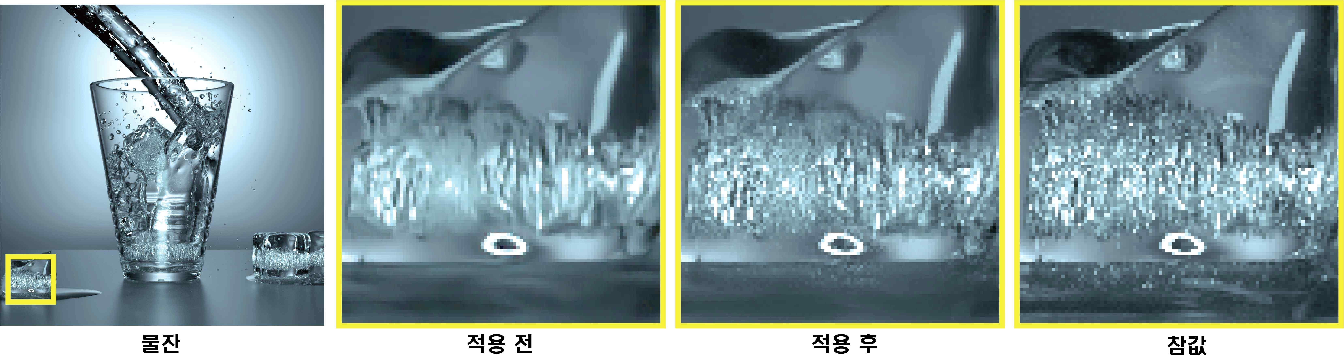
▲ Before and after applying the proposed technique (image comparison by enlarging the ice part of the rendered image of the water glass scene on the far left). The leftmost image is an artificial neural network-based rendering image before applying the technique, and the image in the center is an image after applying the technique. The ‘image after application’ is more similar to the image (far right) that is close to the ‘true value’ obtained by increasing the rendering time (number of samples).

The research team proposed an artificial neural network technique using James-Stain estimator*, one of the traditional techniques in statistics, for the first time in the related field, confirming that CG images can be greatly improved by effectively restoring details of artificial neural network-based rendering images. It can be seen that the error after application decreased by about 5 times compared to before application.(Error before application: 0.02101, error after application: 0.00439)

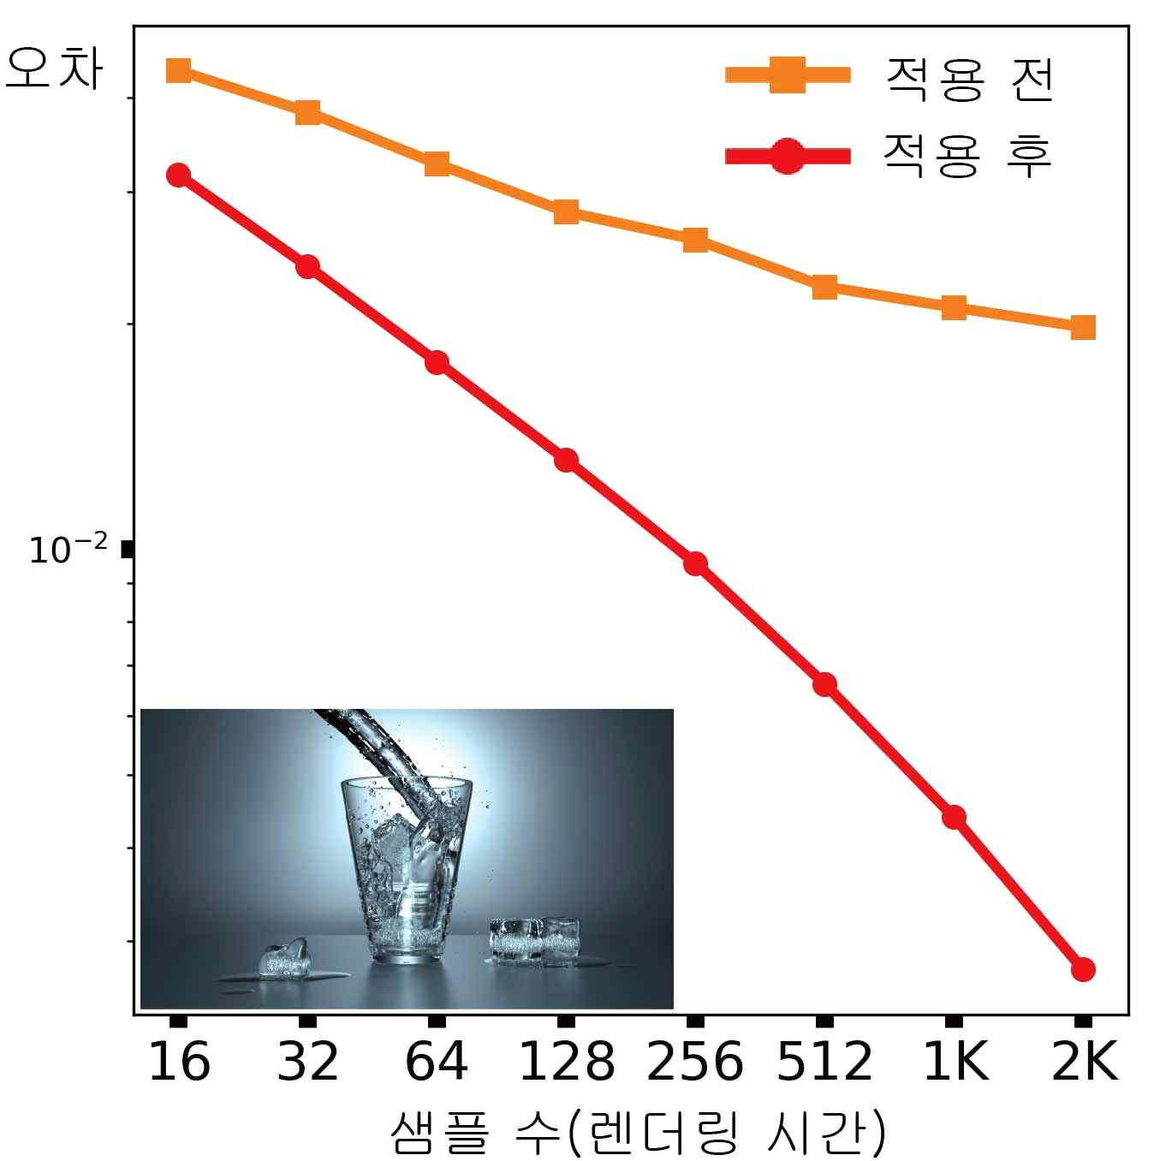
▲ The error (orange line) of the output of the artificial neural network-based image quality improvement technique according to the increase in the number of samples (rendering time) and the error (red line) of the image corrected by the proposed technique. It can be seen from the graph that the error of the proposed method is consistently reduced.

Through this, the rendering image quality improvement technique using artificial neural networks created an opportunity to be used in fields that require high-quality real-life images such as movies and animations.

* James-Stein estimator: An estimator that guarantees that the error of the James-Stein estimation result is always smaller than the error of the input unbiased estimate through the optimal contraction coefficient estimation that shrinks the unbiased estimate to an arbitrary estimate (James and Stein, 1956)

First author Jeongmin Gu said, "We were able to obtain good results this time by combining traditional statistical methods with artificial neural networks and fundamentally improving one of the main problems of the supervised learning-based technology, which currently has the best performance in rendering image quality improvement."

This research was conducted in international research collaboration with Dr. Jose A. Iglesias-Guitian from the University of A Coruña in Spain. For more information, please visit https://cglab.gist.ac You can check it at .kr/sa22neuraljs/.



