Professor Yunho Lee Awarded the Young Water Academic Award

– Providing new knowledge for the management of new contaminants such as antibiotic resistance genes by identifying the mechanism of gene degradation and developing a speed prediction model in the water treatment and disinfection process

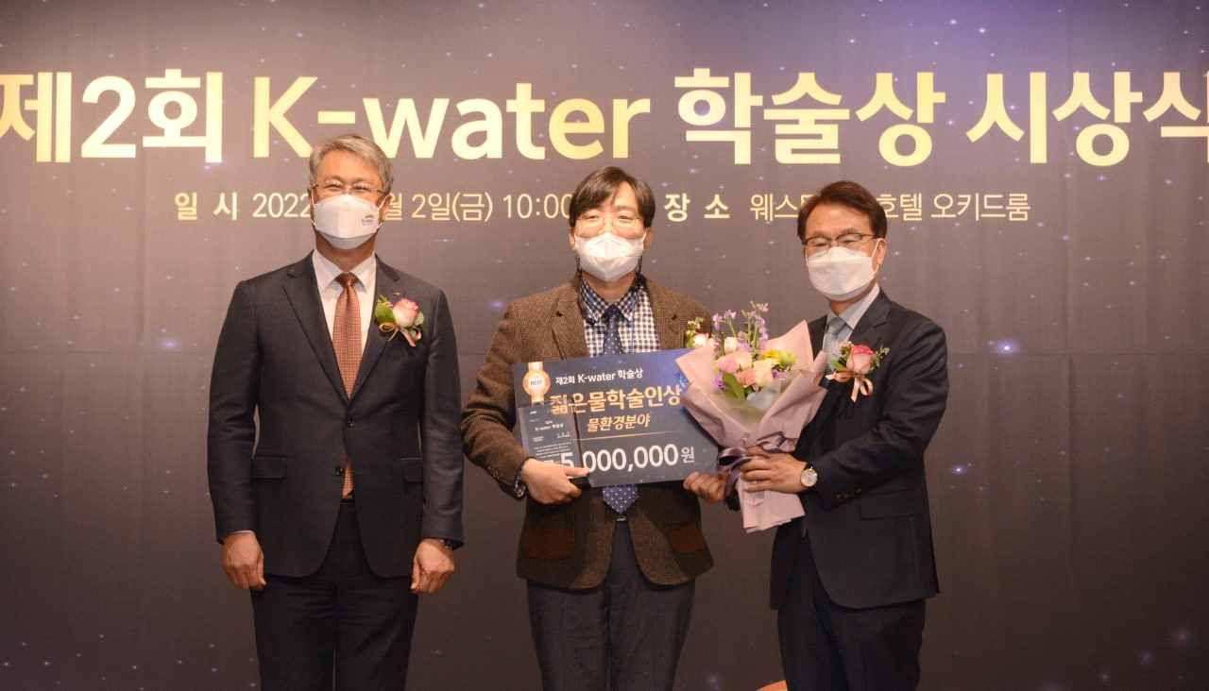
▲ GIST School of Earth Science and Environmental Engineering Professor Yunho Lee received the Young Water Academic Award (water environment field) at the 2nd K-Water Academic Awards Ceremony. (From left) K-Water CEO, GIST Professor Yunho Lee, Seo Il-won, and the Federation of Korean Water Societies President Il-won Seo

GIST (Gwangju Institute of Science and Technology, President Kiseon Kim) School of Earth Science and Environmental Engineering Professor Yunho Lee was awarded the 'Young Water Scholar Award (Water Environment Field)' at the 2nd K-Water Academic Awards Ceremony held at the Western Chosun Hotel in Seoul on Friday, December 2nd.

The ‘K-water Academic Award’ was established by Korea Water Resources Corporation in 2021 to encourage researchers who have contributed to the improvement of people’s quality of life and the development of the water industry through water problem solving and water management technology research and development. This year, in order to secure objectivity and professionalism, the awards were jointly organized with the Korea Federation of Water Science Societies and experts in each field participated in and selected the winners through a comprehensive evaluation.

Professor Yunho Lee conducted in-depth research on the reaction rate and mechanism between chlorine, ozone, and ultraviolet rays, which are widely used in drinking water and sewage treatment disinfection, and antibiotic resistance genes. He was the first to develop a model that could more accurately predict the degree of degradation of antibiotic resistance genes during water treatment, especially using ultraviolet light.

The response model presented in this study is very important in that it enables the prediction of the degree of resistance gene removal by disinfection treatment using resistance gene sequence information. It is also expected that it can be applied to new viruses that have recently become a problem.

Professor Yunho Lee said, "I am very honored to be selected as the recipient of the K-Water Young Water Academic Award, and I would like o thank the students and researchers who collaborated on this study. We will continue to contribute to solving water problems and developing the water industry through steady research activities."

Professor Lee has conducted active research activities in the monitoring and treatment of water and sewage traces and new pollutants, and he has published 42 major papers, including in SCI international journals, over the past five years. He has consistently achieved excellent academic achievements, such as presenting more than 40 papers at domestic and international conferences and workshops.

He is also editor-in-chief of the Journal of Environmental Chemical Engineering, an SCI international journal, and is a member of the Micropollutant Experts Group of the International Water Society (IWA). He is active in research and volunteer activities in the field of science and technology related to water environment at home and abroad, such as serving as the chairman of the Micro Pollutant Expert Group of the Korean Society of Environmental Engineers.



