Professor Kyoung-Woong Kim elected as the president of the Korean Society of Economic and Environmental Geology

– Becomes the 31st president from January 23... Scientific approach to global environmental problems, seeking joint efforts to solve problems, and expecting various academic activities

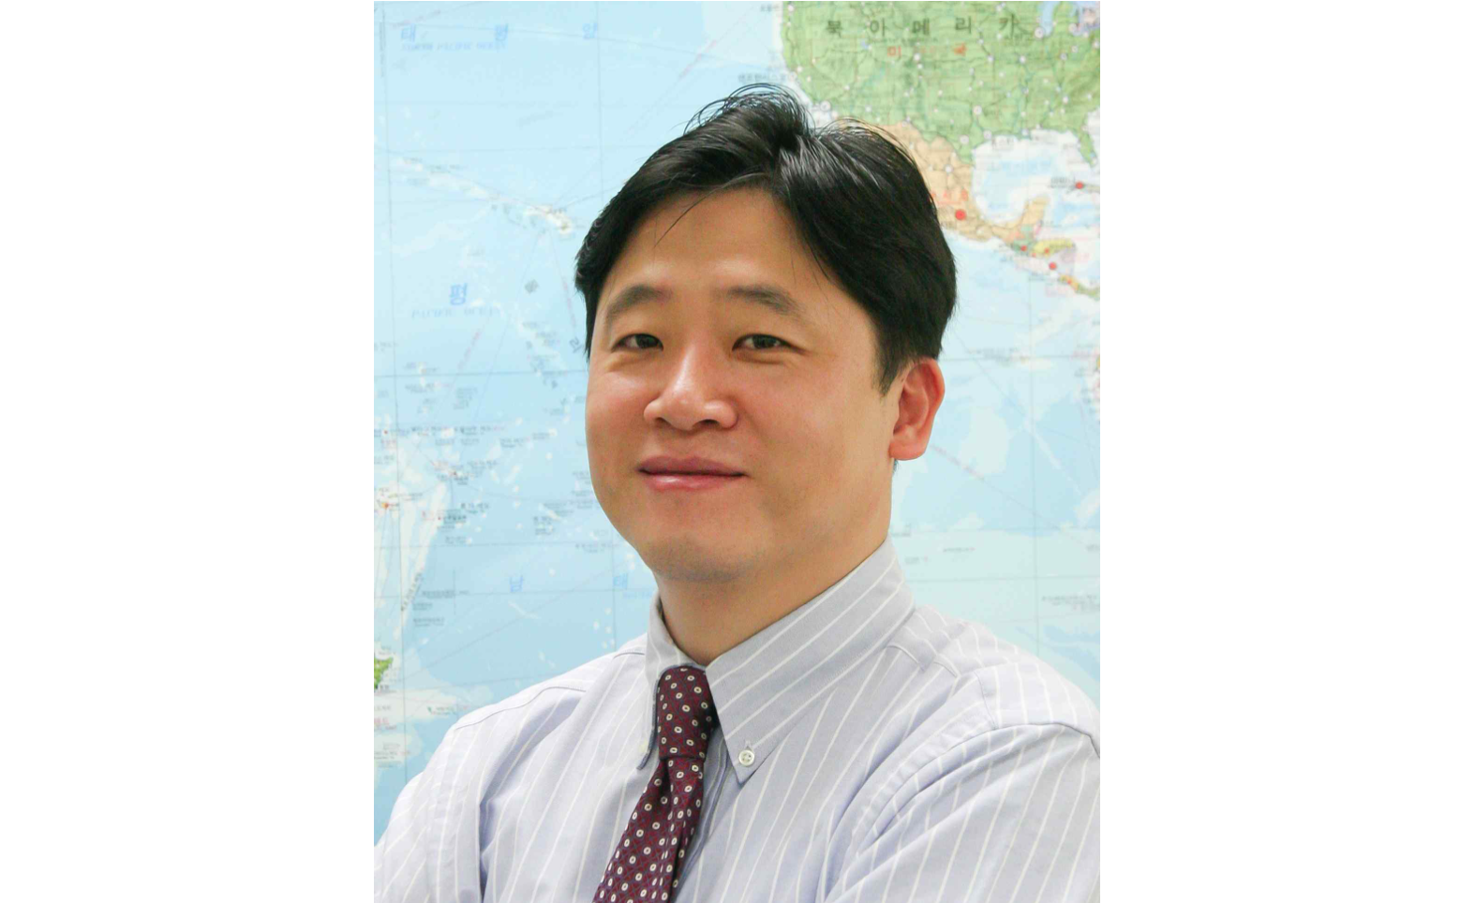▲ School of Earth Sciences and Environmental Engineering Professor Kyoung-Woong Kim

GIST (Gwangju Institute of Science and Technology, President Kiseon Kim) School of Earth Sciences and Environmental Engineering Professor Kyung-woong Kim (Director of International Environmental Research Center) was elected as the 31st president of the Korean Society of Economic and Environmental Geology

The Korean Society of Economic and Environmental Geology held a meeting at the Korea Science and Technology Center on December 2 (Fri) and elected Professor Kim as the new president. Professor Kim plans to serve as the 31st president of the Korean Society of Economic and Environmental Geology for two years starting in January 2023.

The Korean Society of Economic and Environmental Geology was established in 1968 to promote the development of basic science research related to resources and environmental geology as an academic society belonging to the Federation of Korean Science and Technology Societies.

In addition, it is making great contributions to social development through scientific approaches to global environmental problems, joint efforts to solve problems, sharing and providing basic research data for policy establishment, and establishing an industry-university-research cooperation research system.

After joining GIST in 1997, Professor Kim served was active as the dean of the School of Earth Sciences and Environmental Engineering and the dean of the International and Public Affairs, and he is currently the head of the International Environment Research Center.

Professor Kyoung-Woong Kim said, "Recently, the need for technology and science and technology strategies to solve not only future environmental problems caused by climate change but also the securing of strategic mineral resources and related environmental issues is increasing. The Korean Society of Economic and Environmental Geology will make efforts to provide solutions that can respond to various environmental problems that mankind is currently facing."



