Professor SeungJun Kim's team participated in the international mixed/augmented reality symposium and presented outstanding research results and start-up business results

- Research on contents that expand user experience and provide a high level of immersion in the metaverse space
- Introduction of the laboratory startup ‘MIXRIDE’ vehicle-based metamobility XR module and platform

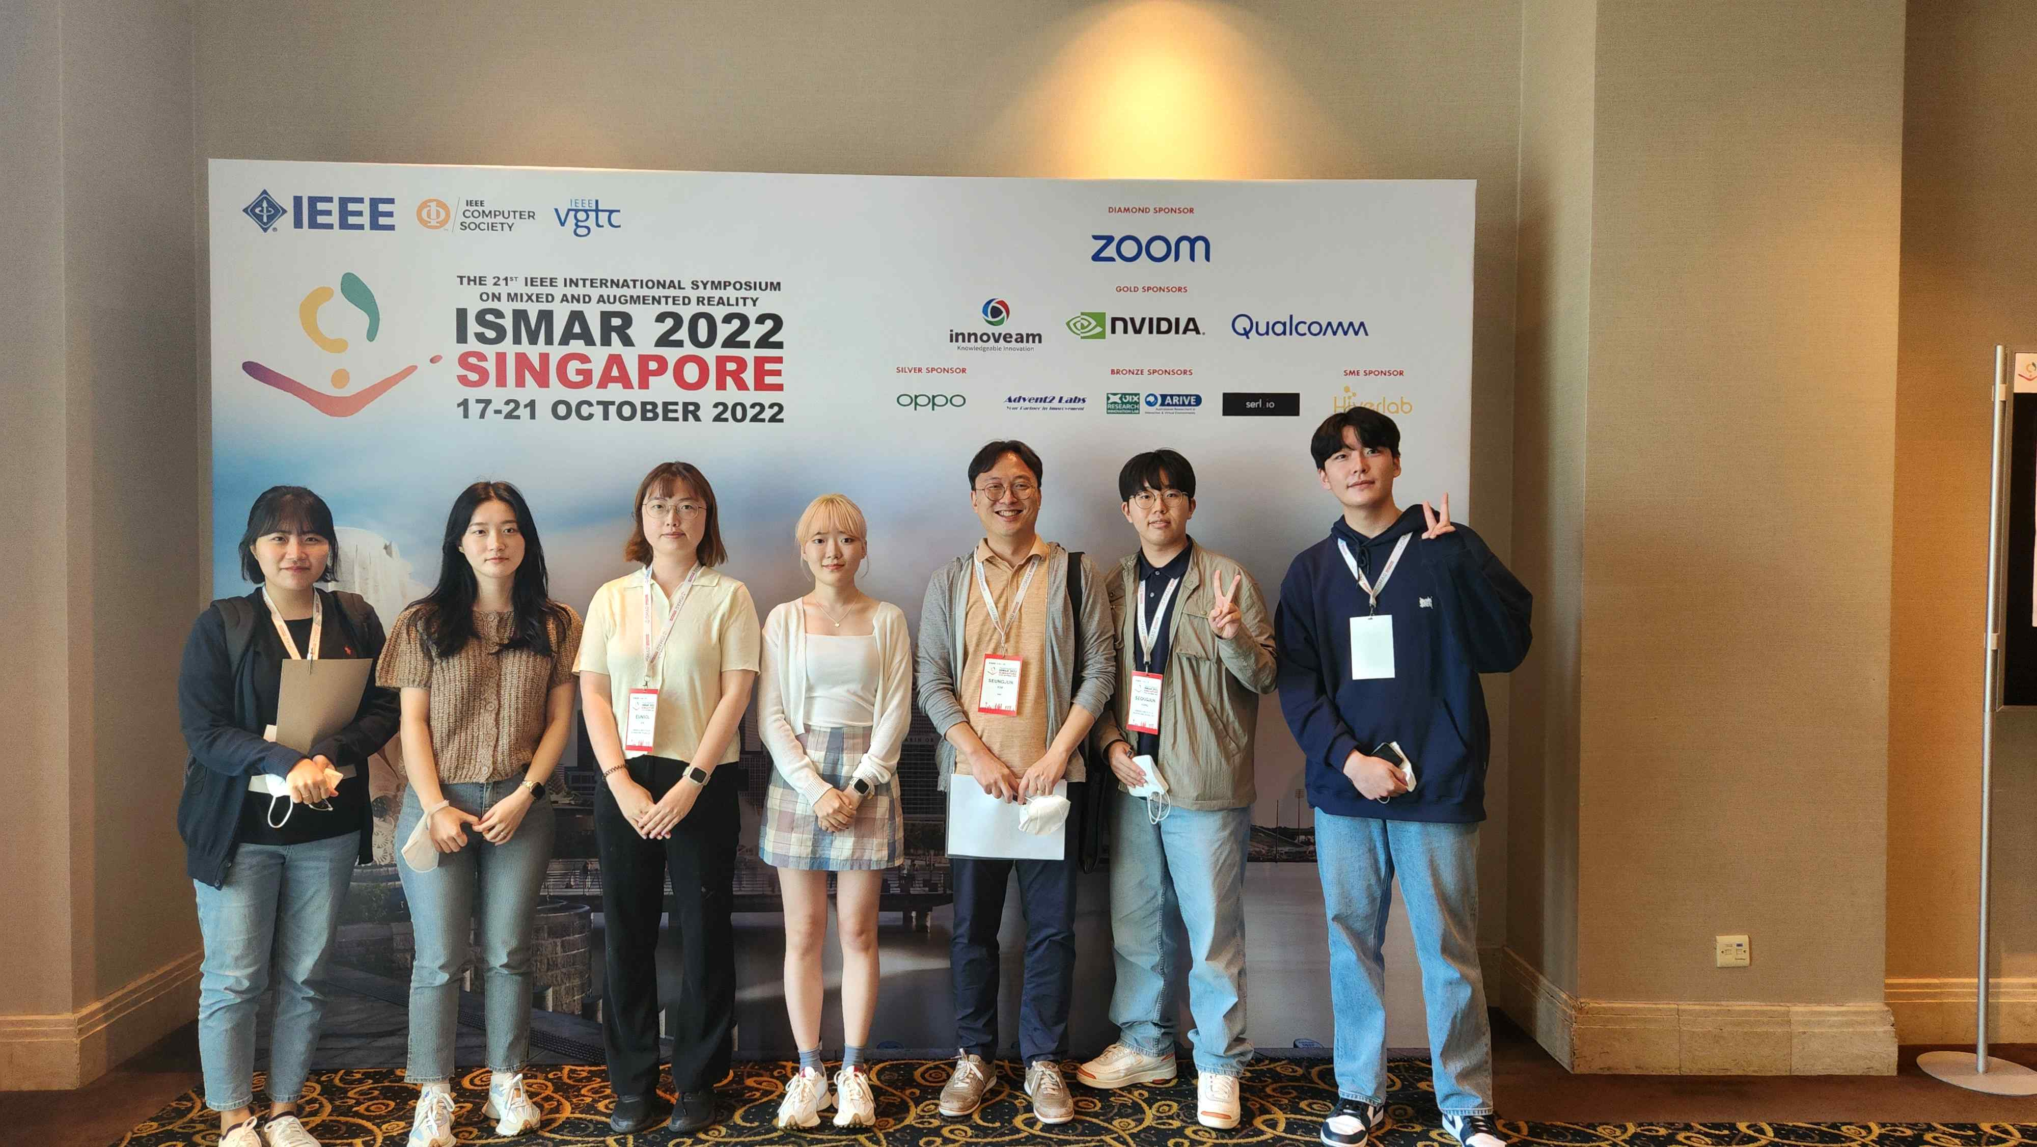
▲ GIST School of Integrated Technology Professor SeungJun Kim's research team participated in the PYL (Pitch Your Lab) session of <IEEE ISMAR 2022> and presented excellent research results in the HCI field.

GIST (Gwangju Institute of Science and Technology, President Kiseon Kim) School of Integrated Technology Professor SeungJun Kim's research team participated in the International Mixed/Augmented Reality Symposium and showed excellent research results in the field of HCI (Human-Computer Interaction).

The research team participated in the PYL (Pitch Your Lab) session of "IEEE ISMAR 2022*" held at the Grand Copton Waterfront Hotel in Singapore from October 17 (Mon) to 21 (Fri) and introduced the research contents of "GIST Metaverse Research Center" and "MIXRIDE."

* The 21st IEEE International Symposium on Mixed and Augmented Reality 2022 conference

Professor SeungJun Kim's research team (GIST HCIS Lab, Human-Centered Intelligent Systems Lab) aims to expand and improve the user experience and develop content that provides a high level of immersion in the metaverse space, which is receiving a lot of attention recently, by conducting research activities.

The ‘GIST Metaverse Research Center’ developed by the research team aims to expand the sense of space and mobility by developing HW/SW and platform technology that supports realistic movement to improve the user experience in the metaverse space.

Since 2021, it has been receiving R&D support for the ‘Metaverse Lab Support Project’ from the Korea Radio Promotion Association (RAPA) and has been conducting an XR-based immersive driving, walking metaverse platform technology and content development project.

The research team developed an immersive driving and twin metaverse platform that utilizes real-world means of transportation as meta-mobility, thereby dramatically increasing the range of movement and experience of users of XR content.

They introduced VR/AR related experts and researchers around the world about research that improved multi-sensory presence and motion sickness based on multi-modal experiences through the development of realistic walking metaverse platforms and contents such as direction-changing walking and mat-type interfaces.

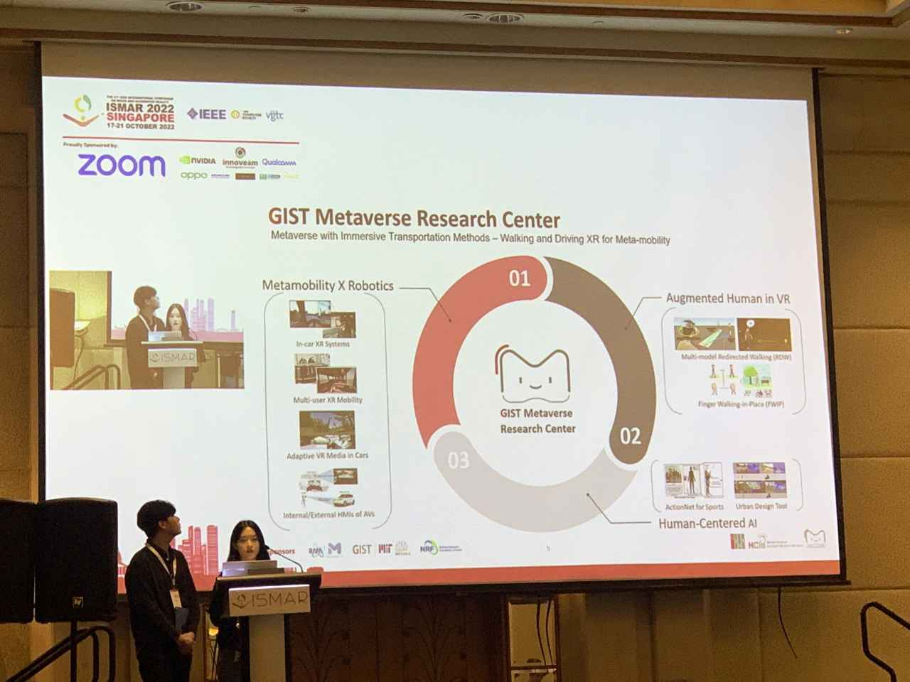
▲ Master's students Taewoo Jo and Yumin Kang from the GIST Metaverse Research Center are participating in the PYL session and giving a presentation.

In addition, GIST HCIS Lab's start-up 'MIXRIDE' (CEO Eun-Sol Ahn, Institute of Integrated Technology master's student) introduced and exchanged vehicle-based metamobility XR (eXtended Reality) modules and platforms in this session.

MIXRIDE is developing metaverse platforms and contents that enable VR/AR entertainment in future mobility with support from the NRF Research Foundation/I-CORPS program.

MIXRIDE's Metamobility XR module is a VR/AR game based on technology that tracks and corrects the location of HMD (head mounted display) so that users do not feel motion sick by accurately compensating for geographic information and speed/acceleration in the mobility environment. It aims to provide a metaverse platform and content service so that people can enjoy it within mobility, such as , infotainment, and education.

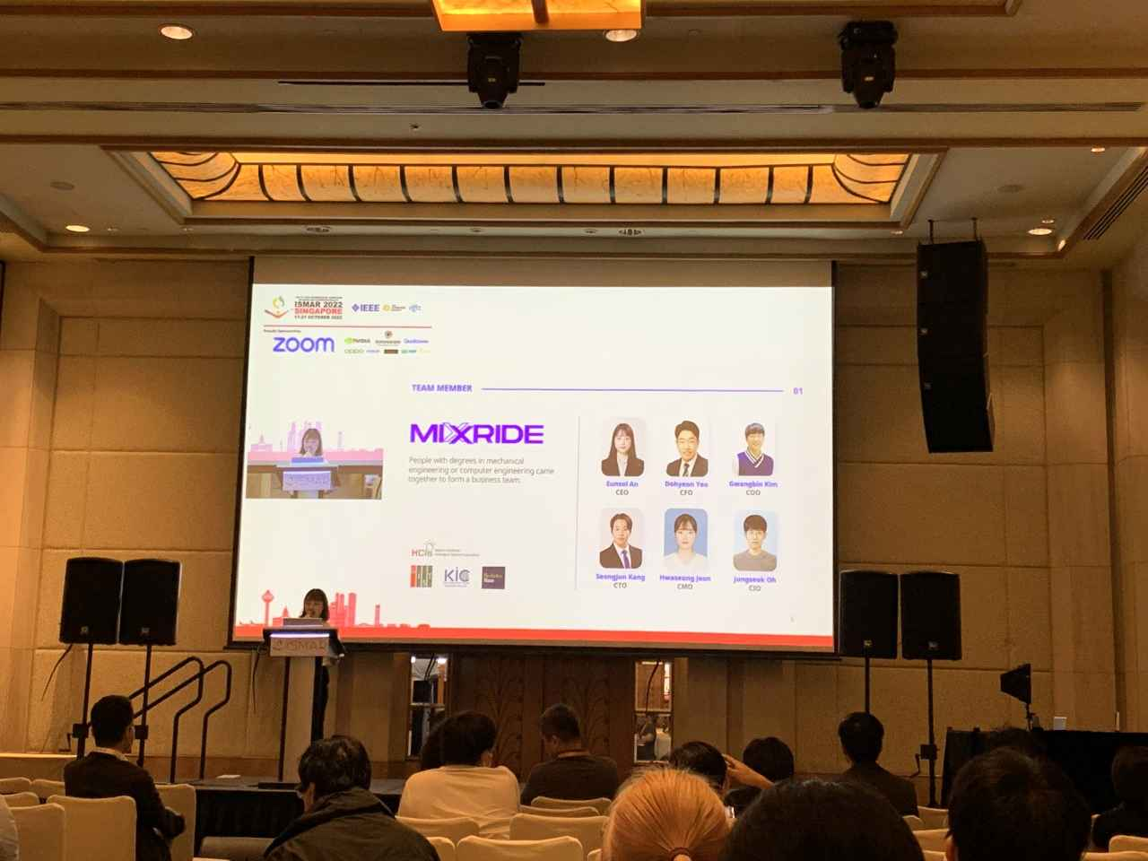
▲ Eun-Sol Ahn, a master's student from the lab startup MIXRIDE, is participating in the PYL session and giving a presentation.

In this PYL session, the company's vision and technology were introduced and the direction and business feasibility of the Metamobility XR module service, which is set to be commercialized next year, were exchanged.

Meanwhile, <IEEE ISMAR 2022> is an international academic competition that pioneers AR (augmented reality) and MR (mixed reality), hosted by the International Electrical and Electronic Engineers Association (IEEE), and sponsored by global IT companies such as ZOOM, Qualcomm, innoveam, and NVIDIA.

Since it was first held in Darmstadt, Germany in 2002, the academic event has been held every year and attracts many participants from all over the world. ISMAR aims to promote technology development in AR and MR fields through thesis presentations, workshops, tutorials, and PYL activities and to bring harmony among experts.



