GIST student Gyudae Sim, won the Director's Award of Energy Technology Evaluation and Planning

- Recognized for excellence in energy personnel nurturing project at <2022 Energy Innovative Talent Forum>
- Conducted joint research with Columbia University in the U.S. on ‘resource recovery-type carbon reduction linkage process’

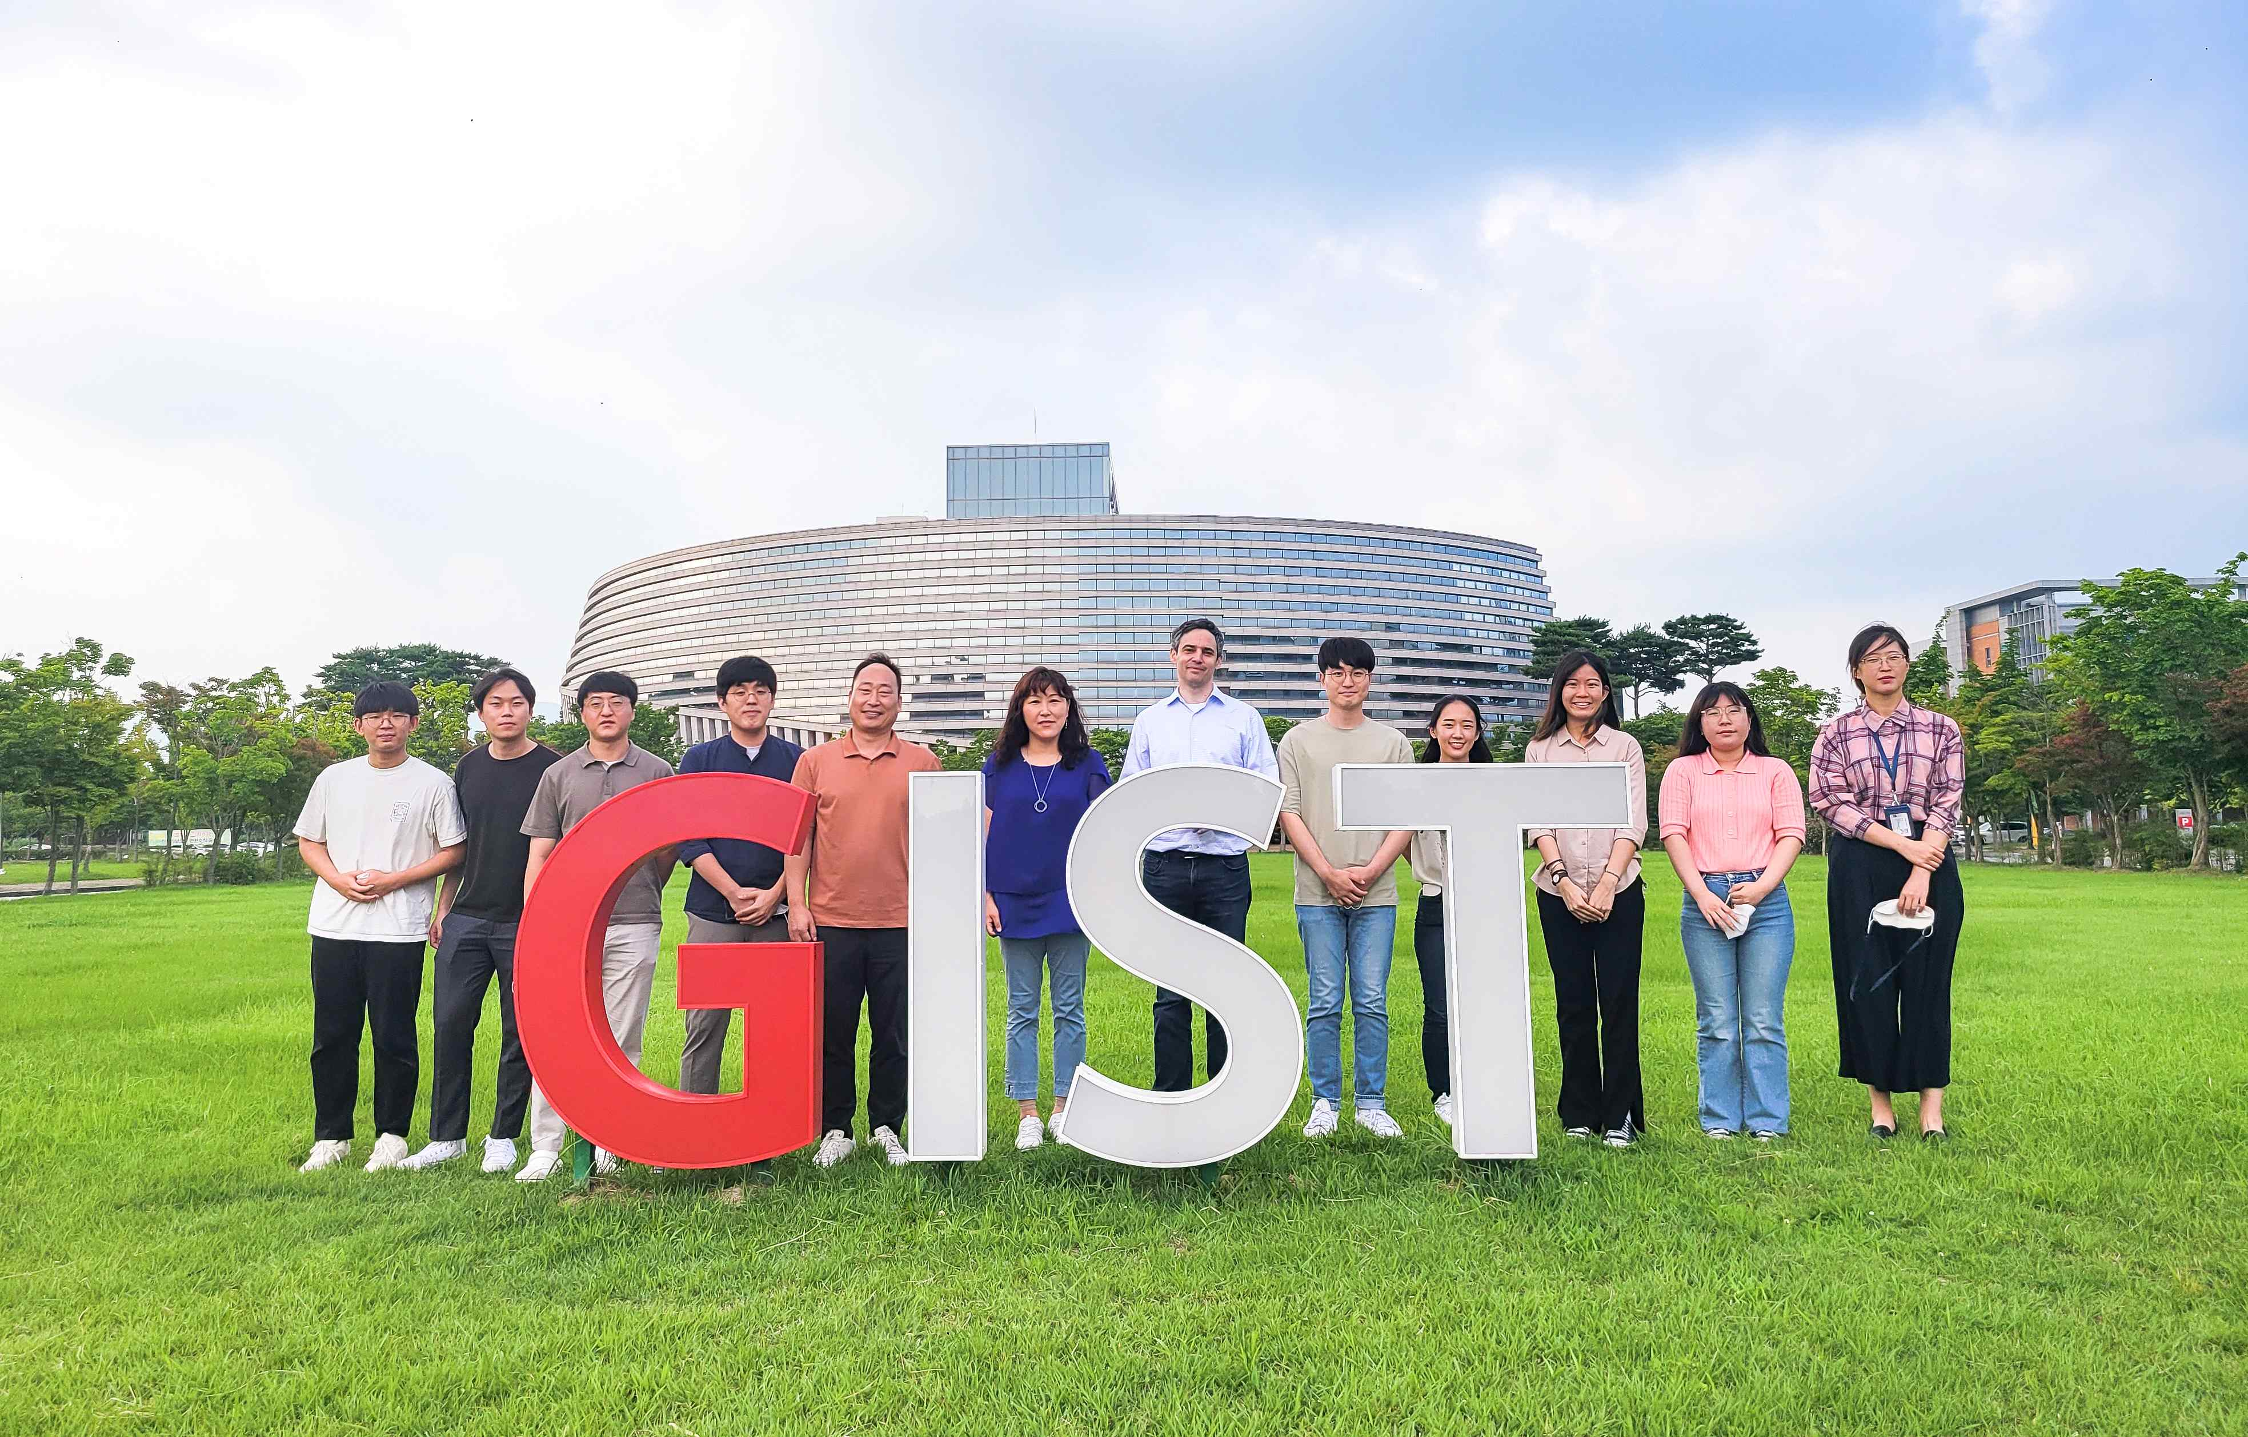
▲ GIST Professor Youngjune Park's research team and Columbia University Professor Ah-Hyung Alissa Park's research team (from the fifth from left): Professor Youngjune Park (GIST), Professor Ah-Hyung Alissa Park (Columbia University, USA), and Professor Aaron Moment (Columbia University, USA)

GIST (Gwangju Institute of Science and Technology, President Kiseon Kim) School of Earth Science and Environmental Engineering integrated master’s and doctoral student Gyudae Sim (advisor: Professor Youngjune Park) received the Director's Award on the 2nd from the Energy Technology Evaluation and Planning Institute at the <2022 Energy Innovation Talents program by the Ministry of Trade, Industry and Energy and supervised by the Korea Energy Technology Evaluation and Planning Institute in recognition of its excellent performance in the energy personnel nurturing project.

Three students, including Gyudae Sim and Professor Youngjune Park's research team's, were sent to Columbia University, an Ivy League university in the US, as a 'Global Talent Cultivation Project for New Energy Industry' from June 2019 to June 2021. International joint research was conducted on the subject of energy and resource recovery convergence technology development.

During the project period, the research team achieved excellent research results, including publishing three SCI (Scientific Citation Index) papers and two presentations at international conferences.

Professor Youngjune Park's research team collaborated with Professor Ah-hyung Alissa Park's research team at Columbia University to develop technology to store carbon dioxide in industrial wastes such as steel slag, and to dramatically recover and concentrate rare metals in the waste.

This technology is a linking of carbon mineralization technology and resource recovery technology. It leaches useful metals (rare earth, calcium, magnesium, etc.) from industrial waste and selectively separates and recovers rare earths by controlling the pH of the solution. It is a technology to store carbon dioxide through a spontaneous reaction with alkali metals (calcium, magnesium, etc.) by injecting carbon dioxide.

Gyudae Sim studied the ‘resource recovery type carbon reduction linkage process’ that stores carbon dioxide while recovering rare earths from steel slag, and he focused on improving the process efficiency. In particular, in the steel slag leaching stage, the leaching efficiency was dramatically improved by introducing the alkali fusion pretreatment method to overcome the problem of reducing the reactivity of raw materials.

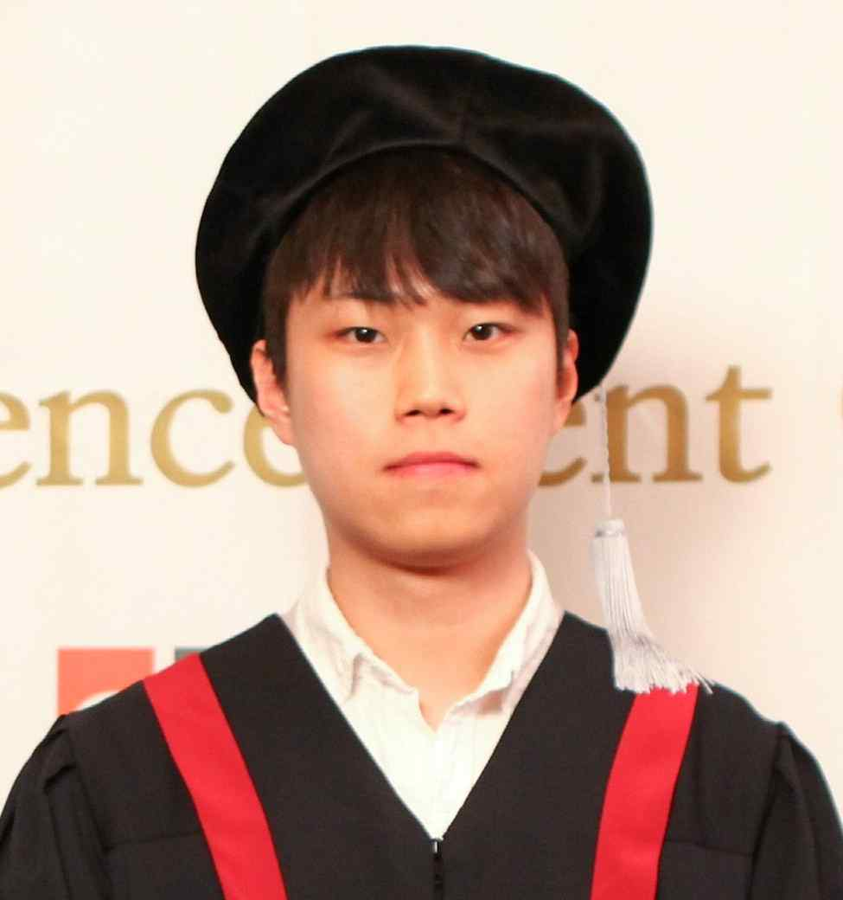
▲ GIST integrated master’s and doctoral student Gyudae Sim received the Director's Award from the Energy Technology Evaluation Institute at the <2022 Energy Innovation Talent Forum>

Student Gyudae Sim said, "It is hoped that the results of this research will contribute to a carbon-neutral and resource-circulating economy society by using industrial wastes that were previously disposed of in landfills and bottoms as carbon dioxide storage media and alternative resources for rare earths."



