"What if Tetris game meets artificial intelligence?" GIST students win international game-AI hackathon

- Students in Professor Kyung-Joong Kim's lab, won first place with 'Emo-Tris', an emotion-based Tetris

- Applying AI technology to the game, recognizing the player's expression to adjust the block type and descent speed

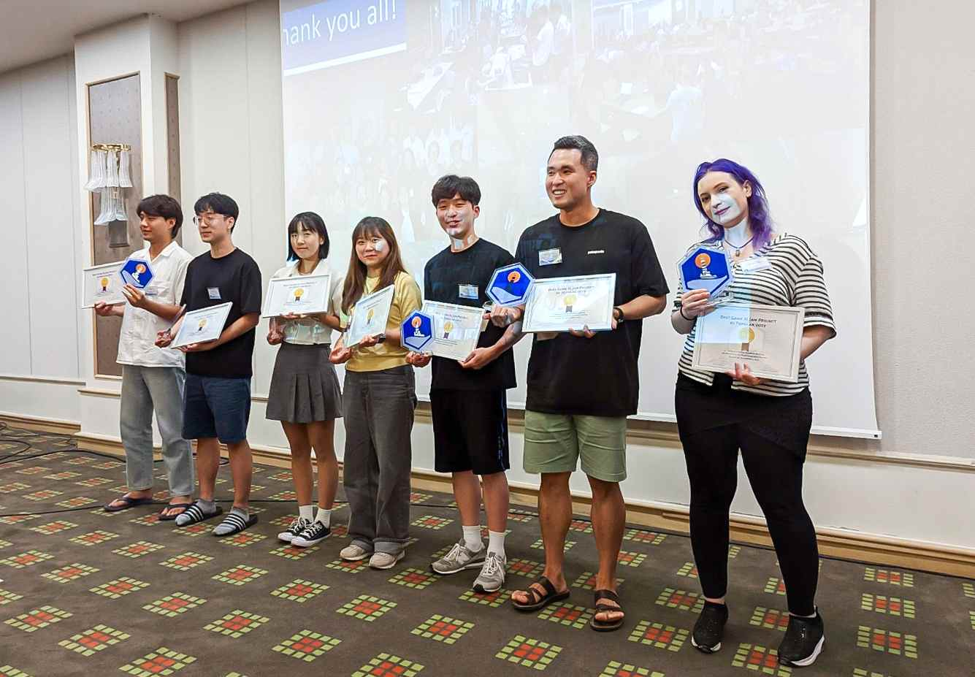
▲ GIST Professor Kyung-Joong Kim's lab students who participated and won the 'Game AI Jam' at the 4th International Summer School on Artificial Intelligence and Games (from left to right) Wonsang You (integrated master’s and doctoral program), Tae-Gwan Ha (master’s program), Eun-Hee Kim (master’s program), Song-Mi Oh (master’s program), Ho-Yun Jeong (master’s program), Jae-Young Moon (doctoral program), Akan Ecehan (doctoral program)

GIST (Gwangju Institute of Science and Technology, President Kiseon Kim) students studying artificial intelligence (AI) technology in the game field won the game-AI hackathon competition held at an international workshop.

The GIST team, made up of 7 graduate students from the GIST School of Integrated Technology Professor Kyung-Joong Kim's lab participated in the 'Game AI Jam' and won the " 4th International Summer School on Artificial Intelligence and Games" held in Chania, Greece.

'Game AI Jam' is a hackathon-type competition in which players perform projects that combine games and AI, such as player modeling, game content generation (Generating AI), and game playing AI (Game Playing AI). The project was completed in two days and the results were evaluated.

This year's event was hosted by 'modl.ai', a game AI engine company, 'AWS Game Tech' of Amazon Web Service in the US, 'Sony AI' by Sony in Japan ‘CLAIRE’, created by the European AI community, participates as a sponsor, 'Google' and 'Microsoft' and 'Electronic Arts (EA)', an American video game maker, Meta AI, Meta AI, which operates Facebook, participated as partners.

Seven students including Jae-Young Moon, Wonsang You, Akan Ecehan, Song-Mi Oh, Tae-Gwan Ha, Eun-Hee Kim, and Ho-Yun Jeong from Professor Kyung-Joong Kim's lab used an emotion-based Tetris game called 'Emo-tris ('Emo-tris)' project, and won a total of $1,400 from Amazon Web Services (AWS) as a prize.

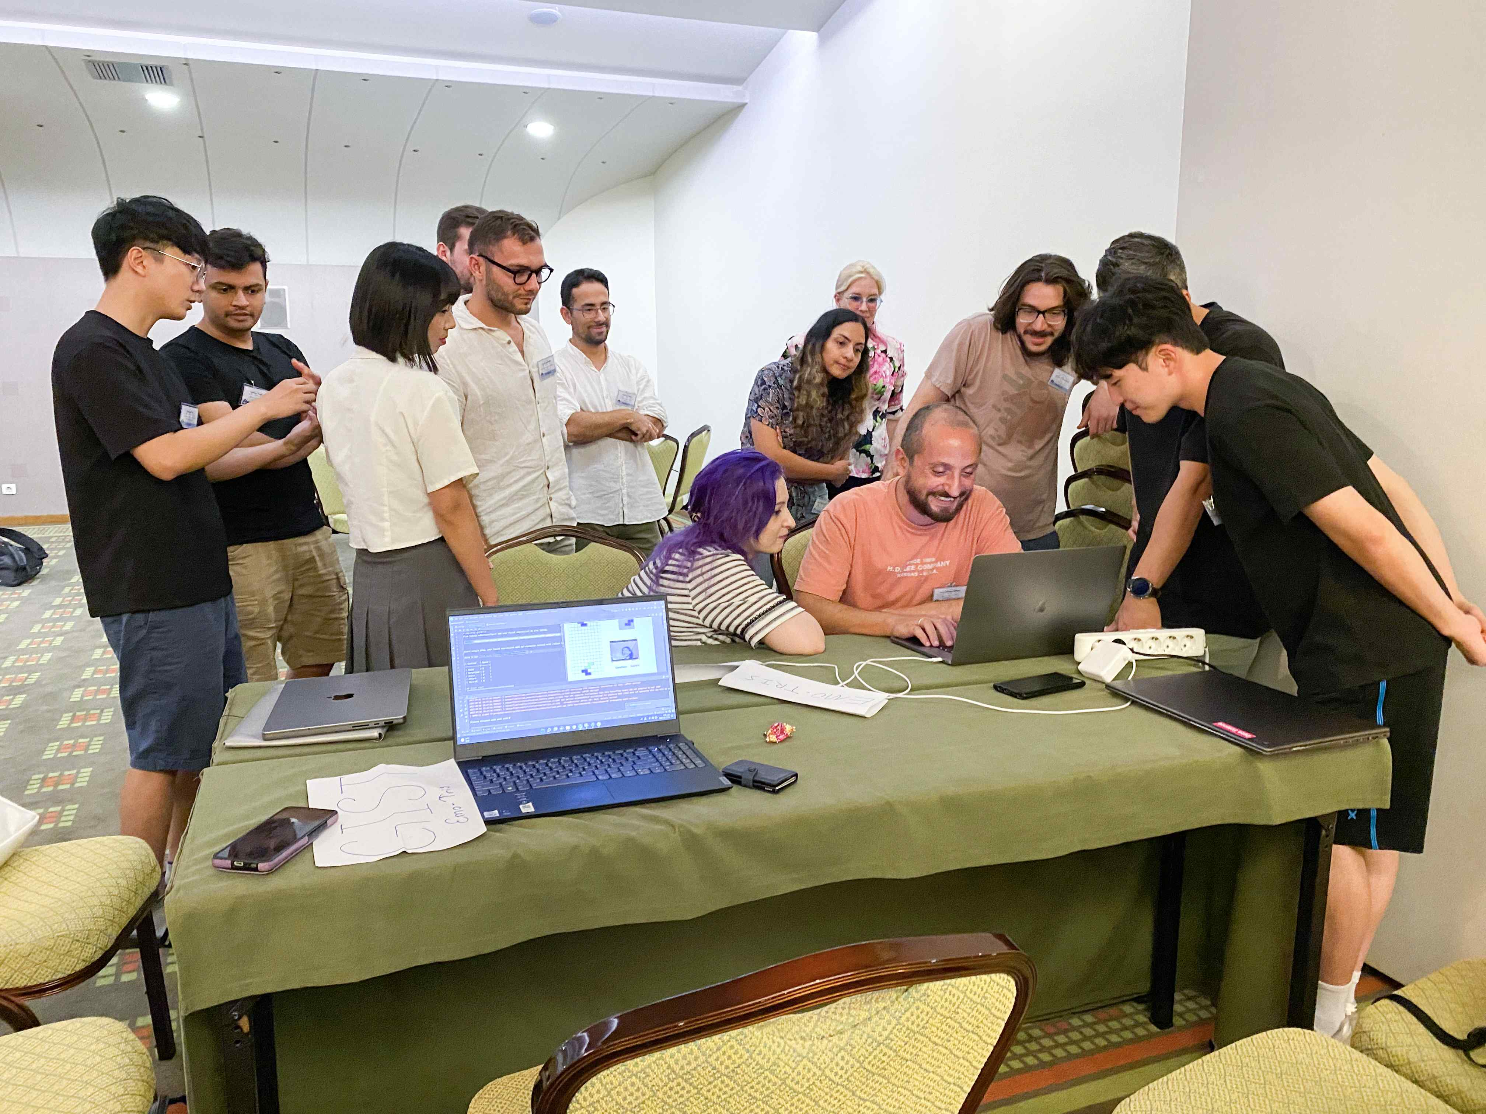
▲ At the 4th International Summer School on Artificial Intelligence and Games, the students of GIST Professor Kyung-Joong Kim's lab who participated and won the 'Game AI Jam' demonstrate the game 'Emo-tris'.

'Emo-tris' is a Tetris game in which the camera recognizes the emotion revealed in the user's expression, and the corresponding block is created as the next block. The speed at which the blocks fall depends on the perceived emotion, so to slow it down, you need to make an overall smile. ‘Emo-tris’ has the characteristic of not only grafting AI technology into the game, but also inducing the user’s pleasant emotions.

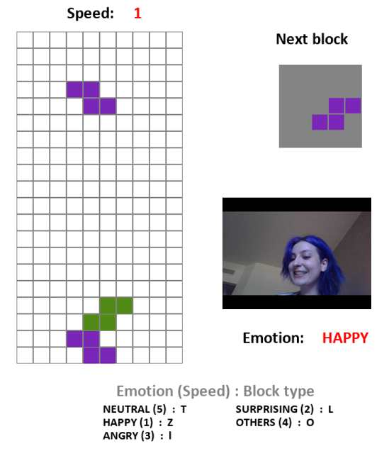
▲ Demonstration scene of 'Emo-tris', an emotion-based Tetris game that combines facial expression recognition and artificial intelligence technology with the Tetris game

Ph.D. students Jae-Young Moon, who led the project, said, "By adding the creativity of the team members to the research skills that they have been building up fiercely every day, they were able to achieve satisfactory results even in a short period of time. I felt that if the creator had fun, the joy would be delivered to the people who use it, and I was able to get inspiration for modeling that uses emotions to enhance the player's experience."

「International Summer School on Artificial Intelligence and Games」is an international workshop for the development of AI technology in the game field, which started in 2018 and is now in its 4th year. Invited lectures on various topics, hands-on workshops provided by world-class practitioners, and the ‘Game AI Jam’ contest were held.

In this workshop, New York University professor Julian Togelius (computer engineering), who is considered one of the world's best experts in artificial intelligence and games, and editor-in-chief of <IEEE Transactions on Games>, a renowned game journal, University of Malta Georgios N. Yannakakis, director and professor of the 'Digital Game Lab', participated as co-hosts.



