GIST student Minwoo Seong won the best thesis award at the Korea Computer Science Conference

– GIST-MIT joint research project support... Designing a virtual reality interface that enhances the experience of capturing in virtual reality, selected as the final paper among 38 papers

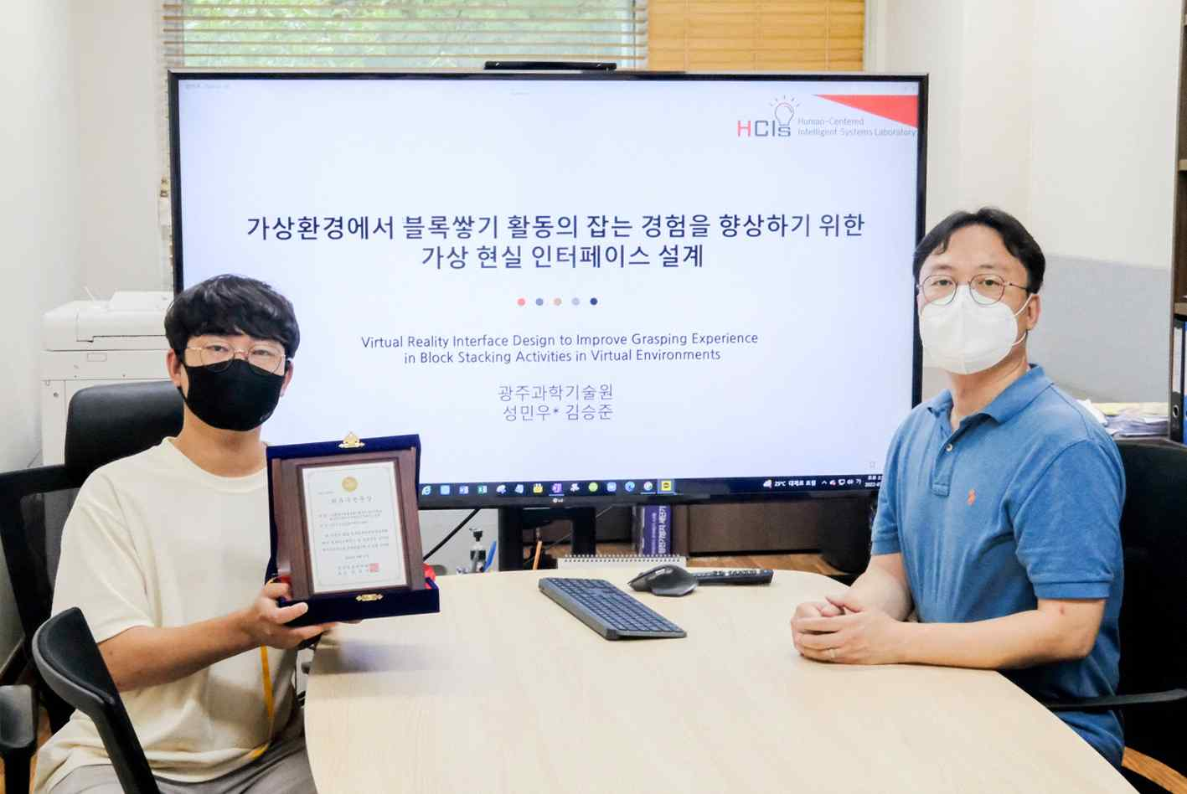
▲ Students Minwoo Seong and School of Integrated Technology Professor SeungJun Kim won the Best Paper Award at the 2022 Korea Comprehensive Computer Science Conference for their thesis “Designing a Virtual Reality Interface to Improve the Experience of Capturing Block Stacking Activities in a Virtual Environment”

A graduate student of GIST (Gwangju Institute of Science and Technology, President Kiseon Kim) won the Best Paper Award at the ‘Korea Computer Science Conference (KCC 2022)’ hosted by the Korean Society of Information Sciences.

School of Integrated Technology student Minwoo Seong (master's program, advisor: Professor SeungJun Kim) won the Best Paper Award for his thesis designing an interface to improve the tactile experience in virtual reality (VR) and verifying the effect of the interface through user-based evaluation*.

* paper title: Virtual Reality Interface Design to Improve Grasping Experience in Block Stacking Activities in Virtual Environments

Minwoo Seong's paper, supported by the GIST-MIT joint research project, is about developing and verifying a virtual reality interface that enhances immersion, reality, presence, and pleasure in tactile experiences in virtual reality. Out of a total of 38 papers submitted to the 'Computer Graphics and Interaction Field' at this conference, one final paper (within the top 3%) was selected.

As one of the representative types of virtual reality-haptic interface system design, the research team developed and designed a method to allow the distal end of the interface to fit into the user's hand to match the distance and angle between the virtual object and the hand at the point of holding the object in the virtual environment.

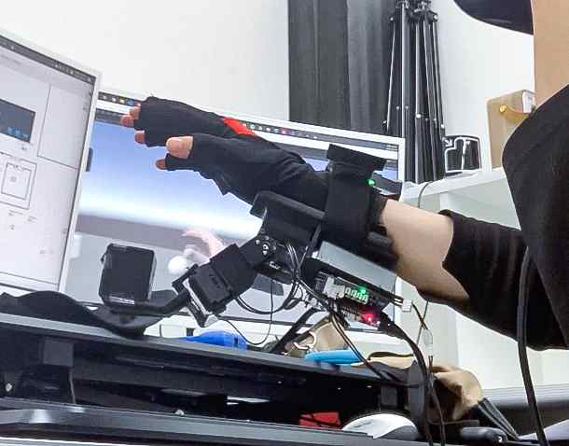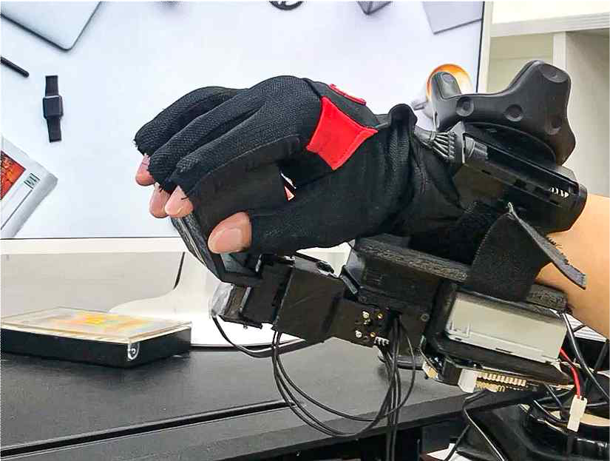
▲ A picture of the virtual reality interface proposed by the research team

Professor SeungJun Kim said, "As virtual reality technology develops, research on new interfaces that can provide a more realistic tactile experience is becoming more and more important. In addition to the experience of holding virtual objects, we plan to conduct research on various tactile sensations such as roughness and elasticity."

The first author, Minwoo Seong, said, "The proposal of a virtual reality interface to increase user experience in virtual reality, which is being actively researched recently, seems to have won a big prize in line with the field of interest of this conference. We plan to conduct research to design a virtual reality interface that can provide a more realistic tactile experience."

Meanwhile, the Korean Society of Information Sciences regularly holds the Korea Comprehensive Computer Science Conference (KCC) to provide an opportunity to present new research results on computer technology and theory and to promote international academic exchange and cooperation.

This year's theme is 'Software Leading Digital Innovation', and general thesis fields include 17 topics including high-performance computing, defense software, Internet of Things, software engineering, artificial intelligence, computer graphics, and interaction with poster presentations being made.



