“Our dog clothes are from ‘Dogley’!” Siggorjavjong Co., Ltd. launches Doggly, a dog clothes recommendation platform

– GIST start-up companies in science and engineering fields such... After beta service, official service started on the 20th
– AI automatically recommends dog clothes size... “Buyer worry less about size, seller focuses on clothes quality”

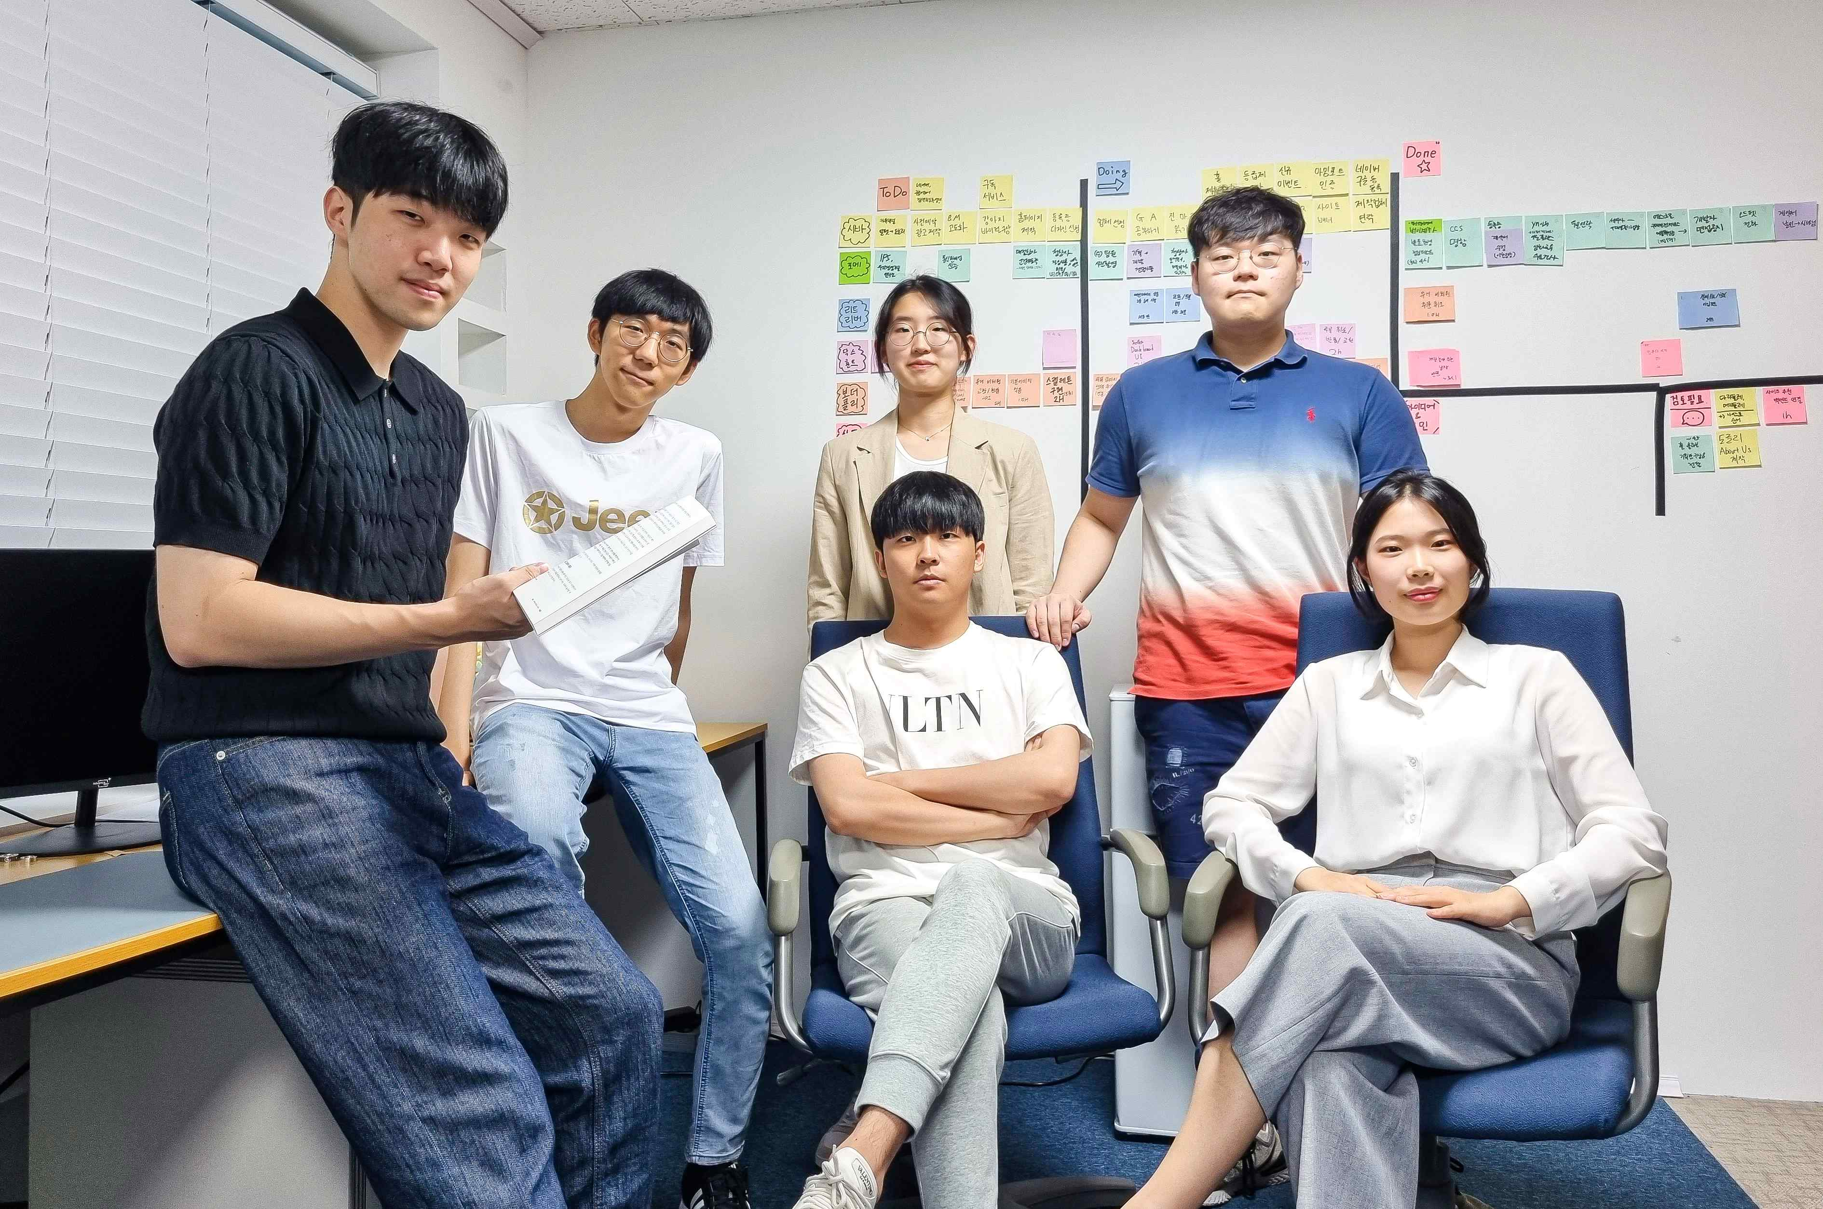
▲ Group photo of 'Shigorjavjong', a startup company of GIST College students in science and engineering fields. Back row (from left) Do-hyeon Koh, Dong-hee Jeon, and Jae-hongJeong / Front row (from left) Jun-myung Lee, COO Yun-hwan Kim, CEO Joo-young Hong

GIST (Gwangju Institute of Science and Technology, President Kiseon Kim), a startup founded by undergraduate students in science and engineering fields, has completed the development of 'Doggly', a dog clothes shopping platform created by applying artificial intelligence (AI) technology. The official service will start from July 20 (Wednesday).

Siggorjavjong Co., Ltd. has been operating a beta service (name: Early Petter) since December last year for the launch of ‘Doggly’ and has been working hard to improve the service together with actual dog owners and dog clothing stores. It announced on the 14th that it would officially operate 'Dogley' from the 20th by increasing the number of stores more than 20 times and improving the accuracy of the size recommendation technology.


▲ Doggly official service scheduled to be released by Siggorjavjong

This official service is equipped with a ‘photo-based size analysis AI function’, and when a dog owner takes a picture of his dog and uploads it, the size is automatically analyzed and a suitable size for each product can be recommended based on the result. In addition, if the owner registers the dog's size information once, it is possible to automatically recommend clothes of the appropriate size for each product.

'Doggly' saw that dog owners had difficulty choosing when purchasing dog clothing at an online shopping mall, even though the same size was presented for each product, and the actual size was different. It is a platform that was born from the idea of solving these problems by applying computer vision technology after seeing the difficulties in making a choice.

For the development of 'Doggly', Siggorjavjong Co., Ltd. directly visited dog owners and sellers of dog clothes, analyzed the current situation and problems in the relevant market, and tried to solve them through an AI application platform.

CEO Joo-young Hong (GIST College School of Electrical Engineering and Computer Science, class of 2018) said, "In the user satisfaction survey conducted during the beta test period, there were many positive responses in that buyers can shop without worrying about size, and sellers can focus on improving product quality by reducing size inquiries, exchanges, and returns. We will try to provide high service satisfaction when 'Doggly' purchases dog clothes in the future by checking additional needs for products."

Before the official service of 'Doggly', Siggorjavjong Co., Ltd. is taking reservations for dog clothes sellers in advance, and sellers who enter the store during the advance reservation period (before July 20) are exempted from fees for up to one year. Along with the benefits, they plan to provide Doggly's unique seller with data feedback.


▲ Doggly logo and description

Detailed information on service use and advance reservations can be found on Doggly Instagram (@doggly_shop) or Doggly site (https://doggly.co.kr).

Siggorjavjong Co., Ltd. is a startup that attracted a seed investment of 100 million won in April this year from Future Science and Technology Holding Co., Ltd., jointly invested by four science and technology institutes (KAIST, GIST, DGIST, and UNIST). ▴ 2022 Daejeon Youth It was selected for ▴ 2022 data voucher project by the Startup Academy ▴ 2021 5 Science and Technology Specialized Universities Joint Startup Competition (XIST) Excellence Award ▴ 2021 GIST Startup Idea Contest ▴ 2021 GIST CEO Forum Encouragement Award, etc.



