GIST to develop game simulation AI technology!

– Selected for a research project and received 3.05 billion won in R&D funding for 3 years... Intelligent NPC creation, online game difficulty verification, etc.

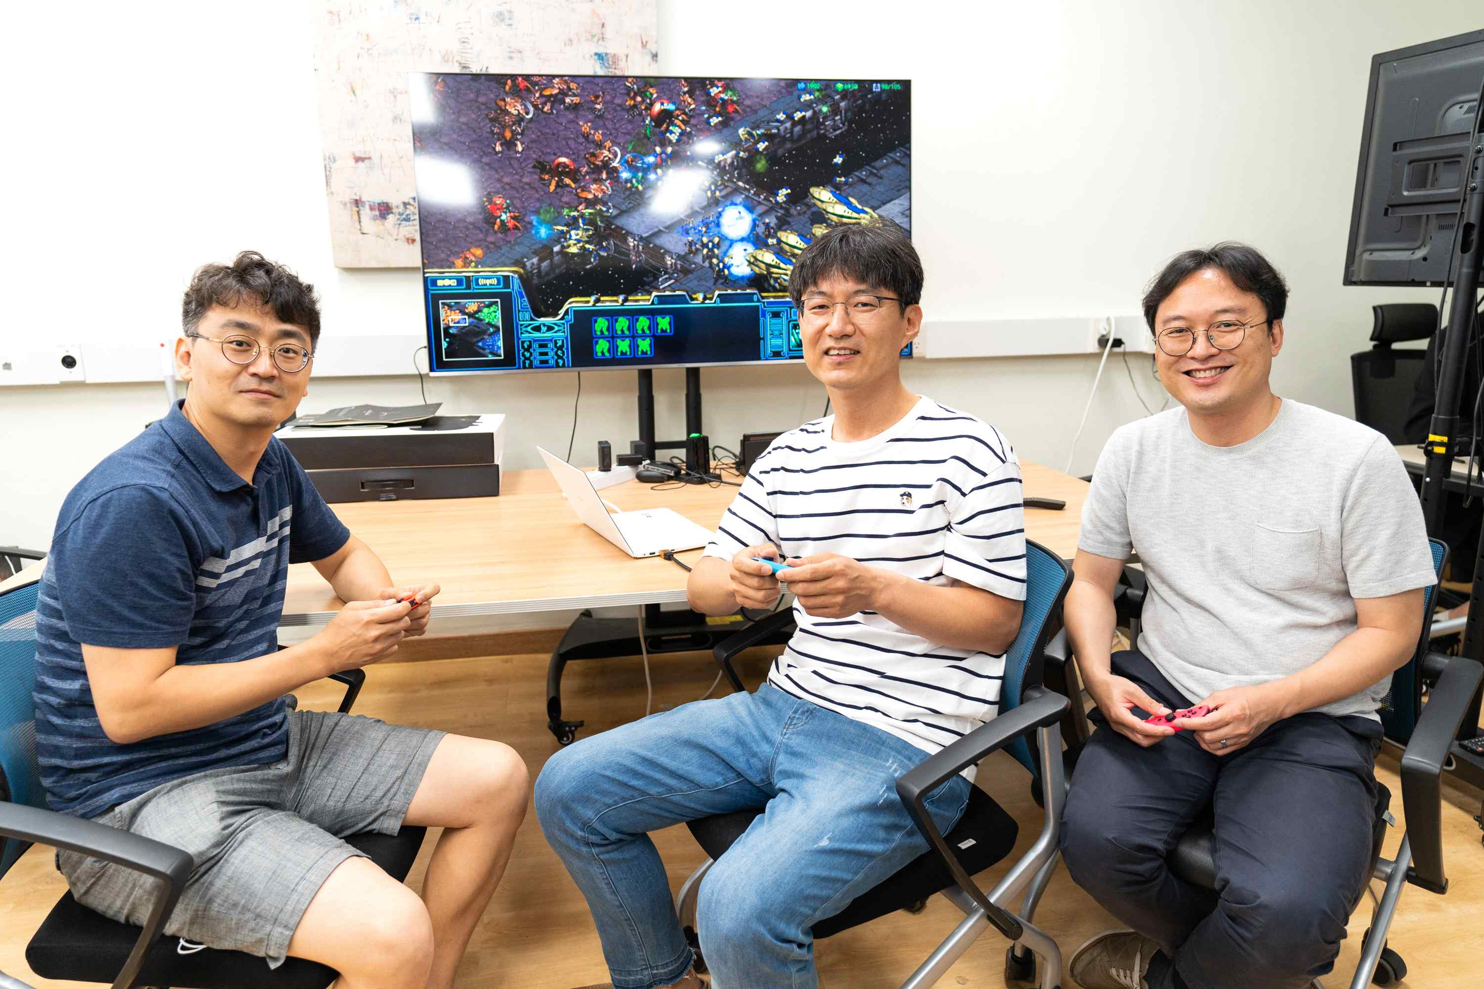
▲ (From left) Professors Jin Hyuk Hong, Kyung-Joong Kim, and SeungJun Kim

The convergence technology experts of GIST (Gwangju Institute of Science and Technology, President Kiseon Kim) will develop artificial intelligence (AI) technology for online game simulation*.

The joint research team consisting of GIST, Hongik University, and researchers from Zinenes, a software development company, plans to develop a game simulation technology that automatically creates game players and various game situations using AI technology.

* game simulation: Before the game is released, refers to a simulation performed for the purpose of verifying the ▴ whether the game is well made ▴ the difficulty level is appropriate ▴ what will be the result if real people play it ▴ various game elements such as how best to adjust the abilities of weapons/items/characters

The <Game Artificial Intelligence Research Center (Director, Professor Kyung-Joong Kim)>, led by Professors Kyung-Joong Kim and Jin Hyuk Hong, who researches culture technology, and Professor SeungJun Kim, who studies human-computer interaction technology at the GIST School of Integrated Technology, was recently selected for the 2022 Culture, Sports and Tourism R&D Support Project and would receive a total of 3.05 billion won by 2024 to carry out the research project "Development of artificial intelligence-based game simulation technology to support online game content production."

The research team plans to conduct research and development of game production and update verification simulators considering user convenience by creating intelligent non-player characters* that play like humans, creating cooperative AI agents for multiplayer games, and automatic creation and verification of artificial intelligence-based game contents.

* non-player character (NPC): A character that the player cannot control directly in the game.

Testing a game before releasing or updating it is very important. It is mainly used by game developers to play directly or to evaluate small game players. Such testing process is time-consuming and costly, making it difficult for small game companies to handle.

In the game simulation technology to be developed by the research team, artificial intelligence players can be used to predict the results of human play. If the simulation results using artificial intelligence and the results played by real people are similar, then it can be used to find out in advance how people will play new content.

The research team is also linked with the 'Human-Centered Game Artificial Intelligence Basic Research Lab (National Research Foundation)' and 'Metaverse Lab Support Project (organized by the Korea Radio Promotion Association)' conducted by the <Game Artificial Intelligence Research Center> to create a ▴ realistic game environment Generating AI ▴ XR (eXtended Reality) games in automobiles ▴ natural UI, etc. XR game source technology and related contents will be developed.

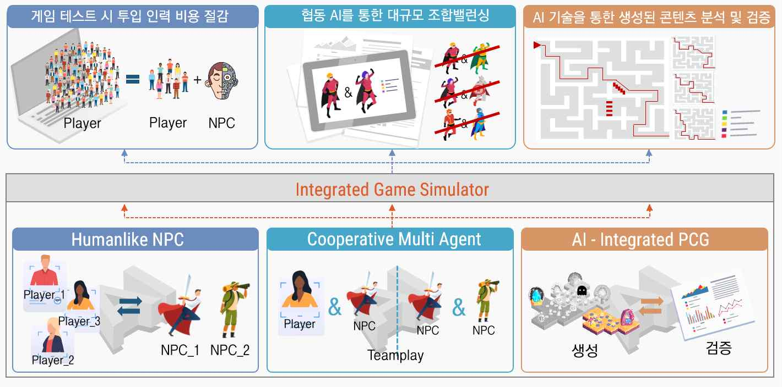
▲ Introduction of artificial intelligence technology to be developed in this project and a game simulation scenario using it

In addition, collaborative research is also promoted through a joint research project (GIST-MIT joint research project) that GIST is conducting with MIT (Massachusetts Institute of Technology) in the United States, fabric UI* production to interpret human behavior patterns and interaction patterns seen in the virtual world, etc.

* Fabric UI: A technology that interacts with a computer using sensors in the form of wearables such as clothes, gloves, and socks

Professor Kyung-Joong Kim, who is intensively researching the field of game AI as a research project manager, said, "In the process of game production, planners and developers think a lot about how to design a game. As artificial intelligence technology develops, more and more attempts are being made to use artificial intelligence in game production, so it is expected that it will help plan and produce game simulations using artificial intelligence technology."

In this study, professors Shinjin Kang and Cheolho Baek of the Department of Game at Hongik University and researchers from Zinenes (CEO Beomseok Ko), a software development company, will participate.



