9 GIST faculty members awarded for scientific and technological achievements

– Commemorating the 2022 Science and Information Communication Day... contributions to achievements in each field, innovation in science education, etc.

– Awarded the Medal of Science and Technology (Emeritus Professor Sun Kyu Lee), Medal of Science and Technology (Professor Youngjoo Chung), etc.

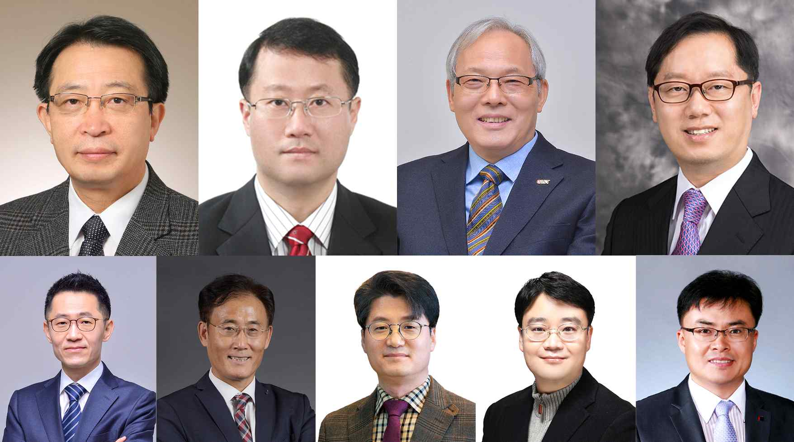
▲ From top left: (Medal of Honor) School of Mechanical Engineering Emeritus Professor Sun Kyu Lee, (Science and Technology Award) School of Electrical Engineering and Computer Science Professor Youngjoo Chung, (Presidential Citation) Department of Physics and Photon Science Professor Do-Kyeong Ko, School of Materials Science and Engineering Professor Gun Young Jung
From bottom left: (Prime Minister's Citation) Department of Physics and Photon Science Professor Keun-Young Kim, School of Electrical Engineering and Computer Science Professor Heung-No Lee, (Minister's Citation) School of Life Sciences Professor Chang-Duk Jun, Department of Physics and Photon Science Professor Unjong Yu, Senior Administrator Yong-ryul Kim

On the 55th Science Day (4.21) and the 67th Information and Communication Day (4.22), nine faculty members, including Emeritus Professor Sun Kyu Lee, were selected as winners of the Government Science and Technology Promotion Award and the Minister's Commendation for their contribution to creating excellent research results and promoting science and technology.

School of Mechanical Engineering Emeritus Professor Sun Kyu Lee has served as the vice president, president, and editor-in-chief of the Korean Society of Precision Engineering since January 2013. He has contributed to the enhancement of the international status of the Korean Society of Precision Engineering along with the establishment of the Asian Society of Precision Engineering. In recognition of his contribution to training and producing world-class specialists in the field of ultra-precision manufacturing machinery, he was awarded the Medal of Honor for Science and Technology.

The Science and Technology Award was awarded to School of Electrical Engineering and Computer Science Professor Youngjoo Chung who contributed to the development of science and technology through research in the field of optical fiber gratings and sensors, and development and commercialization of Wolfram language-based symbol calculation software.

In addition, the Presidential Citation was awarded to △ Department of Physics and Photon Science Professor Do-Kyeong Ko who contributed to the establishment of high-power laser and advanced optical technology by devoting himself to education and research in the field of optics and △ School of Materials Science and Engineering Professor Gun Young Jung who contributed greatly to the entry of the Scientific and Scientific Paper Citation Index (SCI) and the achievement of the high citation index (8.526) of Nano Convergence, Korea's first international journal.

The Prime Minister's Citation was awarded to △ Department of Physics and Photon Science Professor Keun-Young Kim who contributed to the development and expansion of theoretical physics, humanities convergence science education, and educational innovation and △ School of Electrical Engineering and Computer Science Professor Heung-No Lee who contributed to pioneering new fields such as sensor intelligence and machine learning.

The Minister's Citation was awarded to △ School of Life Sciences Professor Chang-Duk Jun who is currently leading the state-designated (creative) research group in the field of immune cell therapy as a representative scholar in the field of immunology T lymphocytes, and who contributed greatly to the global growth of Korean immunology by hosting international academic events as the president of the Korean Society of Immunology △ Department of Physics and Photon Science Professor Unjong Yu who contributed to innovation in university science education, popularization and expansion of science, and research on complex systems and interdisciplinary convergence and △ Senior Administrator Yong-ryul Kim was selected as a responsible administrative officer for his contributions to the selection of future science and technology specialists, such as selecting students with the potential and giftedness to lead science Korea with excellent job performance, and improving the entrance exam system in consideration of socially considerate groups.



