GIST Ph.D. students conducted applied research on brain engineering using artificial intelligence at NCSU, USA

– Visited the U.S. to support the 'Global Core Talent Cultivation Support Project' by the Information and Communication Planning and Evaluation Institute

– Development of brain stimulation technology and brain-computer interface research with local researchers

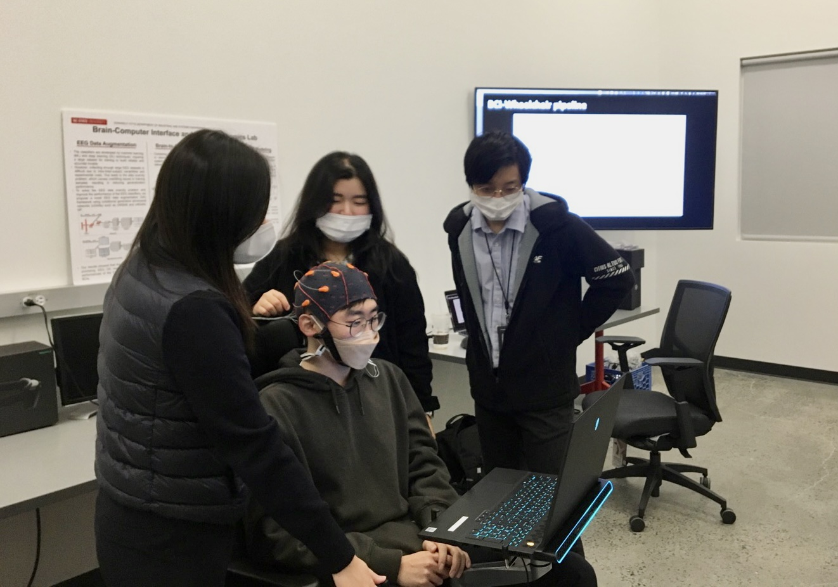▲ NCSU interns are experimenting with brain-computer interfaces.
(Students from right: Sunghan Lee, Da-eun Kwon, Kyungho Won, Su-yeon Kim)

GIST (Gwangju Institute of Science and Technology, President Kiseon Kim) doctoral students went to the United States with the support of government-affiliated organizations to conduct applied research on brain engineering with local researchers.

Sunghan Lee and Kyungho Won (advisor Professor Sung Chan Jun), who are enrolled in the doctoral program in the School of Electrical Engineering and Computer Science, were selected last year for the 'Global Core Talent Cultivation Support Project' by the Information and Communication Planning and Evaluation Institute (IITP) under the Ministry of Science and ICT. They conducted applied research on brain engineering for six months at North Carolina State University (NCSU), which is famous for its industrial engineering field.

The two students, together with Handong Global University Ph.D. student Da-eun Kwon (advisor Professor Min-gyu Ahn) and Seoul National University master's student Su-yeon Kim (advisor Professor Myung-hwan Yoon), who were selected as research interns as part of a joint research team, began in October of last year with Professor Chang-su Nam of NCSU (Department of Industrial and Systems Engineering). They were dispatched to the laboratory and conducted research under the theme of 'Search for AI-based brain signal biomarkers and development of a brain function control system.'

Student Sunghan Lee conducted a study with the NCSU team to analyze brain biosignals using deep learning technology, and student Kyungho Won designed an experimental environment for wheelchair operation using brain-computer interface technology and conducted active joint research.

Student Sunghan Lee said, "I was able to have in-depth discussions with the NCSU research team about brain biosignal processing methods, exchange ideas, and have valuable experiences to broaden cooperative abilities and research perspectives."

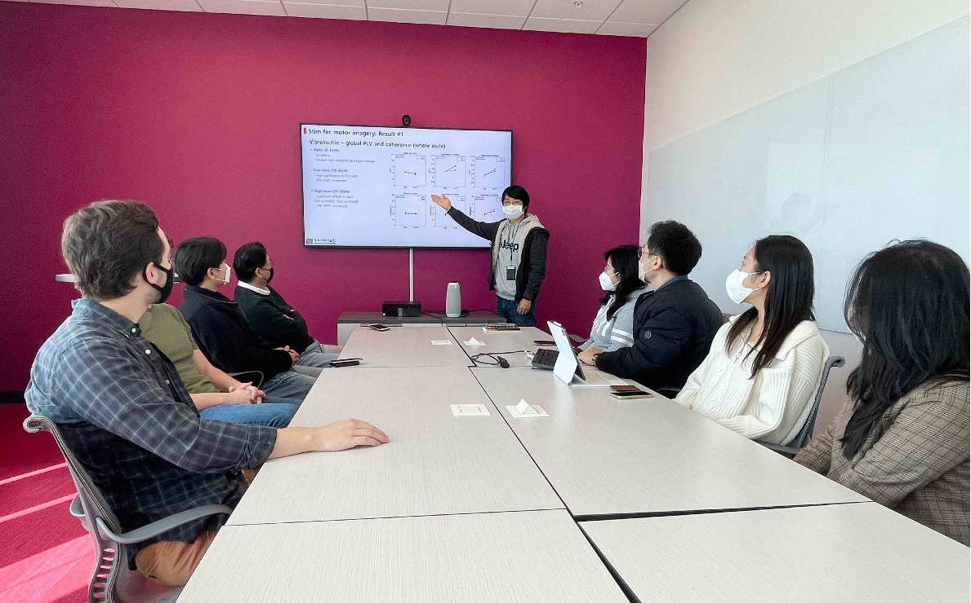▲ Dispatched interns are conducting a joint seminar with NCSU researchers. (Presenter: Sunghan Lee)

Kyungho Won said, "The time spent at a leading overseas university, experiencing an advanced research environment and culture, and sharing research know-how will be of practical help in preparing for a postdoctoral program."

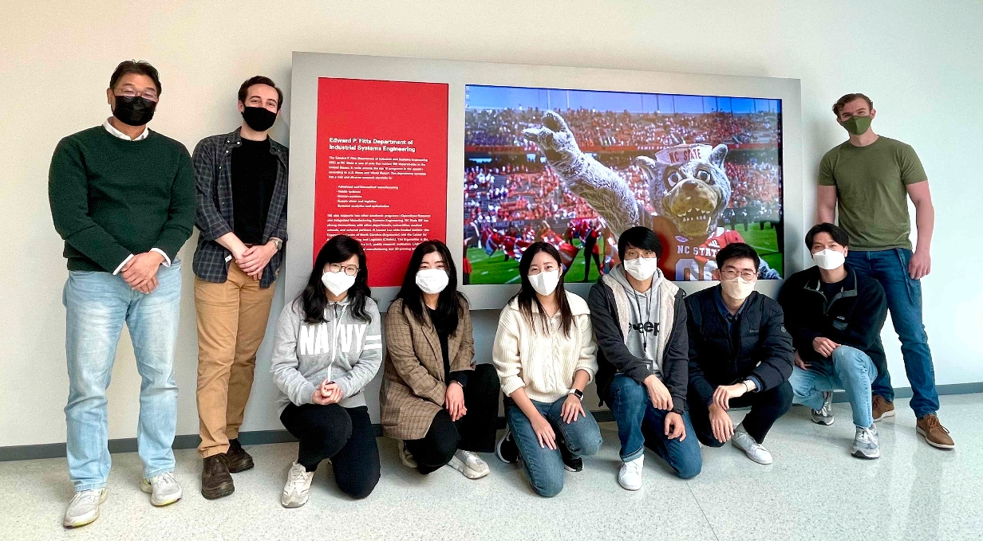▲ Commemorative photo of NCSU interns and researchers (third from right): Kyungho Won, Sunghan Lee, Su-yeon Kim, Da-eun Kwon, and (first from left) Professor Chang-su Nam

IITP's 'Global Core Talent Cultivation Support Project' aims to provide opportunities such as networking with advanced research teams and research field experiences and has an open call in the first half of every year to select about 60 master's and doctoral students (as of 2022).

IITP supports selected graduate students (research interns) with round-trip air tickets, the full cost of staying abroad for 6 months, and expenses for overseas research activities.



