Professor Hyeong Jin Kim selected for the European Union 'M-era.net' project

– Supported with 400 million won for 3 years... Research in the field of lithium-ion batteries with French national research institutes

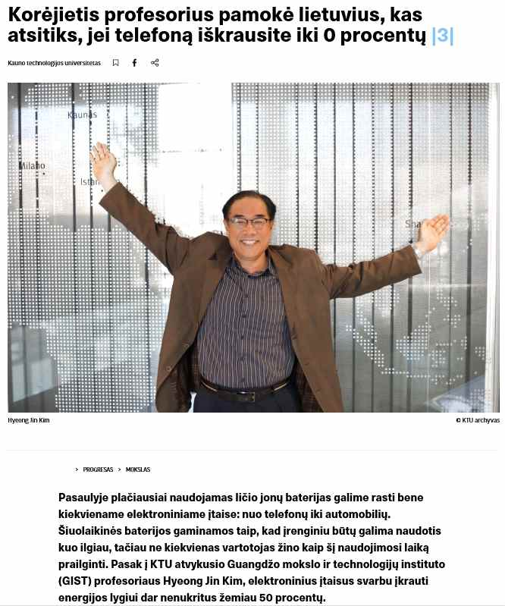
▲ Screen capture of local online media <Delfi> interview with Professor Hyeong Jin Kim

GIST Professor Hyeong Jin Kim (Graduate School of Energy Convergence) was recently selected for the M-era.net project hosted by the European Union (EU).

'M-era.net' is a European research support network that was established to support innovative research in materials science and engineering. Currently, 27 countries within the European Union, Brazil, and South Africa are participating, and outside the EU, South Korea and other countries are participating as observers. In particular, the EU, which places great importance on the fields that affect environmental issues, is solving major problems by forming a consortium targeting climate change and its countermeasures.

Professor Hyeong Jin received 320,000 euros (420 million won) from the Korea Institute for Advancement of Technology (KIAT) for 3 years through the M-era.net project supporting the European Green Deal. He received support to conduct research in the field of lithium-ion batteries together with the leading research institutes, the French Mulhouse Materials Science Institute* and the French National Centre for Scientific Research**. He developed sensors that measure the physical and chemical changes in lithium-ion batteries, which are mainly used in electric vehicles (EV) and energy storage devices (ESS). The goal of this task is to develop a system that can measure stability and various performance in real time by attaching it to the inside or outside of the battery.

* IS2M

** CNRS

Lithuania's Kaunas University of Technology (KTU) and Luxembourg Institute of Science and Technology (LIST) are participating in the consortium for this study, and French battery maker SAFT is participating as a company.

Professor Kim said, "By participating in innovative joint research and development with research institutes, universities, and companies in Europe, I hope that this project will be an opportunity to enhance the status of GIST and Korean battery technology in materials science and batteries."

Professor Kim, who entered the research year from March of this year, discussed joint research on the synthesis of lithium-ion battery materials using lasers with the research team of Kaunas Technology University in Lithuania. He is currently negotiating electric vehicle battery technology with LG Energy Solutions in Warsaw and Wroclaw, Poland.

Professor Kim's research activities are drawing much attention locally, with "Delfi," the largest online media in the three Baltic countries, including Lithuania, reporting interviews and posting introductory articles on the Kaunas University of Technology website. In an interview with Delfi, Professor Kim said, "In the future, Professor Sigitas, a top expert in laser field at Kaunas Technical University, and I will study innovative battery material synthesis together. Through the research exchange agreement between Kaunas University of Technology and GIST, we plan to promote mutual development between students, researchers, and professors."

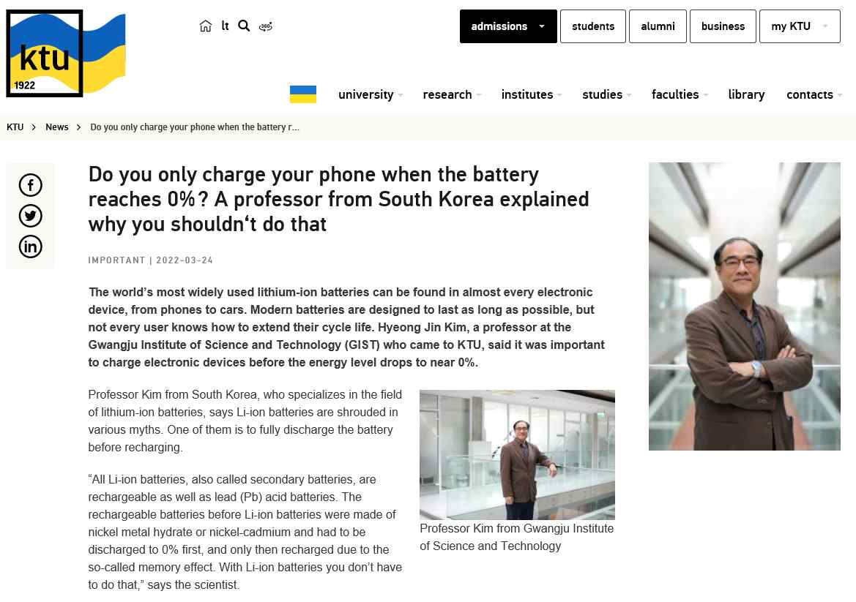
▲ Screen capture of articles related to Professor Hyeong Jin Kim on the Kaunas University of Technology website

Professor Kim will lead collaborations with participating research institutes for the M-era.net project as well as Lithuania during the second half of this year and the rest of the research year. In particular, LG Energy Solution's Polish plant plans to work together with local Polish researchers on new analysis methods for electric vehicle batteries.

Professor Kim said, "European universities and research institutes, which are most sensitive to climate change and environmental issues, and GIST, who conduct various research, have many areas for joint research. We hope that international exchanges with various institutions will give our students an opportunity for beneficial international cooperation."



