Professor Heung-No Lee appointed to editorial board of top journal IEEE Trans. on Cybernetics

– Contributing to the development of artificial
intelligence, block chain, and AI finance

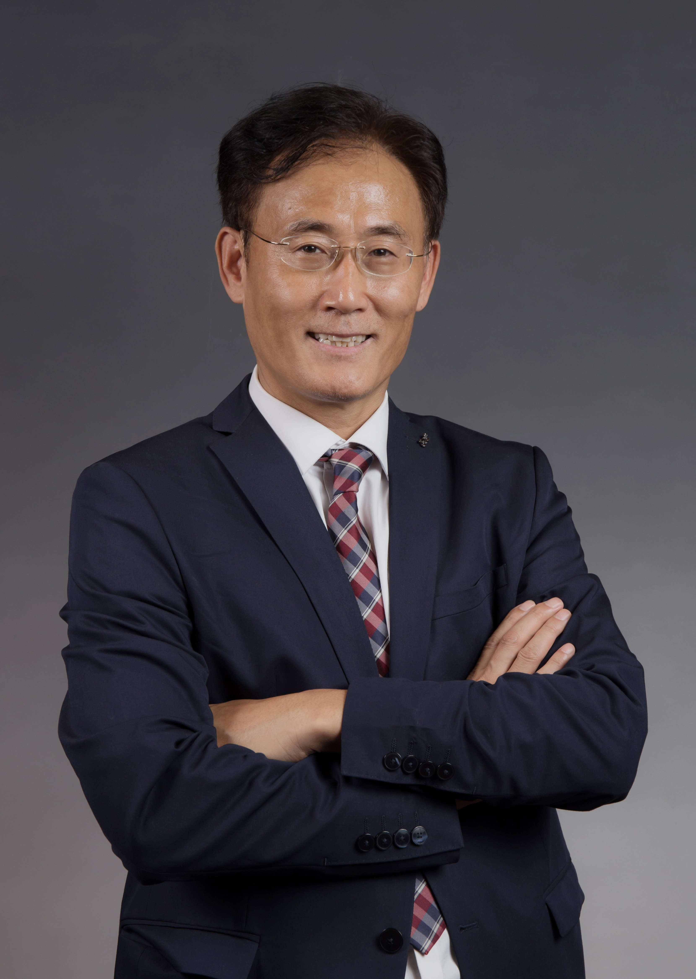
▲ GIST Professor Heung-No Lee

GIST (Gwangju Institute of Science and Technology, President Kiseon Kim) School of Electrical Engineering and Computer Science Professor Heung-no Lee (Director of the ITRC Blockchain Intelligence Convergence Center) in the Department of Electrical and Computer Engineering was appointed as an editorial member of the world's top journal IEEE Transactions on Cybernetics (TC)*.

* IEEE Transactions on Cybernetics (TC): According to Journal Citation Reports (JCR), TC's most recent (2020) Journal Impact Factor was 11.448, and its global ranking in terms of impact factor is in the top 4%. That is, it ranked 6th (96.04%) out of 139 journals in Computer Science and Artificial Intelligence and 2nd (96.62%) out of 63 journals in Automation & Control Systems.

As an editorial board member for the fields of artificial intelligence, joint learning, blockchain, smart contact, decentralized finance, and AI finance, Professor Heung-No Lee selects and evaluates the most important papers for publication in the journal.

Transaction journals published by the IEEE Systems, Man, and Cybernetics Society (hereinafter referred to as the SMC Society) include Cybernetics, Humans and Machines, Systems Science and Engineering, etc. The SMC Society was established in the 1960s, and, in the early days of its birth, the SMC Society pursued research corresponding to the intersection of three fields, which at first glance did not seem to fit together: system structure, human wisdom, and cybernetics control.

The SMC Society started the journal IEEE Transactions on Systems, Man, and Cybernetics in 1971 based on the cybernetics concept of Norbert Wiener*. Since then, it has published articles in a wide range of fields, including biocybernetics, biomedical systems, artificial intelligence, robotics, adaptive systems, large-scale socioeconomic systems, and human-machine systems, and systems science.

* Norbert Wiener (1894-1964): A professor at MIT who was known as a mathematician, electrical engineer, and philosopher. He is remembered as the founder of Cybernetics, a communications science related to biology and machinery that affects system control, computer science, biology, neuroscience, philosophy and social organizations. He argued that all intelligent behaviors are the result of feedback mechanisms, which can be simulated by machines, and his theory provided important early results towards the development of modern artificial intelligence.

Professor Heung-No Lee said, "Artificial intelligence is a technology that pursues efficiency and growth, and blockchain is a technology of distribution, which can contribute to the polarization problem by containing global cryptocurrencies that cannot be printed."

Furthermore, he said, "Through the convergence of artificial intelligence and blockchain technology, the world can be bundled into a virtuous cycle of growth and distribution. As an editorial board member, I will do my best for the development of related studies."

Last July, the Blockchain Intelligence Convergence Center (BIC), headed by Professor Heung-No Lee, was selected as part of the the University ICT Research Center (ICT Research Center Support Project, ITRC) by the Ministry of Science and ICT for 'zero-knowledge sensing, password authentication, and blockchain-based cloud service convergence technology development.'

The center is researching key technologies for digital transformation, such as data-network management systems, IoT device management systems, and a new password security authentication system through convergence of ABCD technology: Artificial Intelligence (AI), Blockchain, Cloud, and Data, which are the core technologies of the 4th Industrial Revolution, and is nurturing advanced talents in related fields.



