GIST undergraduates win the National University Mathematics Competition

– Mathematics minor course is a great help in preparing for the competition... A total of 7 winners were produced

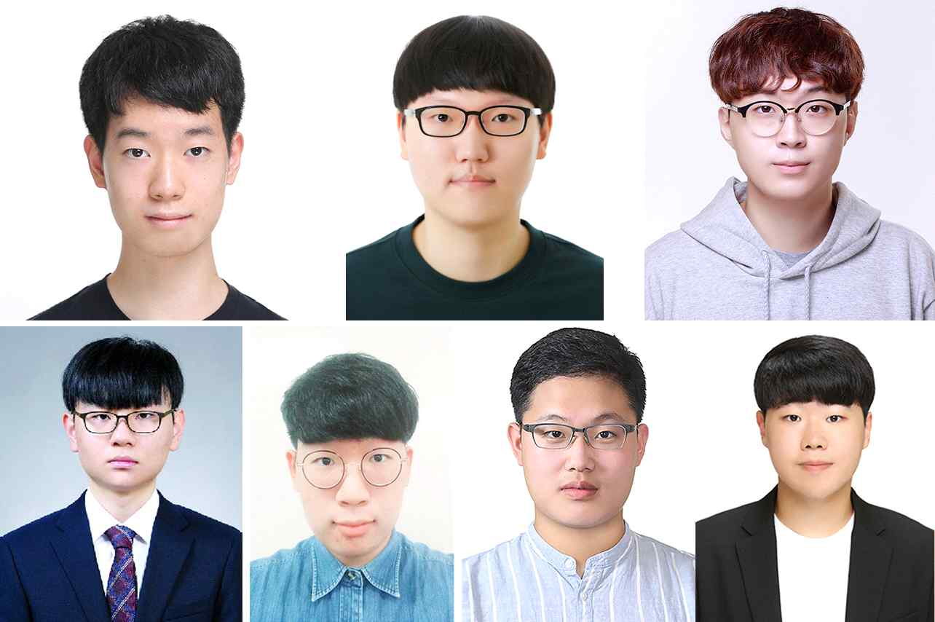
▲ From top left: Chan-hyuk Sung (Department of Physics and Photon Science), Jae-young Choi (Division of Liberal Arts and Sciences), Hye-geun Song (School of Materials Science and Engineering) From bottom left: Yunho Kim (Division of Liberal Arts and Sciences), Se-jun Park (Department of Physics and Photon Science), Jun-hong Park (School of Electrical Engineering and Computer Science),
Seong-won Cho (School of Mechanical Engineering)

GIST (Gwangju Institute of Science and Technology, President Kiseon Kim) undergraduate students achieved excellent results in the 40th National University Student Mathematics Competition.

Chan-hyuk Sung (Department of Physics and Photon Science) and Jae-young Choi (Division of Liberal Arts and Sciences) received the silver prize in the first category, and Hye-geun Song (School of Materials Science and Engineering) received the silver prize in the second category. Yunho Kim (Division of Liberal Arts and Sciences), Se-jun Park (Department of Physics and Photon Science), Jun-hong Park (School of Electrical Engineering and Computer Science), and Seong-won Cho (School of Mechanical Engineering) took the second field and won the bronze prize.

Hye-geun Song, who received the silver prize in the second category, said, "Although GIST does not have a major in mathematics, I was able to take several subjects through the mathematics minor course. It was a great help in preparing for the competition, as I was able to experience many problems through assistant teaching activities in the mathematics minor."

The National University Student Mathematics Contest hosted by the Korean Mathematical Society is divided into the 1st category (math and mathematics-related university students) and the 2nd category (including university students from departments other than the 1st field, including statistics department). It is one of the most prestigious competitions. The range of questions include calculus, advanced calculus, number theory, linear algebra, differential equations, and an introduction to geometry.

On the other hand, the GIST undergraduate program offers students the opportunity to grow into well-rounded convergence specialists through various minor courses such as humanities, social sciences, cultural technology, energy, intelligent robots, and biomedical engineering in addition to the mathematics minor course, which is basic for all science and engineering fields.



