GIST graduate students won the
2021 Voice AI Challenge Encouragement Award

– Proposal of an artificial intelligence model that predicts vocal diseases according to vocal changes from Mel-spectrogram voice data

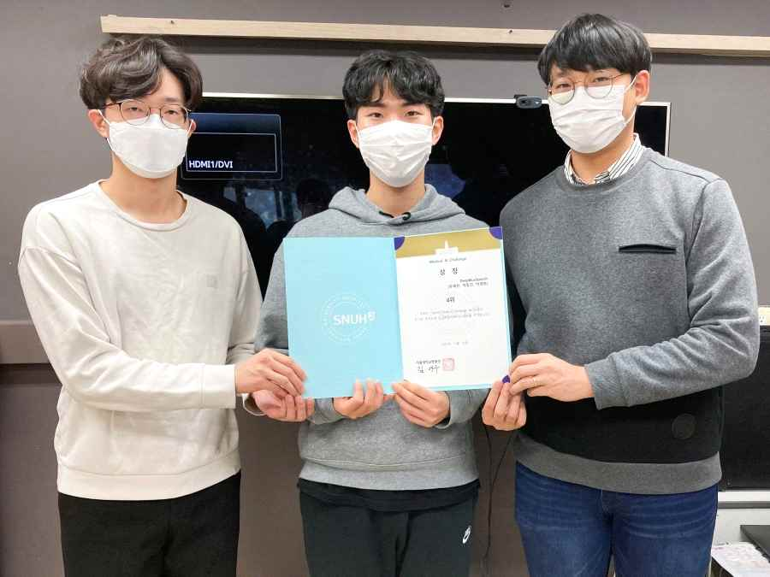
▲ 2021 Voice AI Challenge Encouragement Award (from right): Integrated program
students Ye Chan Yu and Dong Keon Park and master's student Kyeong Wan Park

▲ 2021 Voice AI Challenge Encouragement Award (from right): Integrated program students Ye Chan Yu and Dong Keon Park and master's student Kyeong Wan Park

GIST (Gwangju Institute of Science and Technology, President Kiseon Kim) graduate students of the 'DeepBlueSpeech' team (integrated program students Ye Chan Yu and Dong Keon Park and master's student Kyeong Wan Park) received the Encouragement Award at the '2021 Voice AI Challenge' hosted by Seoul National University Hospital.

The 'DeepBlueSpeech' team designed an artificial intelligence model to distinguish between normal and a total of five types of pathological voices (malignancy, vocal cord paralysis, nodules, polyps, and functional dysphonia) based on three strategies to solve this challenge: ▲ attention aggregation-based long-term short-term cyclic neural network artificial intelligence model design ▲ loss function and scheduler to solve data imbalance ▲ data augmentation and model ensemble technique for generalization.

In particular, to alleviate the problem of small-scale imbalanced data, a binary loss function that distinguishes normal/pathological and a cosine loss function proposed in the field of computer vision were used. In addition, masking-based data augmentation and model ensemble techniques to prevent model overfitting played an important role in the competition.

The DeepBlueSpeech team said, "Based on the experience and knowledge gained through the competition, we want to contribute to the advancement of artificial intelligence technology and the improvement of quality of life by conducting various related research in the future."

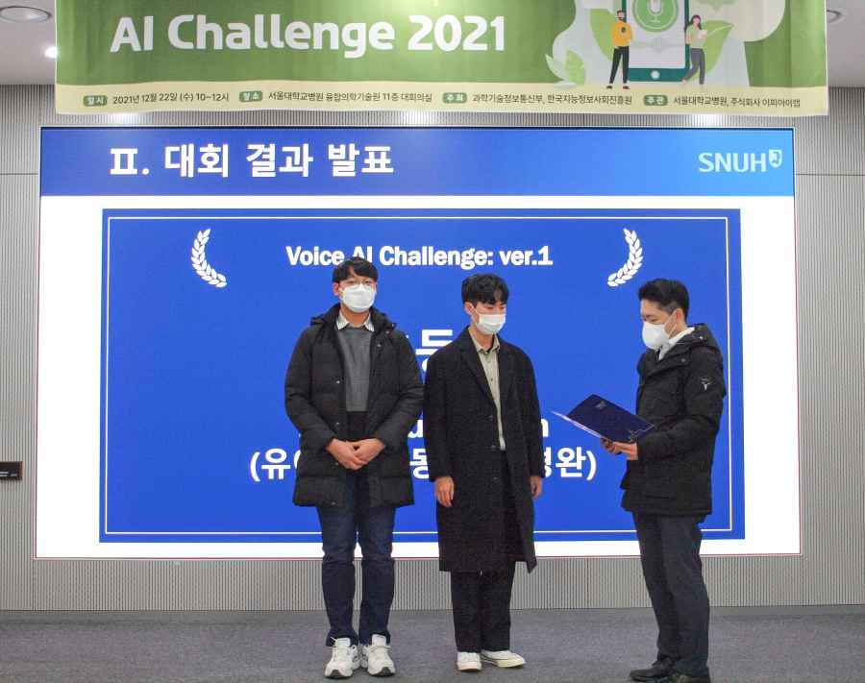
▲ 2021 Voice AI Challenge result announcement and award ceremony (from right): integrated program students Dong Keon Park and Ye Chan Yu

The Gist Audio Intelligence Technology & Research Lab (AiTeR, Professor Hong Kook Kim), to which the DeepBlueSpeech team belongs, is conducting various studies such as voice noise removal, speaker classification, acoustic event detection, and abnormal situation detection.

This competition, which was college students or graduate students who are interested in developing an artificial intelligence learning model using voice medical data, was held for the purpose of diagnosing and classifying vocal diseases using voice (Mel-spectrum) data, and the awards ceremony was held on December 22 (Wednesday) at Seoul National University Hospital.



