GIST Ph.D. student Minwoo Kim won the Excellent Paper Award for Computational
Fluid Engineering in Korea

– Analysis of turbulence transition phenomenon
using innovative multi-accuracy techniques

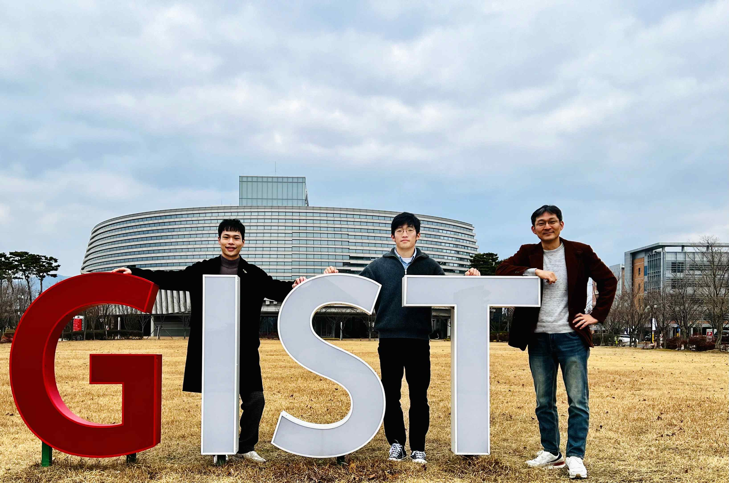
▲ From left: Ph.D. student Minwoo Kim, Ph.D. student Jiseop Lim, and Professor Solkeun Jee

GIST (Gwangju Institute of Science and Technology, President Kiseon Kim) School of Mechanical Engineering Ph.D. student Minwoo Kim (advisor Professor Solkeun Jee) won the Excellent Paper Award from the Korean Society of Computatuonal Fluids Engineering.

In his thesis 'Calculation of Transition Boundary Layer Using Multi-Accuracy Technique,' Ph.D. student Minwoo Kim presented an innovative multi-accuracy technique that can perform high-accuracy analysis at a low cost and successfully applied this to boundary-layer flows in which turbulent transitions occur, which is an engineering challenge.

Turbulence flows are common flows in mechanical/aerospace/marine applications and is one of the most unpredictable engineering challenges. A turbulent transition is the onset of turbulence, making it more difficult to predict and interpret.

The flow on the surface of vehicles such as automobiles, airplanes, and ships is called the boundary layer flow, and turbulent transitions generally occur in the boundary layer flow. Because the flow resistance of the vehicle rapidly increases due to the turbulent transition, an accurate analysis of the boundary layer flow including the turbulent transition is a very important factor in vehicle design.

Existing studies on flow in which turbulent transition occurs have mainly focused on low-cost techniques with fast calculation results, but it has been difficult to apply to various flow phenomena due to low accuracy.

Recently, high-accuracy numerical analysis studies have been conducted, but, due to the slow calculation speed, numerical analysis of the boundary layer flow in which the turbulent transition occurs is practically impossible without the use of a high-performance supercomputer.

Student Minwoo Kim developed a multi-accuracy technique and was able to successfully simulate turbulent transitions with high computational speed. Considering the fact that there is a laminar-transient-turbulent flow process, he developed a way to combine effective techniques for each situation.

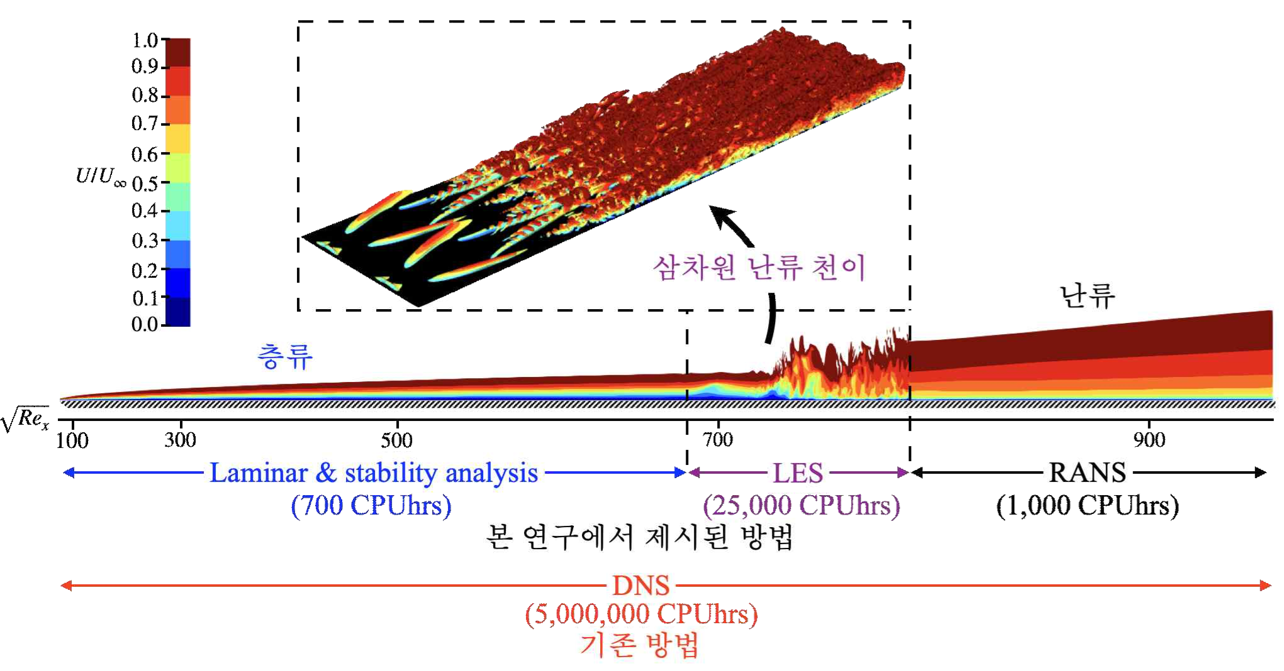
▲ [Picture] Visualization of boundary layer flow on a plate. The original laminar flow is changed to a turbulent flow by transition. CPUhrs is calculated as (number of CPU cores used × time taken to calculate). Because it requires CPUhrs, it is possible to predict turbulent flow transitions with very little computer resources. In this study, laminar flow and turbulent flow were quickly calculated using the stability theory and Reynolds-mean flow field analysis technique, respectively, and the nonlinear turbulence transition phenomenon was accurately predicted using the vortex simulation technique.

In laminar flow, a general flow stability analysis technique is used; and in the transition process, a large-eddy simulation technique is used to simulate a nonlinear transition phenomenon. In the turbulent flow where the transition is completed, the Reynolds-averaged Navier-Stokes simulation technique was applied, and the variables between the techniques were effectively exchanged at each interface.

School of Mechanical Engineering Professor Solkeun Jee said, "The multi-accuracy technique developed by Ph.D. student Minwoo Kim can predict the turbulent transition phenomenon of the high-speed vehicle flow very accurately, and the calculation cost has been greatly improved to a situation where a personal computer can also be instead of a supercomputer. Student Minwoo Kim clearly understood the strengths and weaknesses of various flow analysis techniques, so he was able to develop a novel approach that uses only the strengths of these techniques."

Ph.D. student Minwoo Kim's thesis 'Calculation of Transition Boundary Layer Using Multi-Accuracy Technique' was the result of a joint research project with Pusan National University Department of Aerospace Engineering Professor Dong-Hoon Park. For his contribution to the field of computational fluid dynamics in Korea, he won the Excellent Paper Award in 2021. The awards ceremony was held on November 11 at the Autumn Conference of the Korean Society of Computatuonal Fluids Engineering.



