GIST School of Earth Science and Environmental Engineering Professor In Seop Chang elected as a new member to the National Academy of Engineering of Korea

– Elected as a next-generation member of the Korean
Academy of Science and Technology in 2022

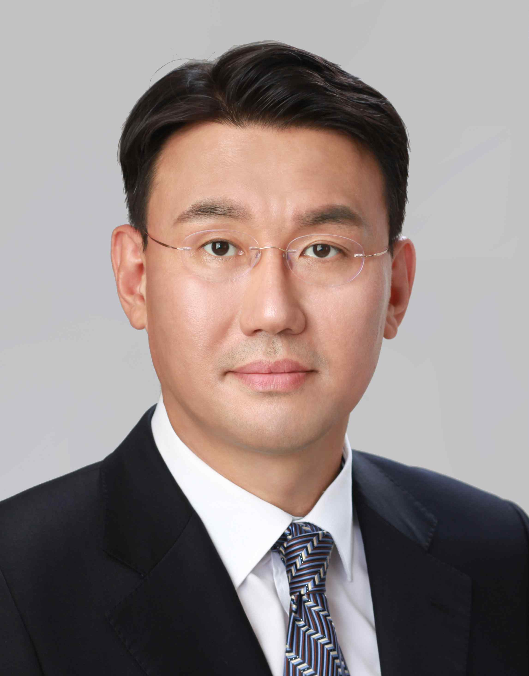
▲ School of Earth Science and Environmental Engineering Professor In Seop Chang

GIST (Gwangju Institute of Science and Technology, President Kiseon Kim) School of Earth Science and Environmental Engineering Professor In Seop Chang elected as a new member to the National Academy of Engineering of Korea in 2022.

Professor In Seop Chang was elected as a general member in the field of chemical and bioengineering at the National Academy of Engineering of Korea in recognition of his top-level research capabilities in biofuel cell source technology and enzyme-electrode electron transfer mechanism.

After receiving his doctorate from Swansea University in Wales, Professor In Seop Chang worked as a senior researcher at the Environmental Research Center at the Korea Institute of Science and Technology (KIST), and was appointed to the GIST School of Environmental Science and Engineering (currently, the School of Earth Sciences and Environmental Engineering) in 2005.

Professor Chang not only has leading thesis presentations and research capability indicators in his research field, but he also serves as a Board Member of 'International Society for Microbial Electrochemistry and Technology' and is on the Editorial Board of 'Bioresource Technology.' Along with his active research activities, he is considered a researcher with a highly regarded international reputation.

In particular, in June, Professor In Seop Chang's (energy environment convergence/industrial technology convergence) Innovative Energy and Carbon Optimized Synthesis for Chemicals Research Center was selected as a leading research center supported by the Ministry of Science and ICT, and he is currently the head of the GIST ECOSysChem Research Center.

This research center aims to secure source technology for solving social problems through the development of eco-friendly treatment and upcycling technology for municipal solid waste (MSW) through research on biotechnology for conversion of syngas-type total gas derived from MSW, catalysts for conversion of residual carbon dioxide after reaction of syngas, development of reaction technology, research on recovery of organic and inorganic by-products derived from syngas, stabilization, and development of high-addition technology.

Annually, the National Academy of Engineering of Korea selects top experts who have greatly contributed to national development through outstanding research achievements or innovative technology development in engineering industry technology and related fields. The term of office for general members of the National Academy of Engineering of Korea selected this time is three years from January 1, 2022 to December 31, 2024, and reappointment is possible after review.



