GIST School of Mechanical Engineering student Suhun Cho won the gold prize in the National University Student
Fluid Engineering Contest

- Study of turbulent flow analysis of non-Newtonian
fluids in various mechanical/chemical processes

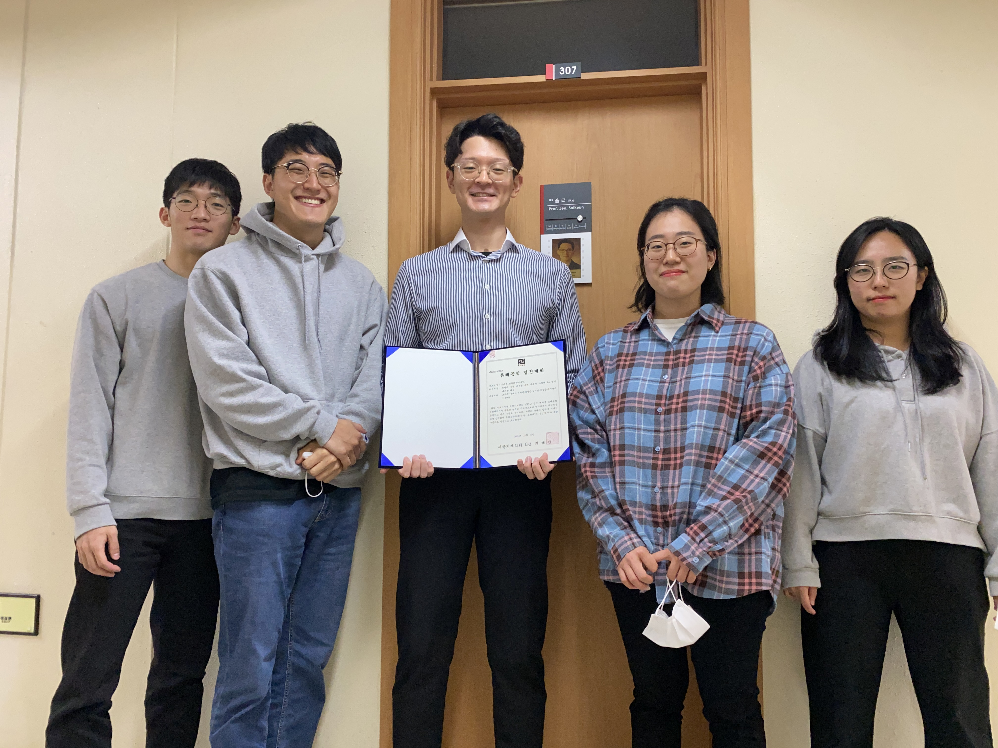▲ From left: GIST School of Mechanical Engineering students Jiseop Lim,
Young Min Park, Suhun Cho, Yeji Yun, and Seoyeon Heo

GIST (Gwangju Institute of Science and Technology, President Kiseon Kim) mechanical engineering student Suhun Cho (advisor, Professor Solkeun Jee), won the gold medal at the recently held '13th National University Student Fluid Engineering Contest.'

The paper 'Subcritical re-region vs. eddy current analysis of non-Newtonian fluid flow around a cylinder' presented by student Suhun Cho is a leading research on turbulent flow in non-Newtonian fluids. It covers the very challenging fields of turbulence and non-Newtonian fluids that are not covered by the undergraduate level curriculum.

Turbulence flow is a common flow in general mechanical engineering. The flow around vehicles such as automobiles, airplanes, and ships is mainly turbulent, and many of the flows handled in mechanical/chemical/materials processes are also turbulent flows.

A non-Newtonian fluid is a fluid whose viscosity changes due to flow, and it is often related to various compound liquids handled in mechanical/chemical/material processes.

Among the main results of this study, it is noteworthy that the turbulent transition of the exfoliated flow is significantly changed due to the viscous properties of non-Newtonian fluids.

In shear-thinning fluid with reduced viscosity, the viscosity decreased due to the shear stress factor of the peeled flow, and the flow became incomplete and rapidly transitioned to turbulence. In the opposite shear-thickening fluid, it was found that the opposite viscosity increased and the transition was delayed.

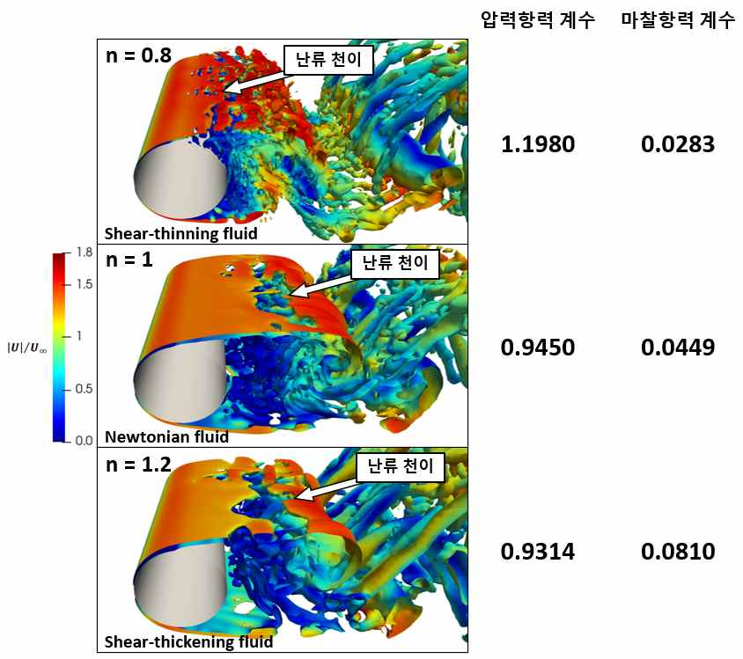
▲ [Figure] In a non-Newtonian fluid whose viscosity changes according to the flow, the turbulence transition changes rapidly according to the increase or decrease of the viscosity, and, accordingly, the drag force due to the flow changes significantly. In this figure, different flow patterns are visualized according to a shear-thinning fluid with decreasing viscosity, a Newtonian fluid with no change in viscosity, and a shear-thickening fluid with increasing viscosity.

Professor Solkeun Jee, the advisor, said, "Among the properties of non-Newtonian fluids, little is known about the behavior of non-Newtonian fluids under turbulent flow conditions. The advanced research conducted by Suhun Cho can ultimately contribute to process structure optimization and process flow condition optimization."

Student Suhun Cho said, "Numerical analysis of turbulent flow is a very difficult field for college students to study. As it was a difficult topic, there were difficult moments, but thankfully, I was able to overcome it with the help of my advisor and colleagues in the lab."

Meanwhile, the National University Student Fluid Engineering Contest is hosted by the Korean Society of Mechanical Engineers and is held for the purpose of identifying the principles of fluid phenomena and creative and engineering design, analysis, and design. This year, it was held on November 5 (Fri) at the Kimdaejung Convention Center in Gwangju.



