GIST Ph.D. student Do-hyeong Kim wins silver prize at BIXPO 2021 University (Graduate) Student Idea Contest

- Proposal to build a green hydrogen production base in Southeast Asia...
Expected to lower the price of hydrogen


▲ GIST Ph.D. student Do-hyeong Kim

GIST (Gwangju Institute of Science and Technology, President Kiseon Kim) Graduate School of Energy Convergence Ph.D. student Dohyeong Kim (advisor Professor Chanho Pak) won the silver prize at the BIXPO 2021 University (Graduate) Student Idea Contest.

This contest was held under the theme of solutions to recent issues and problems in the electricity industry, such as carbon neutrality, for university and graduate students across the country. After selecting 20 teams through the first document screening, the second presentation screening was held at BIXPO 2021 through a poster session.

Under the theme of 'Establishment of green hydrogen production bases in Southeast Asia for carbon neutrality in 2050,' Do-hyeong Kim presented the idea of establishing infrastructure for renewable energy and green hydrogen production bases in Southeast Asia to revitalize carbon neutrality and hydrogen economy in 2050 with four reasons (▲ renewable energy resources in Southeast Asia ▲ energy security and economic issues in Southeast Asia ▲ Korea’s energy security ▲ the right time to enter Southeast Asia).

In particular, based on the geographical environment close to Korea along with the abundant renewable energy resources of Southeast Asia, it attracted the attention of the participants by suggesting that the hydrogen import price can be lowered by up to $2.5 per kg of hydrogen by transporting it as liquid hydrogen.

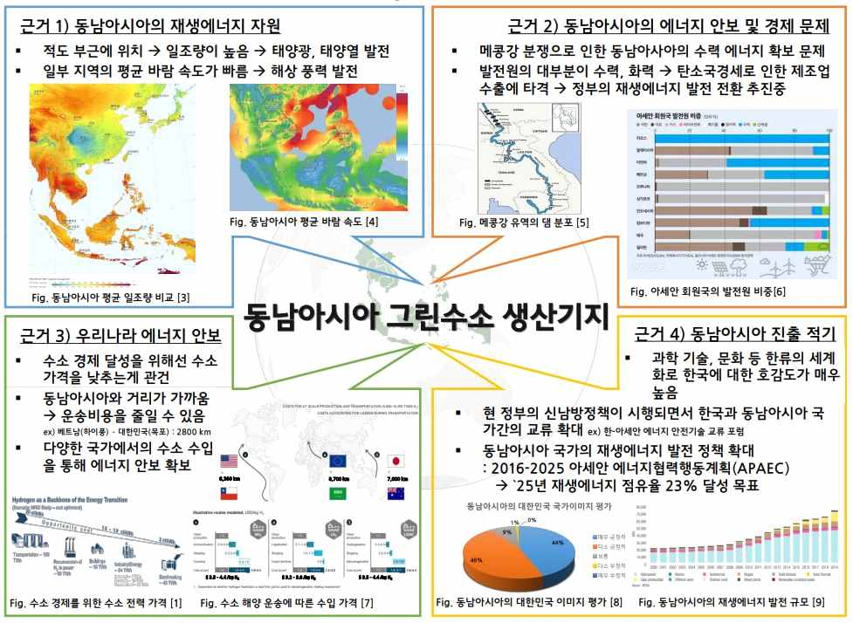
▲ Southeast Asian green hydrogen production base idea

Student Do-hyeong Kim said, "It is an honor to be recognized for the ideas that I came up with based on the information I gained through conferences and seminars before graduating. In the future, I would like to contribute to overcoming the climate crisis and carbon neutrality through creative energy policy proposals and various related studies."

'Bitgaram International Electric Power Technology Expo 2021 (BIXPO 2021),' which celebrated its 7th anniversary this year, was held at the Kimdaejung Convention Center in Gwangju for three days from November 10th (Wednesday) to 12th (Friday) as an international comprehensive energy expo.



