GIST Professor Jongseok Lee's research team selected for the Samsung Future Technology Development Center project

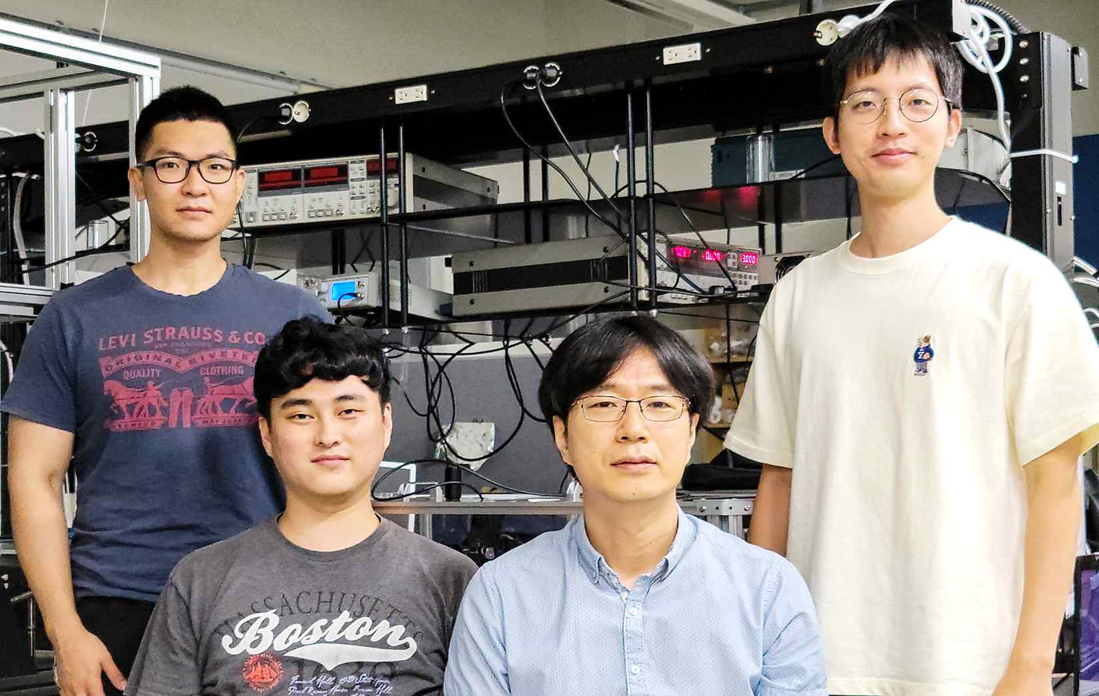
▲ From left: Ph.D. student In-hyuk Choi, integrated master's and Ph.D. student Do-gyeom Jeong, Professor Jongseok Lee, and Ph.D. student Hwi-in Ju

GIST (Gwangju Institute of Science and Technology, President Kiseon Kim) Department of Physics and Photo Science Professor Jong-seok Lee's research team was selected for the Samsung Future Technology Development Center project supported by Samsung Electronics.

Professor Jongseok Lee's research team plans to conduct research to understand and effectively remove the heat movement occurring at the nano-scale interface.

The research team aims to find a fundamental solution to the thermal problem of nano devices by using a new research technique called phonon transmittance spectral measurement* to seek a fundamental understanding of heat transport through nanointerfaces.

* phonon transmittance spectrum measurement method: When heat flows from one medium to another adjacent medium, it is a measurement method that determines the heat transmittance through the phonon transmittance spectrum at the interface formed between two mediums. Due to the large amount of information to be dealt with and the complicated calculation formulas involved, high-level optimization methods including machine learning and deep learning are used to obtain the final result.

Based on this, the research team plans to implement a new concept nano-interface thermal device such as a phonon frequency filter, a phonon frequency converter, and a nano-sheet phonon diode by adding heat transport functionality to the nano-interface.

As transistors, memory devices, and thermoelectric devices are miniaturized to the nanometer level, a serious heat problem is occurring due to the high degree of integration of the corresponding unit devices. To prevent damage caused by heat, the clock frequency of semiconductor devices including CPU and GPU is intentionally limited.

Therefore, to allow a higher clock frequency and increase device integration to achieve high-performance and high-efficiency device development, it is essential to solve the heat problem.

In the case of electromagnetic waves, the transmittance of transparent glass or thin film can be defined and the spectrum can be easily measured, but it is very difficult to define and experimentally measure the transmittance spectrum of phonon for a specific interface.

The research team has successfully developed a technique for determining the phonon transmission spectrum through thermal reflectance measurement and modeling based on the Boltzmann transport equation and intends to attempt a full-scale study using it for the first time in the world.

Professor Jongseok Lee said, "The phonon transmittance measurement method for the interface requires advanced experimental and analysis technology, and research based on it is very rare in the world. With the support of this project, it is expected that a new research field will be pioneered and, furthermore, a breakthrough will be prepared to solve the thermal problem of nano devices."

Meanwhile, the Samsung Future Technology Promotion Project is a science and technology research support project for the public interest, operated by Samsung Electronics with 1.5 trillion won since 2013 with the goal of developing Korea's basic science and nurturing world-class scientists and engineers. In the second half of this year, a total of 22 tasks were selected, including six in the material field.


