Professor Inchan Kwon received a commendation on Intellectual Property Day from the Ministry of Trade, Industry and Energy

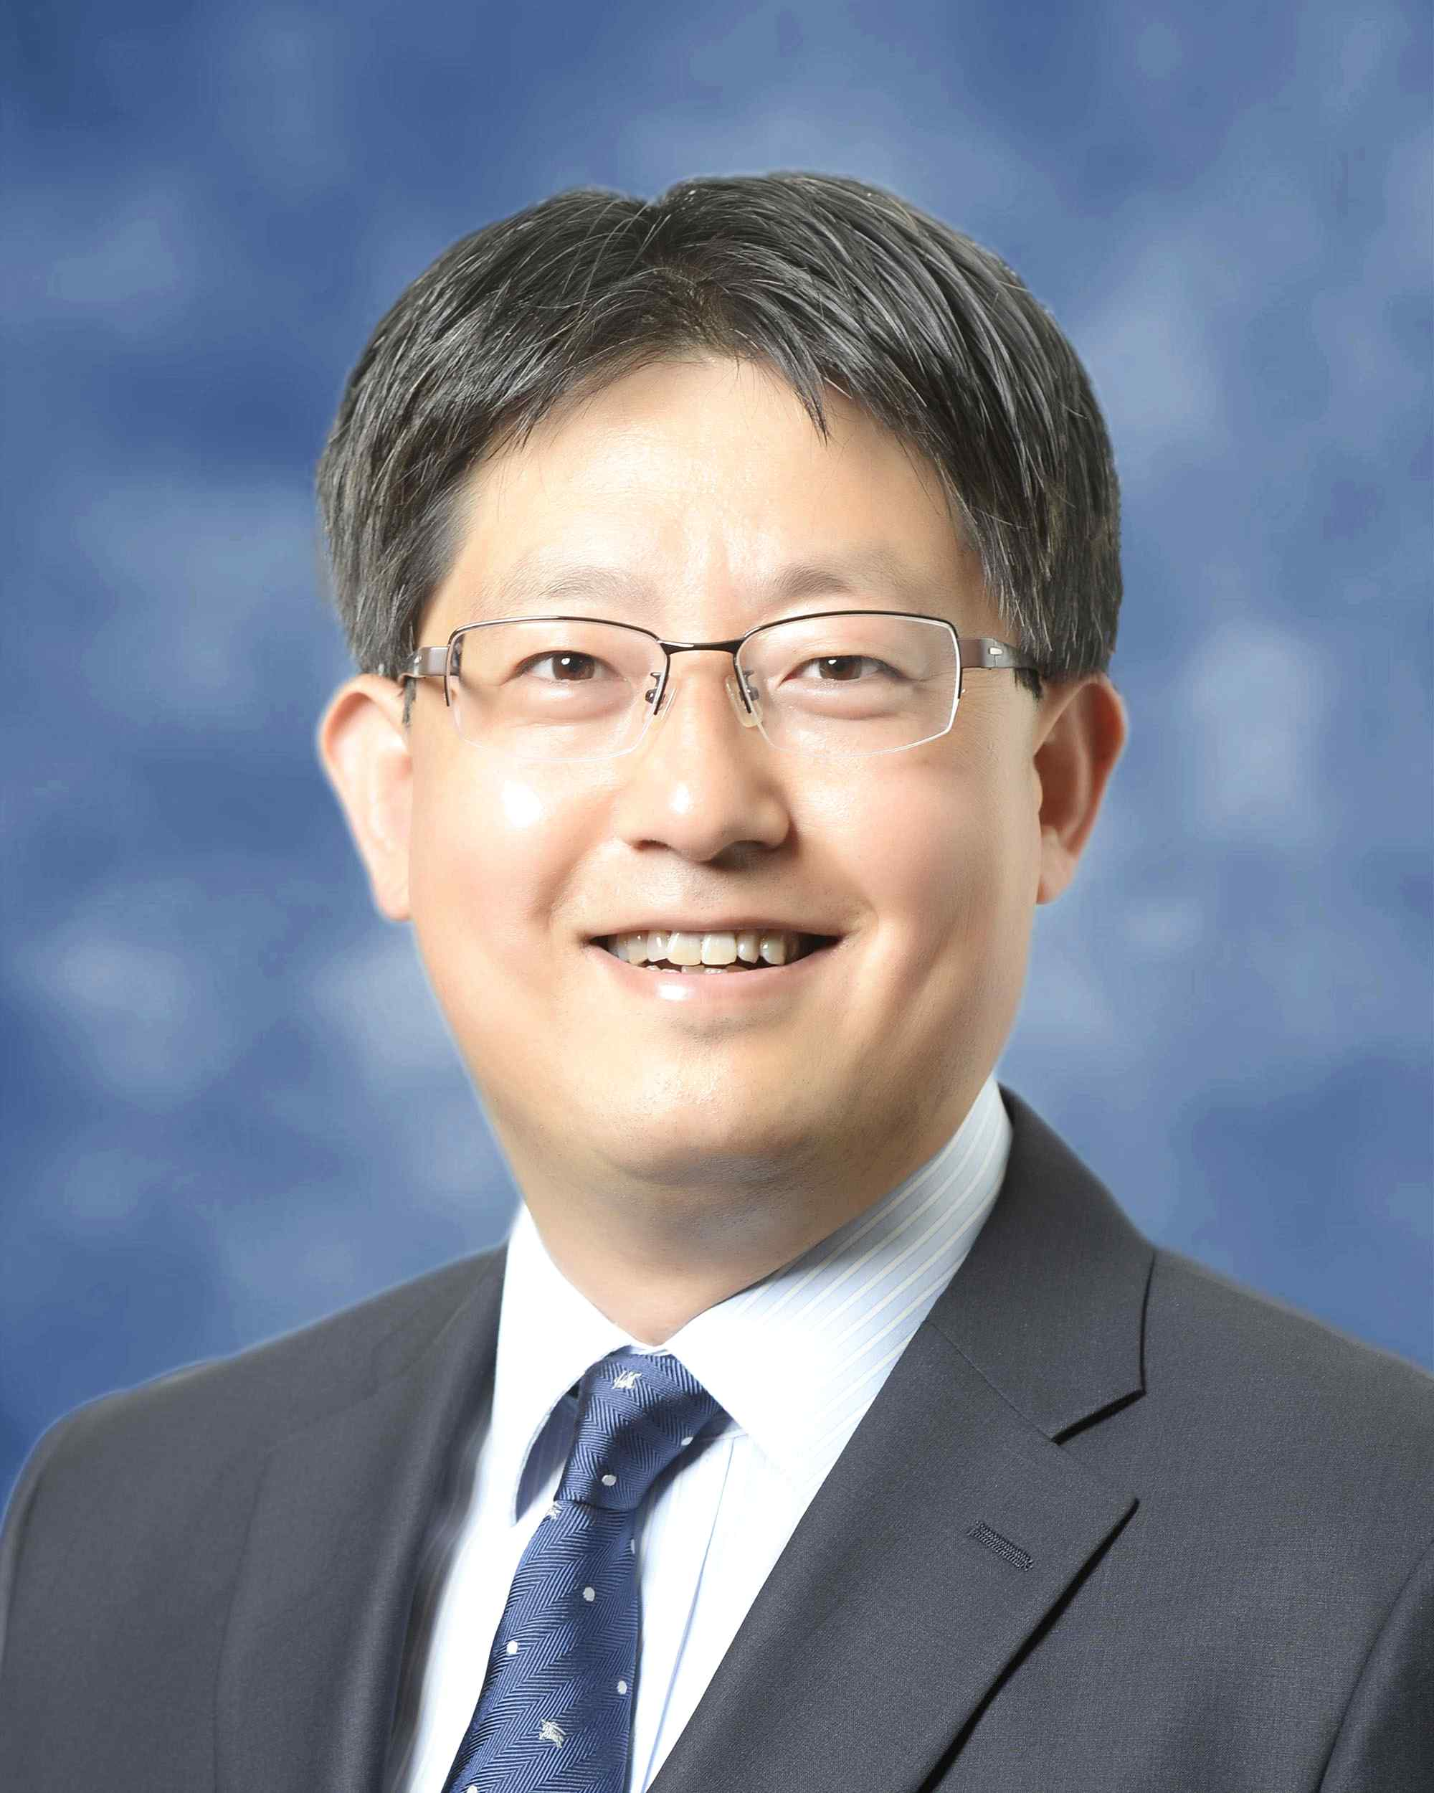
▲ School of Materials Science and
Engineering Professor Inchan Kwon

GIST (Gwangju Institute of Science and Technology) School of Materials Science and Engineering Professor Inchan Kwon received a commendation from the Ministry of Trade, Industry and Energy at a ceremony for the 2021 Intellectual Property Day in recognition of his contribution to the creation and commercialization of intellectual property rights through the development of biotherapeutic technology. The award ceremony was held online on September 1 (Wednesday) to prevent the spread of COVID-19.

Professor Inchan Kwon has been an assistant professor at Virginia State University since 1996 when he was a researcher at the LG Life Sciences and Technology Institute. While he was a professor in the School of Materials Science and Engineering at GIST, he transferred the intellectual property for new drug development to a pharmaceutical start-up company and contributed to the promotion of public technology businesses while serving as the CTO.

Professor Kwon developed biotherapeutic drugs and related technologies, applied for and registered more than 40 domestic and foreign patents, and, in particular, recently transferred four bio-better platform technologies to biopharmaceutical companies for a total of more than 2 billion won. He was also selected for the meritorious intellectual property award in recognition of his direct contribution to the commercialization of biotherapeutic technology by actively participating in technology development as CTO of ProApptech Co., Ltd.

In particular, the company developed a new bio-better platform technology that was significantly improved compared to the existing technology and applied it first to gout therapy first and then transfered the technology to ProApptech Co., Ltd., after filing for a patent in 2020. ProApptech Co., Ltd., has recently succeeded in attracting 5 billion won in Series A investment for global non-clinical trials of gout treatment drugs that have been transferred.

Professor Inchan Kwon said, "Over the past four years, I have experienced the commercialization of technology as a bio-venture startup and CTO through technology transfer of patents and learned that intellectual property rights in academia are very likely to be commercialized. We are planning to start a new business using patents that we have or will create in the future."



