GIST School of Electrical Engineering and Computer Science Dr. Gil-joo Lee appointed assistant professor at Busan National University

- Appointed as an assistant professor in the Department of Electrical Engineering at Busan National University from September

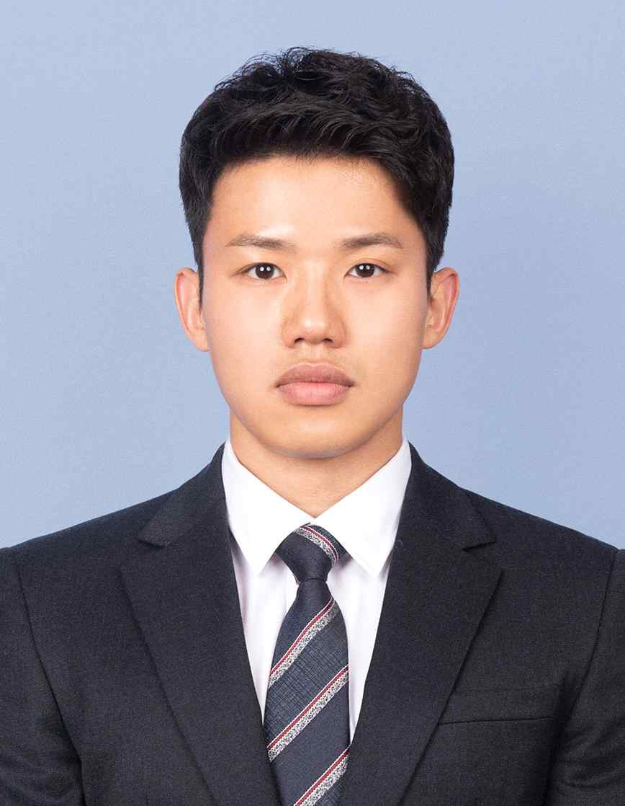
▲ GIST graduate Dr. Gil-joo Lee

GIST (Gwangju Institute of Science and Technology) School of Electrical Engineering and Computer Science graduate Dr. Gil-joo Lee (advisor: Professor Young Min Song, graduated February 2021) will be appointed as an assistant professor in the Department of Electrical Engineering at Busan National University from September of this year.

Dr. Gil-joo Lee completed his bachelor's degree in electrical engineering at Busan National University and entered the School of Electrical Engineering and Computer Science at GIST in September 2016 in the integrated master's and doctoral program. Afterwards, under the guidance of Professor Young Min Song, he received his doctorate in February 2021 with a thesis on 'Thermal Emitter of Optimal Optical Structure for Passive Radiative Cooling.'

In addition, a total of 33 research results were reported in international journals, including top-level journals such as Nature Electronics and Science Advances, on flexible optoelectronic devices and energy-saving eco-friendly optical materials during the course of the degree.

After graduating from GIST graduate school, Dr. Gil-joo Lee was selected as the Sejong Science Fellowship (a project to support young researchers) organized by the Korea Research Foundation, and he conducted research on zero-carbon/ultra-cooled radiative optical materials* as a post-doctoral researcher at GIST from March 2021 to August 2021.

* radiative optical material: A material with a high reflectivity of over 93% in the solar wavelength region (0.28 – 4 μm) and a high emissivity of over 95% in the window thermal radiation region of the atmosphere (8 – 13 μm).

In recognition of such outstanding research experience and experience, Dr. Gil-joo Lee was appointed as an assistant professor in the Department of Electronic Engineering, Pusan National University, without experience as a postdoctoral researcher abroad.

Dr. Gil-joo Lee said, "I would like to continue research on eco-friendly and next-generation optoelectronic devices using electromagnetic waves with infinite potential to develop them into highly practical technologies applicable to industries. I will do my best to become a respected educator who serves as a role model for juniors."



