GIST opens human-centered game artificial intelligence basic laboratory

- Selected as a Basic Research Laboratory (BRL) by the Ministry of
Science and ICT with support of KRW 1.375 billion for 3 years


▲ From left: Professor Kyung-Joong Kim (project manager), Professor SeungJun Kim, Professor Jin Hyuk Hong, and Professor Eunsung Song

GIST (Gwangju Institute of Science and Technology) School of Integrated Technology Professor Kyung-Joong Kim (task manager), Professor SeungJun Kim, Professor Jin Hyuk Hong, and Professor Eunsung Song proposed 'Human-centered Game Artificial Intelligence Basic Laboratory' was selected as a Basic Research Laboratory (BRL) by the Ministry of Science and ICT.

The research team consists of experts in game artificial intelligence and human computer interaction, and it plans to work with NCsoft AI Center, Netmarble AI Center, Almond Soft Co., Ltd., and the Korea Electronics and Telecommunications Research Institute to study artificial intelligence source technology for game players.

Game artificial intelligence has various applications such as producing artificial intelligence players in games, automatically creating game contents, and modeling game players.

While existing artificial intelligence technologies focus on achieving high winning rates through optimization, human-centered game artificial intelligence technologies aim to study artificial intelligence technologies that focus on fun/interest/immersion/personalization to satisfy game players.

In particular, in connection with the 'XR Lab Support Project' hosted by the Korea Radio Promotion Association, which the research team is conducting, it plans to develop XR game source technology and related contents, such as AI for creating a game environment that reflects reality, XR games in cars, and Natural UI.

Collaborative research with MIT through the 'GIST-MIT joint research project,' such as the production of Fabric UI and Action Net to interpret human behavior patterns and interaction patterns seen in the virtual world, will also be promoted.

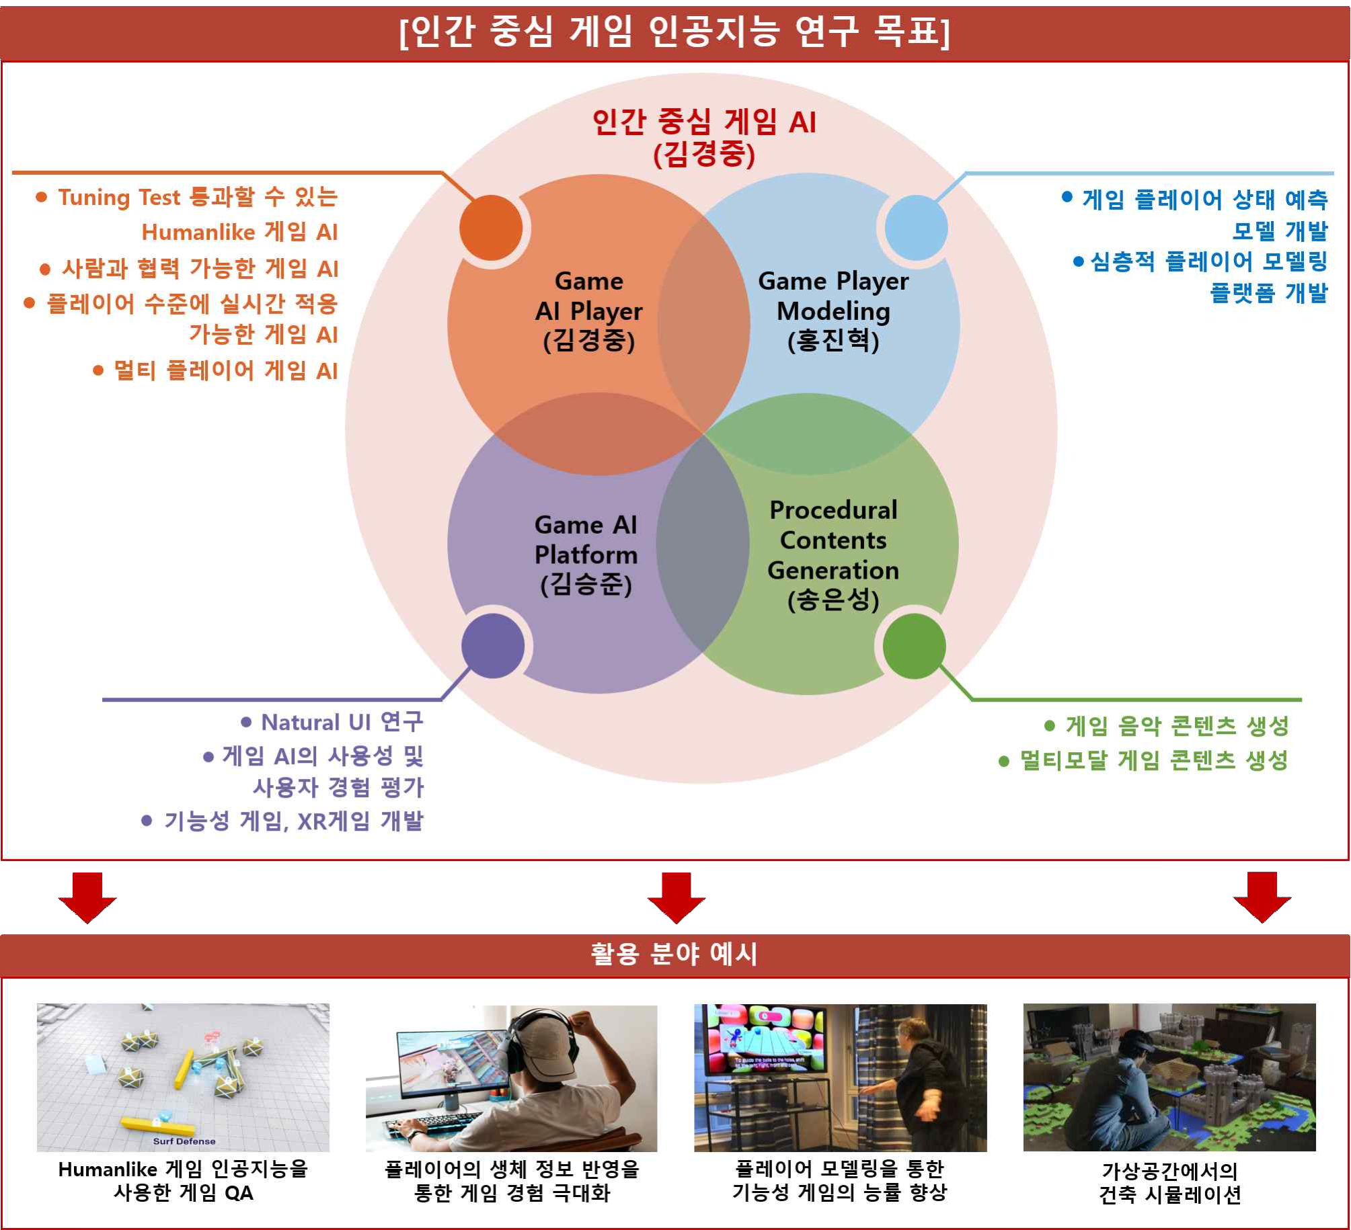
▲ Human-centered game AI research goal

Professor Kyung-Joong Kim, who is in charge of the project for this basic laboratory, is intensively researching the field of game artificial intelligence. He has been co-organizing the IEEE Conference on Games 2020, running the IEEE CoG StarCraft AI contest, and the IEEE CIG Game Data Mining contest.

Professor Kim said, "The AI technology research for the satisfaction of game players, which is carried out by the convergence of GIST experts in the field of game AI and HCI, is meaningful in that it is human-centered, and I am very much looking forward to how the research will proceed in the future."

The Basic Lab Project, designated by the Ministry of Science and ICT and supported by the National Research Foundation, is to facilitate joint research by supporting small-scale group research of three to four people, and to lay the foundation for securing source technology for scientific and technological development. Selected laboratories receive KRW 1.375 billion for three years to carry out the project, which can be extended for up to six years.



