
Gwangju Institute of Science and Technology
Official Press Release — https://www.gist.ac.kr

GIST students win the grand prize in the 2021 National Science and Technology Content Contest

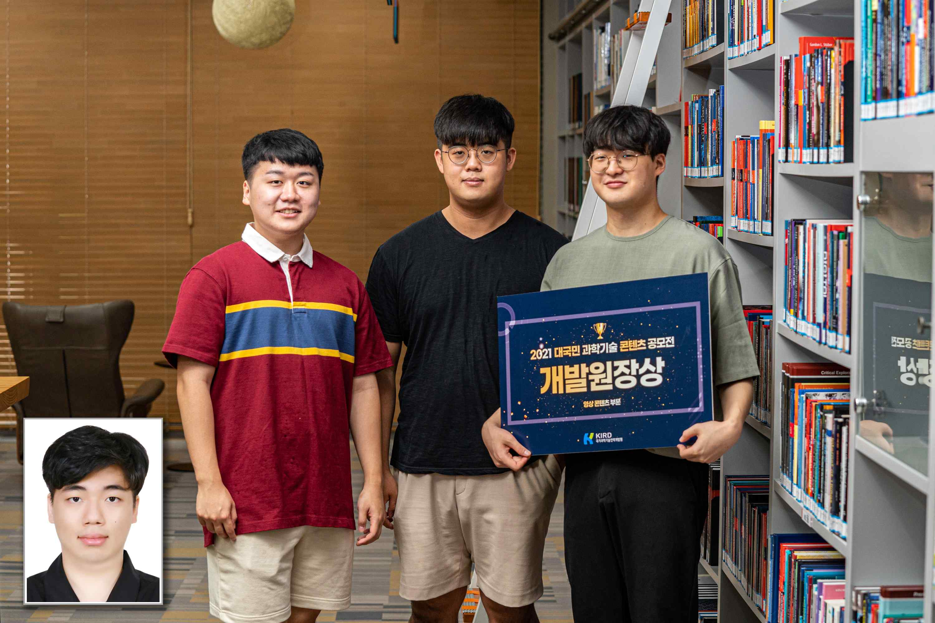


▲ GIST students won the grand prize at the 2021 National Science and Technology Content Contest (from left) GIST students Woo-seok Song, Ju-min Park, Dong-hyuk Jeong, and Tae-yoon Kim

GIST (Gwangju Institute of Science and Technology) students won the grand prize at the '2021 National Science and Technology Content Contest' hosted by the National Institute of Science and Technology Human Resources Development (KIRD).

Woo-seok Song, a student in the combined master's and doctoral program of GIST, Dong-hyuk Jeong, a master's student, and Tae-yoon Kim and Ju-min Park students in the bachelor's program participated in the video category and won the grand prize, the Director's Award, and the National Institute of Science and Technology Human Resources Development Award, and 1 million won in prize money.

According to the judges, the award-winning film is a well-made web drama using professional filming skills. In particular, the performances of the actors were evaluated as impressive.

GIST students participated in this contest by making a short film titled ‘Wonder Dreamer’ through video communication class.

The film contains content about how scientists overcome ideals and reality when they are different from what they think, and a message supporting scientists.

Woo-seok Song, a student in the combined master's and doctoral program, said, "I am happy to be recognized for my professionalism by gradually improving my skills in video production club activities that I started as a hobby. I felt many things in the process of making a movie based on what I felt while doing research, and I hope that by applying this to my research, I can achieve good results like the main character."

Dong-hyuk Jeong, a student in the master's program, said, "Taking a video communication class as an opportunity, I experienced short film production after a long time. It was hard work that put a lot of time and effort, but it was a good opportunity to feel the fun and pleasure of making the video for the first time."

Undergraduate students Tae-yoon Kim and Ju-min Park said, "It was a valuable experience that I learned a lot from my seniors, from the scenario composition to the stage of filming and editing the video. Through film making, we became very interested in science and technology researchers, and we were able to learn a lot about making videos."

This contest was held in two categories, video and image, with creative and interesting themes to promote the value and importance of science and technology.

‘Wonder Dreamer,’ which won the grand prize in the video category, can be viewed on GIST’s YouTube channel ‘GISTV.’

