
Gwangju Institute of Science and Technology
Official Press Release — https://www.gist.ac.kr

Section of Dongsun Cho Nayeong Lee
Public Relations Section Chief Senior Administrator
062-715-2061 062-715-2062

Contact Person Professor In Seop Chang
for this Article School of Earth Science and Environmental Engineering
062-715-3278

Release Date 2021.06

Professor In Seop Chang was selected for the 'Leading Research Center' project by the Ministry of Science and ICT

□ GIST (Gwangju Institute of Science and Technology) School of Earth Science and Environmental Engineering Professor In Seop Chang's research team was selected for the 'Leading Research Center' project by the Ministry of Science and ICT for 2021.



∘ The Ministry of Science and ICT announced on the 27th that it has selected 14 leaders who support Korea's best researchers and 17 leading research centers, which are excellent research groups for science and engineering graduate schools.

□ For the engineering field (ERC), the ‘(Energy Environment Convergence/Industrial Technology Convergence) Innovative Conversion Center for Urban Type Household Waste and Gasified Materials’, in which Professor In Seop Chang is responsible for research at GIST, was selected.

∘ This center researches and synthesizes biotechnology for converting MSW-derived syngas with the goal of securing source technology to solve social problems through the development of eco-friendly treatment and upcycling technology of urban household waste (MSW). After gas reaction, it plans to develop a catalyst for conversion of residual carbon dioxide, development of reaction technology, recovery of organic and inorganic by-products derived from syngas, stabilization, and development of high-addition technology.

∘ The research personnel will include 11 professors at GIST as well as the Gwangju Bioenergy Research and Development Center of the Korea Energy Technology Institute and will receive 13.5 billion won in research funds for seven years from this year to 2028.

□ Professor In Seop Chang said, "This research project is expected not only to present a new paradigm of waste energy and resource-based upcycling but will also use alternative technologies for practical use and to enter various related technology markets."

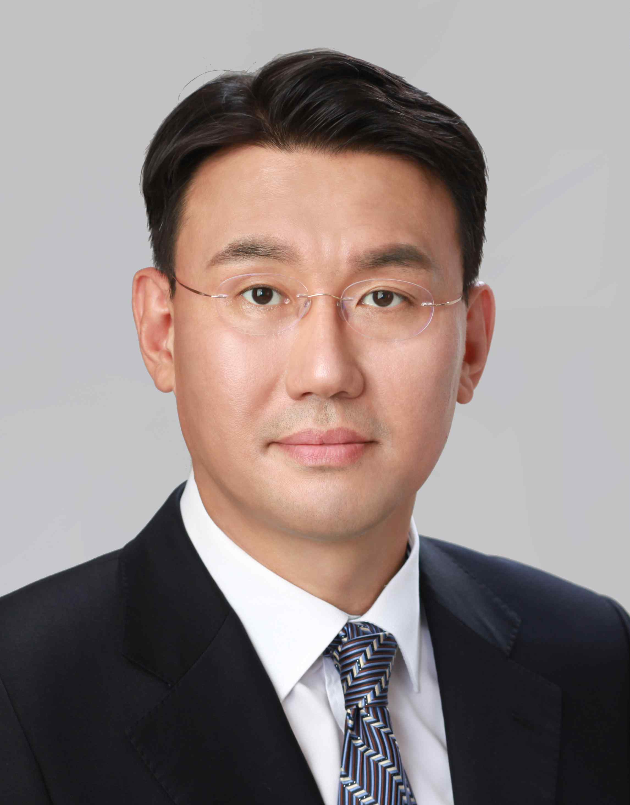
▲ GIST School of Earth Science and Environmental Engineering Professor In Seop Chang



