
Gwangju Institute of Science and Technology
Official Press Release — https://www.gist.ac.kr

Section of Dongsun Cho Nayeong Lee
Public Relations Section Chief Senior Administrator
062-715-2061 062-715-2062

Contact Person Professor Hisam Kim
for this Article Division of Liberal Arts and Sciences
062-715-3654

Release Date 2021.06.23

Professor Hisam Kim has been appointed to
the National Economic Advisory Council

□ GIST (Gwangju Institute of Science and Technology) Division of Liberal Arts and Sciences Professor Hisam Kim was appointed as an advisor to the National Economic Advisory Council, an economic advisory body under the direct control of the President, on June 12. The inauguration ceremony of the 4th National Economic Advisory Council will be held on the 24th, and the term of office is one year until June 11, 2022.



∘ The National Economic Advisory Council is the highest advisory body under the Constitution that assists the president in major economic policies. It consists of the President, Vice-Chairman Keun Lee (Professor of Economics at Seoul National University) and not more than five ex officio members and not more than 30 civilian members.

□ This advisory council is divided into the macroeconomic division, people's economic livelihood economic division, innovative economic division, and external economic division. Professor Hisam Kim serves as a member of the macroeconomic division.

□ Professor Hisam Kim said, "It is necessary to preemptively respond to social and economic challenges such as the global economic downturn and increased uncertainty due to COVID-19, structural transformation due to a non-face-to-face interactions, spread of inequality, and demographic changes. The National Economic Advisory Council will endeavor to contribute to the establishment of policies for balanced recovery, sustainable growth, and quality of life improvements, which are more important than a quick recovery."

∘ Professor Hisam Kim was appointed to GIST in 2016 and is a main member of the Presidential Committee on Low Fertility and Aging Society and has been actively performing policy advisory roles at the national level, such as a private member of the National Statistical Committee, a member of the Special Committee on Future Talent of the National Science and Technology Advisory Committee, and an adjunct research member of the Korea Development Institute, and is currently serving as the director of the GIST Center for Educational Innovation.

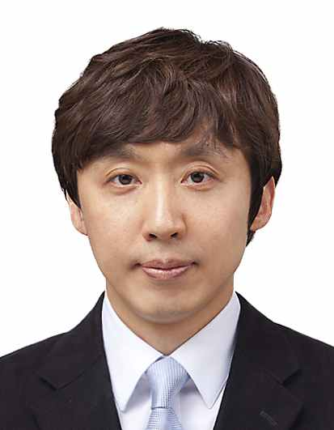
▲ GIST Division of Liberal Arts and Sciences
Professor Hisam Kim



