
Gwangju Institute of Science and Technology
Official Press Release — https://www.gist.ac.kr

Section of Dongsun Cho Nayeong Lee
Public Relations Section Chief Senior Administrator
062-715-2061 062-715-2062

Contact Person You Seung Su, Administrator
for this Article Section of Public Affairs
062-715-2025

Release Date 2021.06.08

Vice President for Public Affairs Young-jip Kim
participated in the 'Go Go Challenge'


□ GIST (Gwangju Institute of Science and Technology) announced on the 8th that it participated in the "Go! Go! Challenge," a campaign to remove plastic in daily life hosted by the Ministry of Environment.

∘ The Go Go Challenge is a public interest campaign that the Ministry of Environment started in January to reduce plastic in daily life.

∘ GIST Vice President for Public Affairs Young-jip Kim, who was nominated for the challenge by Seong-hwa Na, president of the Gwangju Economic and Employment Promotion Agency, said, "GIST doesn't use plastic bags to help reduce plastic waste. We are trying to preserve the environment, such as using a shopping cart instead."

□ GIST is leading the research and development of social problems as well as fostering global scientific specialists and plays a key role in the creation of an artificial intelligence center in Gwangju.

□ Meanwhile, GIST Vice President for Public Affairs Young-jip Kim nominated National Assembly member Yong-bin Lee, who took the lead in the Yeongsan River Forum, as the next participant of the campaign.

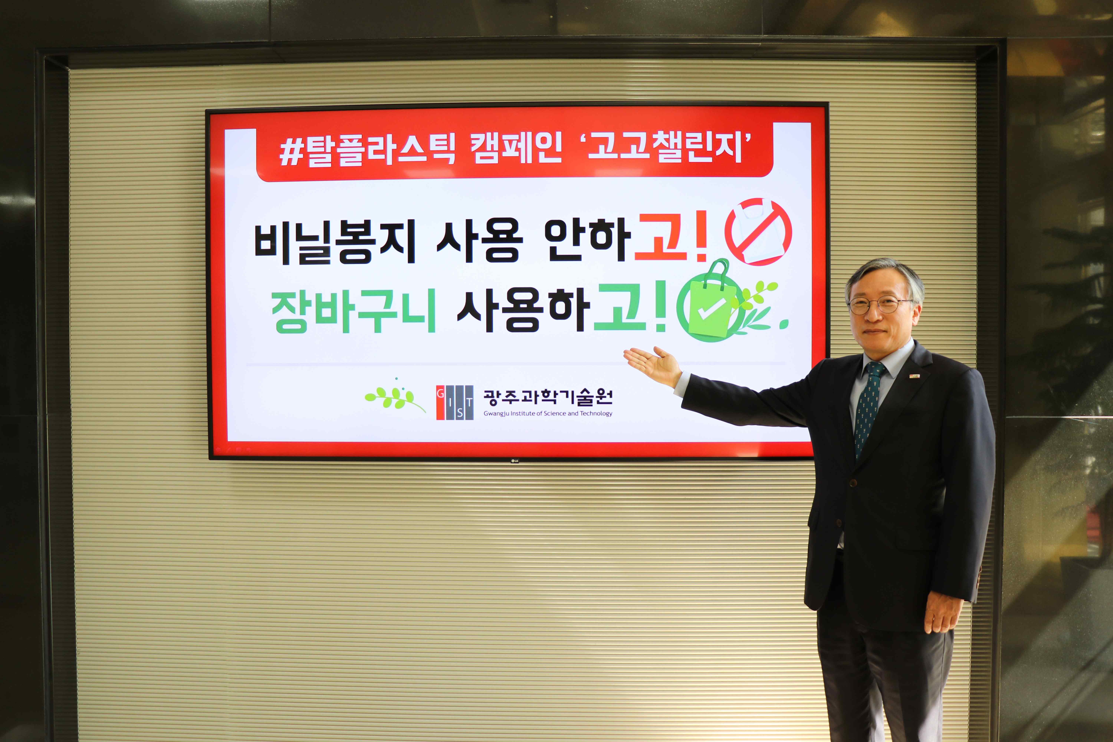
▲ GIST Vice President for Public Affairs Young-jip Kim participated
in the 'Go Go Challenge,' a campaign to remove plastic in daily life



