
Gwangju Institute of Science and Technology
Official Press Release — https://www.gist.ac.kr

Section of Dongsun Cho Nayeong Lee
Public Relations Section Chief Senior Administrator
062-715-2061 062-715-2062

Contact Person Professor SeungJun Kim
for this Article School of Integrated Technology
062-715-5331

Release Date 2021.05.31

GIST AI convergence technology research team makes all-out effort into securing future car XR technology and contents



□ GIST (Gwangju Institute of Science and Technology) School of Integrated Technology Professor SeungJun Kim's research team will develop vehicle XR (eXtented Reality, virtual fusion technology) platform technology and contents to enhance the passenger experience for the future car environment. Furthermore, through joint research between GIST-MIT and student exchanges, full-fledged training of XR practitioners together with excellent overseas researchers will be promoted.

∘ Professor SeungJun Kim's team has been selected as the host organization for the '2021 XR Lab* Support Project' implemented by the Ministry of Science and ICT and the Korea Radio Promotion Association, and it will receive a total project fund of 900 million won for up to three years until 2023. The '2021 XR Lab Support Project' is a project to train XR working-level personnel that links results of development of convergence contents to start-up and commercialization through excellent XR laboratories for leading development of convergence contents.

* XR (eXtented Reality) Lab: Led by master's and doctoral students, it refers to a project lab that develops contents and services that enable virtual and reality to coexist vividly by using virtual convergence technologies such as virtual reality, augmented reality, and mixed reality.

□ 'GIST Vehicle XR Lab' plans to develop elementary technologies such as XR platform technology for smooth utilization of HMD (headwear display) in vehicles and to produce AR/VR contents that can be enjoyed in autonomous driving environments.

∘ ▲ The first is project is augmented city contents using video-view vehicle XR in the vehicle. The goal is to recognize geographic information and driving situations through external sensors and provide connected contents. ▲ The second project supports detailed elementary technology and content design with real car VR games and 3D avatar contents that reflect driving data.

□ In particular, Professor SeungJun Kim's team is collaborating through the GIST-MIT joint research project with Professor Wojciech Matusik, a computer graphics expert at MIT, and Daniela Rus, the head of the Computer Science and Artificial Intelligence Research Center who is an artificial intelligence/robotics expert, to discover a number of cooperative tasks, including leading technologies to be used in specific projects, and to secure global references for development content.

∘ GIST is carrying out the 'HCI+AI convergence research for human-centered physical system design' project with MIT (Research Director: Professor SeungJun Kim, 2021-2025). The two organizations are collaborating to develop a fabric UI and passenger behavior sensing platform that can be applied to XR content control in vehicles and to build behavioral data sets for adaptive interactions.

□ The research director, Professor SeungJun Kim, is an expert in interdisciplinary convergence research that combines human-computer interaction (HCI) and artificial intelligence (AI). He has conducted a number of research on vehicle electronics systems incorporating the latest technologies such as AR/VR and NUI in the UX environment of future vehicles such as unmanned shuttle buses.

□ Professor SeungJun Kim said, "Through joint research with outstanding overseas research institutes, we will operate the Vehicle XR Lab as an educational and research innovation hub that combines XR contents with the future car industry. Based on this project, we plan to connect R&D results with commercial content by nurturing excellent talents at the master's and doctoral level and promoting laboratory start-ups."

□ Meanwhile, Professor SeungJun Kim's team was selected as the Zist Laboratory Start-up Support Project (T2M) at the end of April after a review by TIPS operator, Hyundai Angel Partners, based on vehicle XR-related technologies and intellectual property rights. It is planning to commercialize 'Vehicle XR Lab' technology and contents in conjunction with XR Lab support.

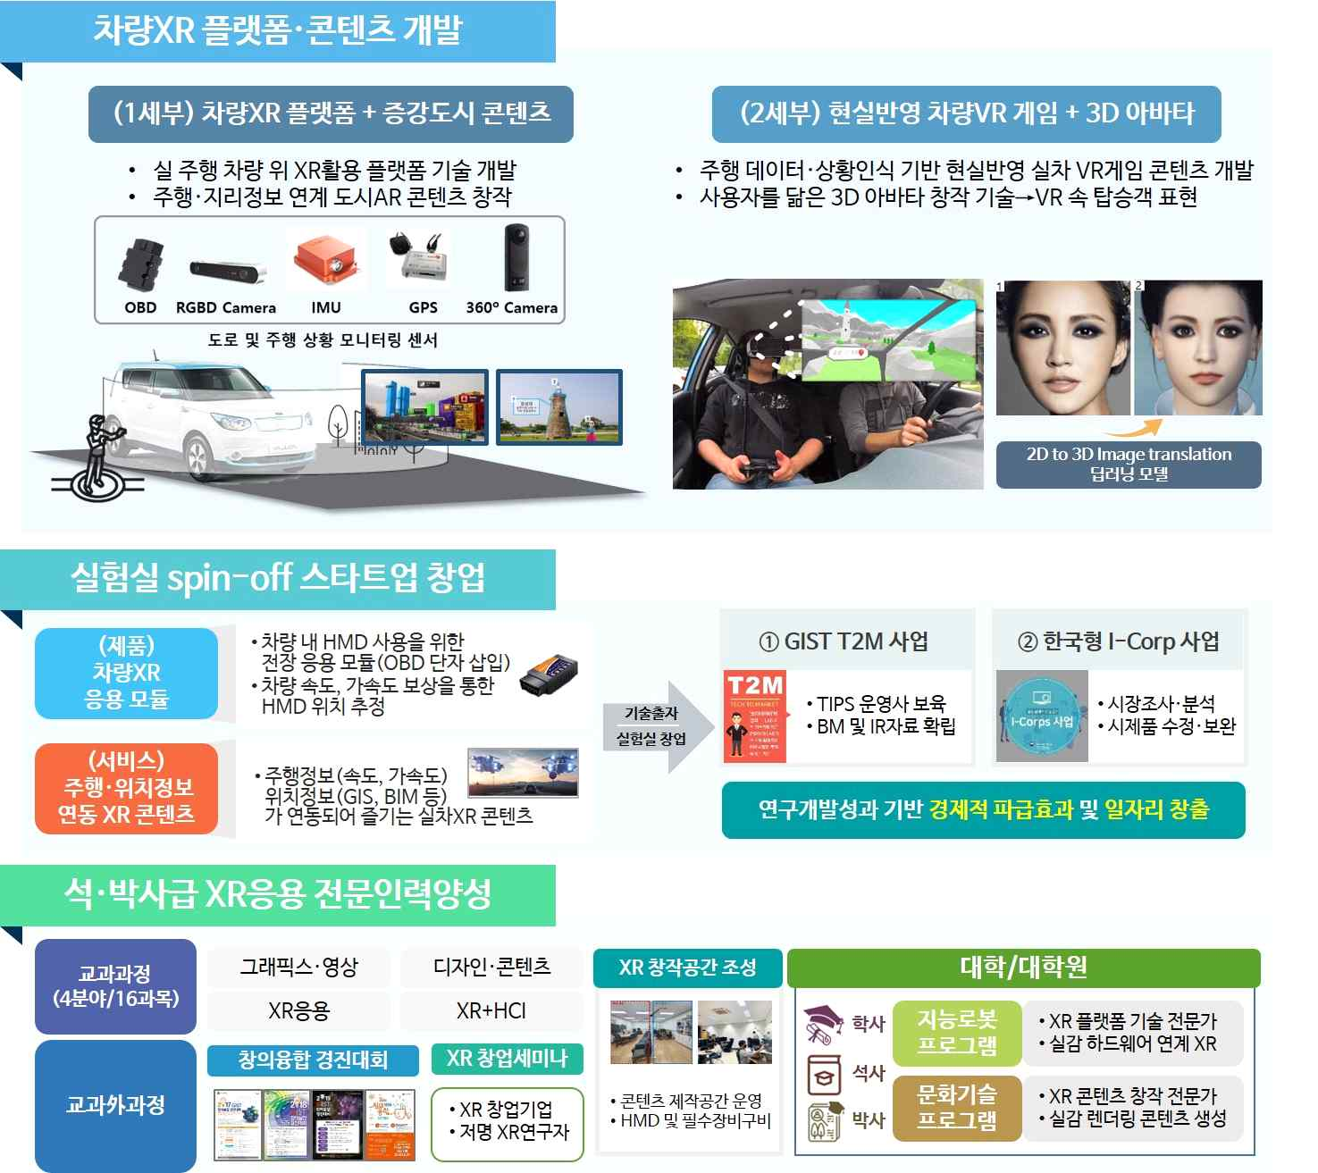
▲ GIST Vehicle XR Lab Task Outline



