
Gwangju Institute of Science and Technology
Official Press Release — https://www.gist.ac.kr

Section of Dongsun Cho Nayeong Lee
Public Relations Section Chief Senior Administrator
062-715-2061 062-715-2062

Contact Person GIST Auditor Office
for this Article 062-715-2008

Release Date 2021.05.14

Auditor Kwang-sik Shin appointed as a member of the Gwangju Autonomous Police Committee

□ GIST (Gwangju Institute of Science and Technology) Auditor Kwang-sik Shin from the Auditor Office was commissioned as a member of the Gwangju Metropolitan Autonomous Police Committee and will serve from three years from May 10, 2021 to May 9, 2024.



∘ The Gwangju Autonomous Police Committee, composed of experts in several fields, including two legal, two academic, one civic group, one journalist, and one former police officer, including Auditor Kwang-sik Shin, is related to school violence and crimes related to children and women. will conduct independent duties with the right to deliberate and decide on appointment, budget, etc. and is in charge of public welfare affairs, such as traffic laws and regulations, and shall perform independent duties with the right to appoint public officials in charge and deliberate and vote on budgets, manpower, policies, etc.

□ Auditor Kwang-sik Shin said, "By listening to the voices of Gwangju citizens and activating resident-friendly security activities, we will do our best so that the self-governing police system can function effectively."

∘ Auditor Kwang-sik Shin served as vice chairman of the Gwangju Bar Association and is currently active in the community as a legal expert, including a non-executive auditor of the Gwangju Metropolitan Office of Education, and a member of the Gwangju Koryoin Village Free Legal Support Group.

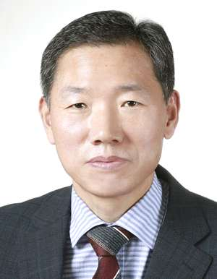
▲ Photo 1: GIST Auditor Kwang-sik Shin

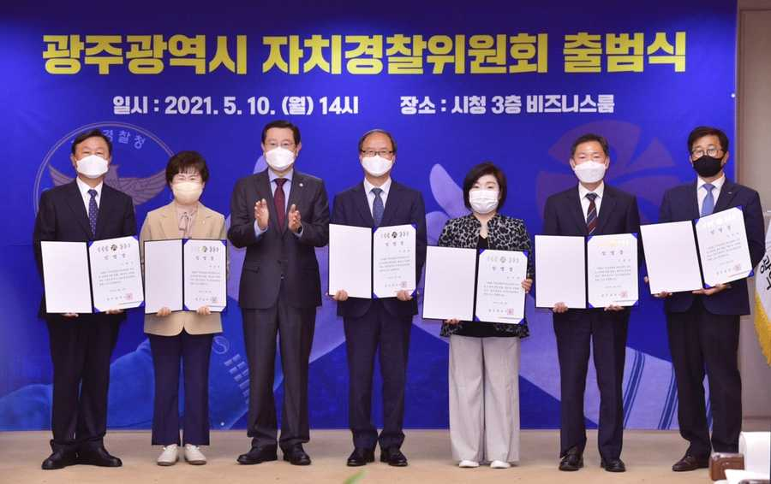
▲ Photo 2: Gwangju Metropolitan City Autonomous Police Commission inauguration ceremony



