
Gwangju Institute of Science and Technology
Official Press Release — https://www.gist.ac.kr

Section of Dongsun Cho Nayeong Lee
Public Relations Section Chief Senior Administrator
062-715-2061 062-715-2062

Contact Person Section of Public Relations
for this Article 062-715-2062

Release Date 2021.05.12

Professor In S. Kim publishes an international professional book to secure seawater desalination water resources in preparation for climate change



□ GIST (Gwangju Institute of Science and Technology) School of Earth Sciences and Environmental Engineering Professor In S. Kim (acting president) worked with four foreign scholars to publish a book in English on seawater desalination technology in preparation for climate change, which is a global hot topic: 'Seawater Reverse Osmosis Desalination: Assessment and pre-treatment of fouling & scaling.'

□ The book covers reverse osmosis membrane-based seawater desalination technology, which is the most popular technology for securing water resources in the future to prepare for the ever-increasing global climate change.

∘ The theory of reverse osmosis membranes used for the production of drinking water and industrial water, pretreatment for actual plant operation, fouling (pollution level) and scaling of the membrane, along with seawater, river water, salt groundwater, and sewage treatment water, etc. were analyzed.

□ The International Water Association (IWA), the publisher of this book, is an international, non-profit organization dedicated to improving urban water management in urban water and is involved in the science, technology and industry of water supply and treatment, collection, treatment, exclusion of wastewater, and overall management of water quality and quantity.

∘ Headquartered in London, UK, it is linked with 140 member countries around the world and publishes 12 science and technology journals and more than 40 specialized books every year. The author Professor In S. Kim was the first Korean to be elected in 2010 as an active IWA Fellow.

□ Professor Kim said, "Reverse osmosis membrane-based seawater desalination technology is the most popular technology to secure future water resources and solve human water shortages. We hope that this book will benefit students, professors, engineers, plant contractors, consultants, and plant operation experts around the world."

□ Professor In S. Kim is an expert on organic-inorganic membrane material that combines nanoparticles and polymers such as graphene and MXene, module technology based on the fluid dynamics of nanofibers and hollow fiber membranes, biofouling and control mechanisms. He has performed system engineering research for large-scale plant application and has published about 340 SCI international papers and domestic papers in this field.

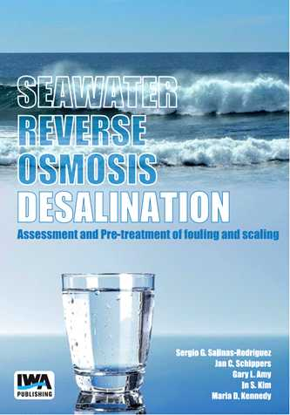

"Seawater Reverse Osmosis Desalination" book cover

▲ Sergio G. Salinas-Rodríguez (Associate Professor, IHE Delft Institute, Netherlands)
▲ Jan C. Schippers (Professor Emeritus, IHE Delft Institute, Netherlands)
▲ Gary L. Amy (Dean Distinguished Professor, Clemson University, USA)
▲ In S. Kim (Professor, GIST School of Earth Sciences and Environmental Engineering)
▲ Maria D. Kennedy (Professor, IHE Delft Institute, Netherlands)



