
Gwangju Institute of Science and Technology
Official Press Release — https://www.gist.ac.kr

Section of Dongsun Cho Nayeong Lee
Public Relations Section Chief Senior Administrator
062-715-2061 062-715-2062

Contact Person Section of Public Relations
062-715-2062

for this Article 2021.04.23

Release Date

Professor Kwanghee Lee receives award for the
2021 Science and Information and Communication Day



□ On the occasion of the 54th Science Day (4/21) and the 66th Information and Communication Day (4/22), GIST (Gwangju Institute of Science and Technology) Professor Kwanghee Lee and nine faculty members who contributed to the creation of excellent research results and the promotion of science and technology received the Government Award for Technology Promotion and Ministerial Citation.

□ Professor Kwanghee Lee of the School of Materials Science and Engineering is a world-renowned authority in the field of organic electronic devices. In recognition of his contribution to raising the national status through technology transfers and by publishing in world-class journals such as Science, he was awarded the Science and Technology Innovation Award.

∘ The Presidential Citation was awarded to School of Electrical Engineering and Computer Science Professor Hong Kook Kim for his contribution to improving national technology and fostering human resources based on voice and audio recognition and to School of Earth Science and Environmental Engineering Professor In Seop Chang for overcoming the difficulties in the practical use of biofuel cells and for economic recovery of low-concentration bioethanol.

∘ The Prime Minister's Citation was awarded to School of Electrical Engineering and Computer Science Professor Dong-Seon Lee for contributing the expansion of the base of high-resolution next-generation display technology and the development of eco-friendly, non-toxic and low-cost solar cells, to School of Life Sciences Professor Yong-Chul Kim for contributing to the development of innovative new drug research and specialists for the national new drug industry through the establishment of a new drug development venture company, and to Advanced Photonics Research Institute Senior Researcher Woo-jin Shin for contributing to innovative growth such as developing original technology in the domestic optical fiber laser field and transferring technology.

□ The Science and Technology Minister's Citation was awarded School of Electrical Engineering and Computer Science Professor Sung Chan Jun and to School of Life Sciences Professor Hai-Hong Shen for contributing to the spread of science and technology achievements through various academic activities at home and abroad.

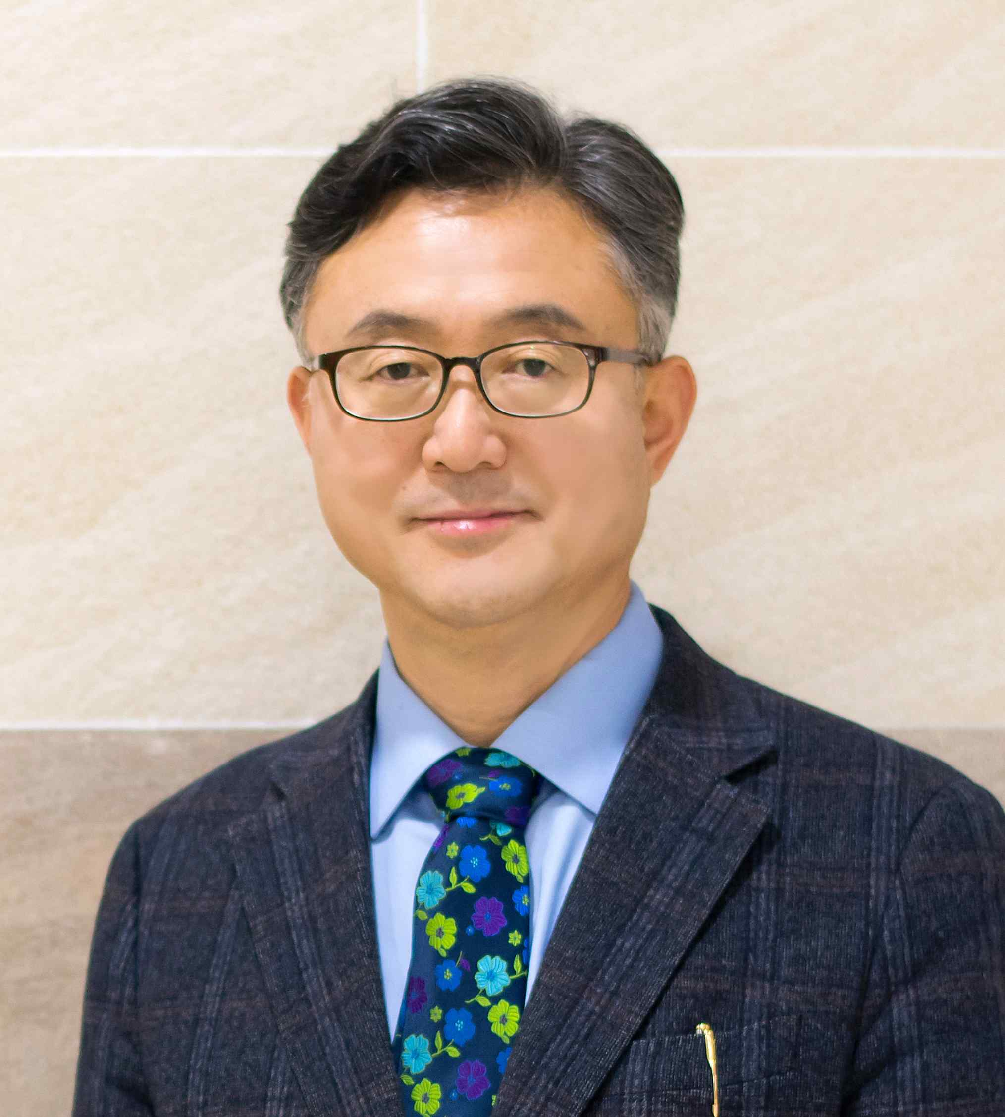
▲ School of Materials Science and Engineering Professor Kwanghee Lee
won the Science and Technology Innovation Award



