
Gwangju Institute of Science and Technology
Official Press Release — https://www.gist.ac.kr

Section of Dongsun Cho Nayeong Lee
Public Relations Section Chief Senior Administrator
062-715-2061 062-715-2062

Contact Person Professor Hyyong Suk
for this Article Department of Physics and Photon Science
062-715-3350

Release Date 2021.04.15

GIST Department of Physics and Photon Science
Ph.D. graduates recognized for research excellence

□ GIST (Gwangju Institute of Science and Technology) Department of Physics and Photon Science Ph.D. graduate were recognized for their excellent research skills in their respective fields after graduation.



∘ Dr. Do-geun Jang (graduated in 2017) and Dr. In-hyuk Nam (graduated in 2015) were the graduates receiving recognition. Recently, Dr. Do-geun Jang was selected as a recipient of the Plasma Division's New Scientist Award by the Korean Physical Society (Chairman Tae-won Noh), which is awarded to young and excellent scientists within five years of receiving a Ph.D.

∘ Dr. In-hyuk Nam was recognized for his excellence by presenting the research results of a new free electron laser oscillation method in Nature-photonics last month as the lead author. Nature-photonics has the highest impact factor of 31.2 in the optical field and is known as the world's best paper in the optical field.

□ Both doctors conducted laser-plasma research while attending the GIST Department of Physics and Photon Science Ph.D. program under the guidance of Professor Hyyong Suk. After graduating, Dr. Do-geun Jang was a postdoctoral researcher at the University of Maryland, USA, and has been working as a senior researcher at the Pohang Accelerator Research Institute since 2020.

∘ After graduation, Dr. In-hyuk Nam worked as a postdoctoral researcher at the Stanford Linear Accelerator Center, a renowned national research institute in the United States, and has been working as a senior researcher at the Pohang Accelerator Research Institute since 2017.

□ GIST Department of Physics and Photon Science Professor Hyyong Suk said, "I am proud of the GIST graduates who have shown that they can succeed through their own efforts despite difficult conditions. We hope that more GIST researchers will perform well on the world stage in the future."

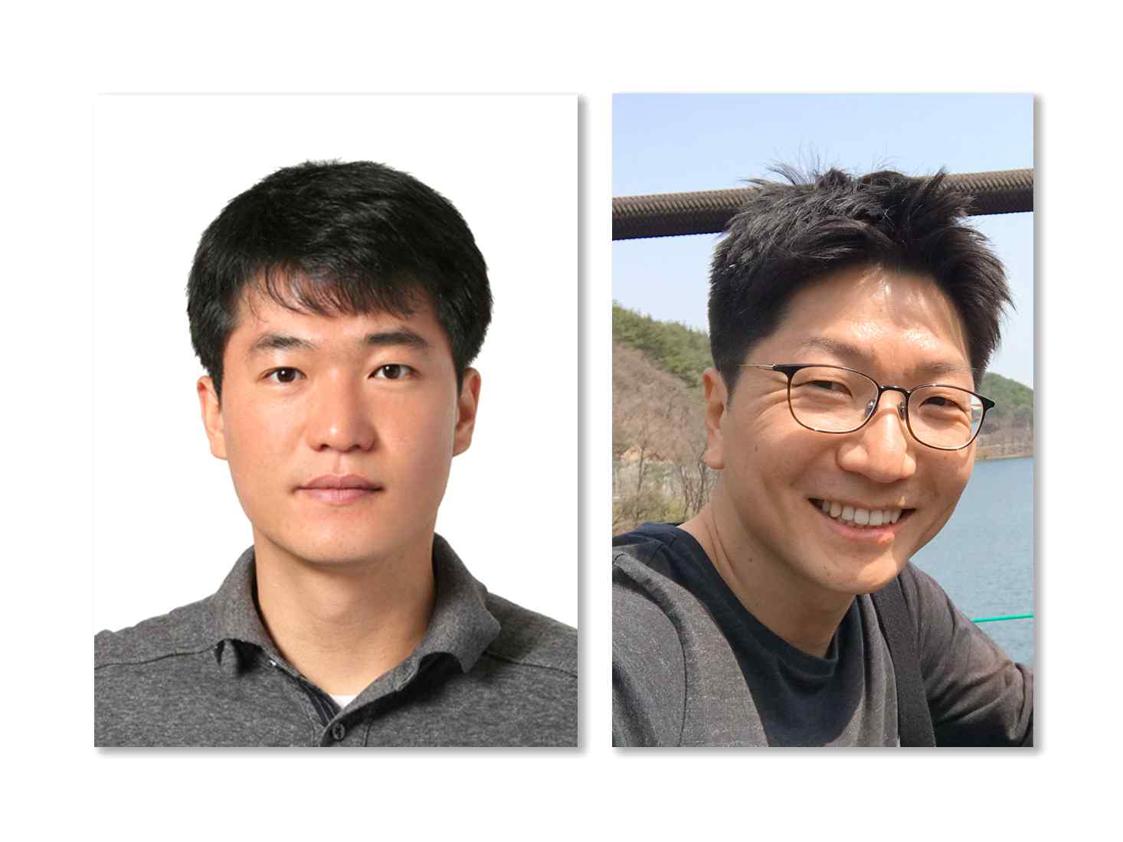
▲ From the left, Dr. Do-Geun Jang and Dr. In-hyuk Nam,
graduates from the GIST Department of Physics and Photon Science



