
Gwangju Institute of Science and Technology
Official Press Release — https://www.gist.ac.kr

Kook-hyun Moon, Chairman of Silicon Valley
Business Forum Korea, visits GIST



□ Kook-hyun Moon, Chairman of Silicon Valley Business Forum Korea, visited GIST on the afternoon of April 6, 2021, and met with GIST Acting President In S. Kim, Vice President for Public Affairs Young-jip Kim, Graduate School of Energy Convergence Dean Chanho Park, and Gwangju Free Economic Zone Authority Director Jin-chul Kim to discuss key areas of GIST's research and plans for industrial exchanges.

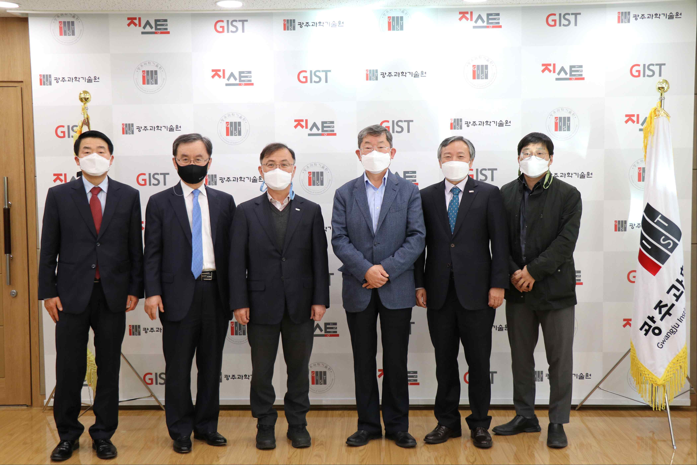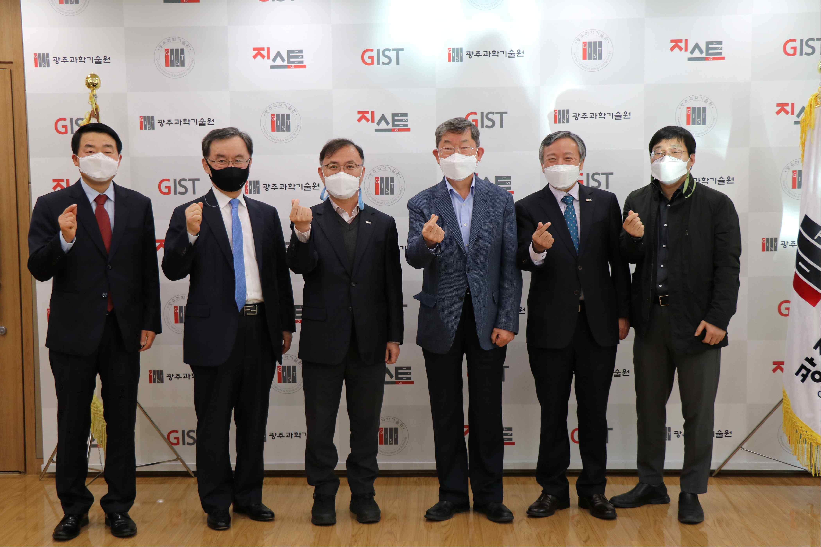

▲ From the left: Gwangju Free Economic Zone Authority Director of Investment Funding Dong-seok Choi, Gwangju Free Economic Zone Authority Director Jin-chul Kim, GIST Acting President In S. Kim, Chairman of Silicon Valley Business Forum Korea Kook-hyun Moon, Vice President for Public Affairs Young-jip Kim, and Graduate School of Energy Convergence Dean Chanho Park



