
Gwangju Institute of Science and Technology
Official Press Release — https://www.gist.ac.kr

Section of Dongsun Cho Nayeong Lee
Public Relations Section Chief Senior Administrator
062-715-2061 062-715-2062

Contact Person Professor Bong Joong Kim
for this Article School of Materials Science and Engineering
062-715-2341

Release Date 2021.03.18

Professor Bong Joong Kim receives a commendation from the Ministry of Science and ICT for promoting growth engines

□ GIST (Gwangju Institute of Science and Technology, President Kiseon Kim) School of Material Science and Engineering Professor Bong Joong Kim received a commendation from the Ministry of Science and ICT in recognition of his contribution to the discovery and fostering of the growth engine field. The awards ceremony was held at the Ministry of Science and ICT on March 8, 2021.



∘ Professor Bong Joong Kim contributes to research and development of advanced materials and can support future industries and respond to changes in the future environment among the 13 major growth engines. He was selected as a meritorious person for promoting growth engines in 2020 by contributing to the research and development of future high-tech materials for the six future core industrial groups, including new energy industries.

□ Professor Kim has been a professor at the School of Materials Science and Engineering since joining GIST in March 2012, and he has greatly contributed to the development of the national growth engines by analyzing and developing nanostructure materials, properties of nanoparticles, and nanodevices through real-time electron microscopes and real-time optical equipment.

∘ A total of 17 papers have been published in internationally renowned journals, and all 17 papers are within the top 10% of JCR, and 14 papers have a citation index of 10 or higher.

∘ In October of last year, he was selected as a top 100 scientist for research excellence in 2020 National Research and Development (mechanical material sector) for the "development a capacitor that has low air-level dielectric and self-recovers from electrical/genetic breakdown." In addition, Professor Bong Joong Kim is actively engaged in external activities as the international cooperation director and academic director of the Korean Microscopy Society to apply excellent research results to the field of national growth engines.

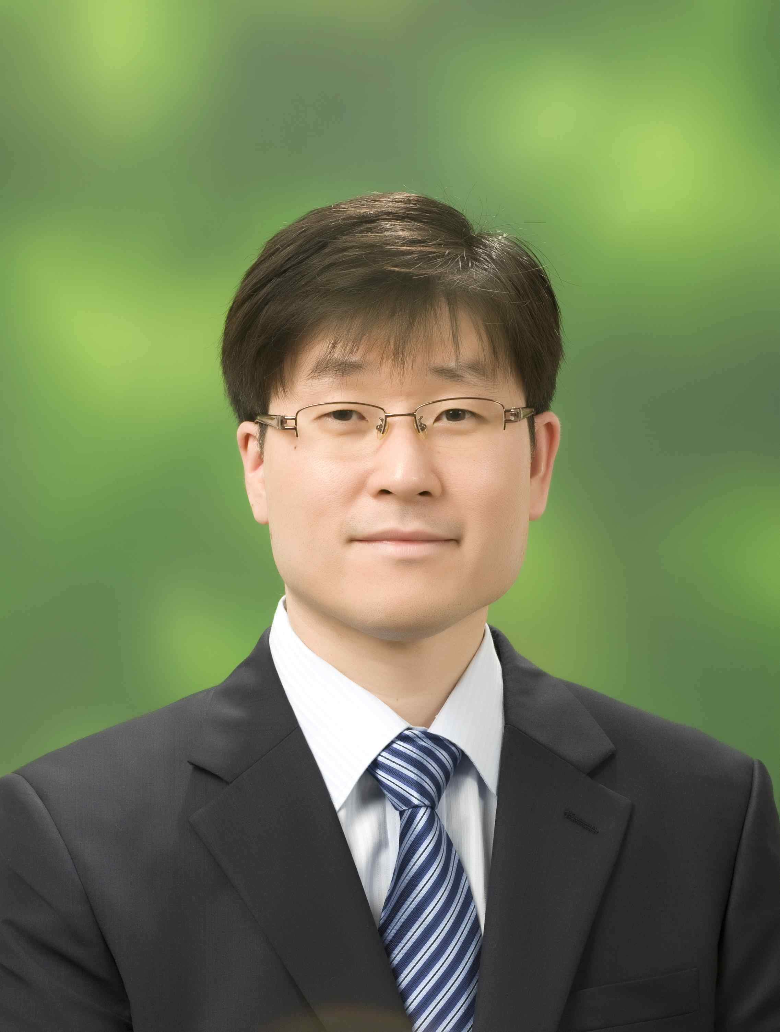
▲ GIST School of Material Science and
Engineering Professor Bong Joong Kim

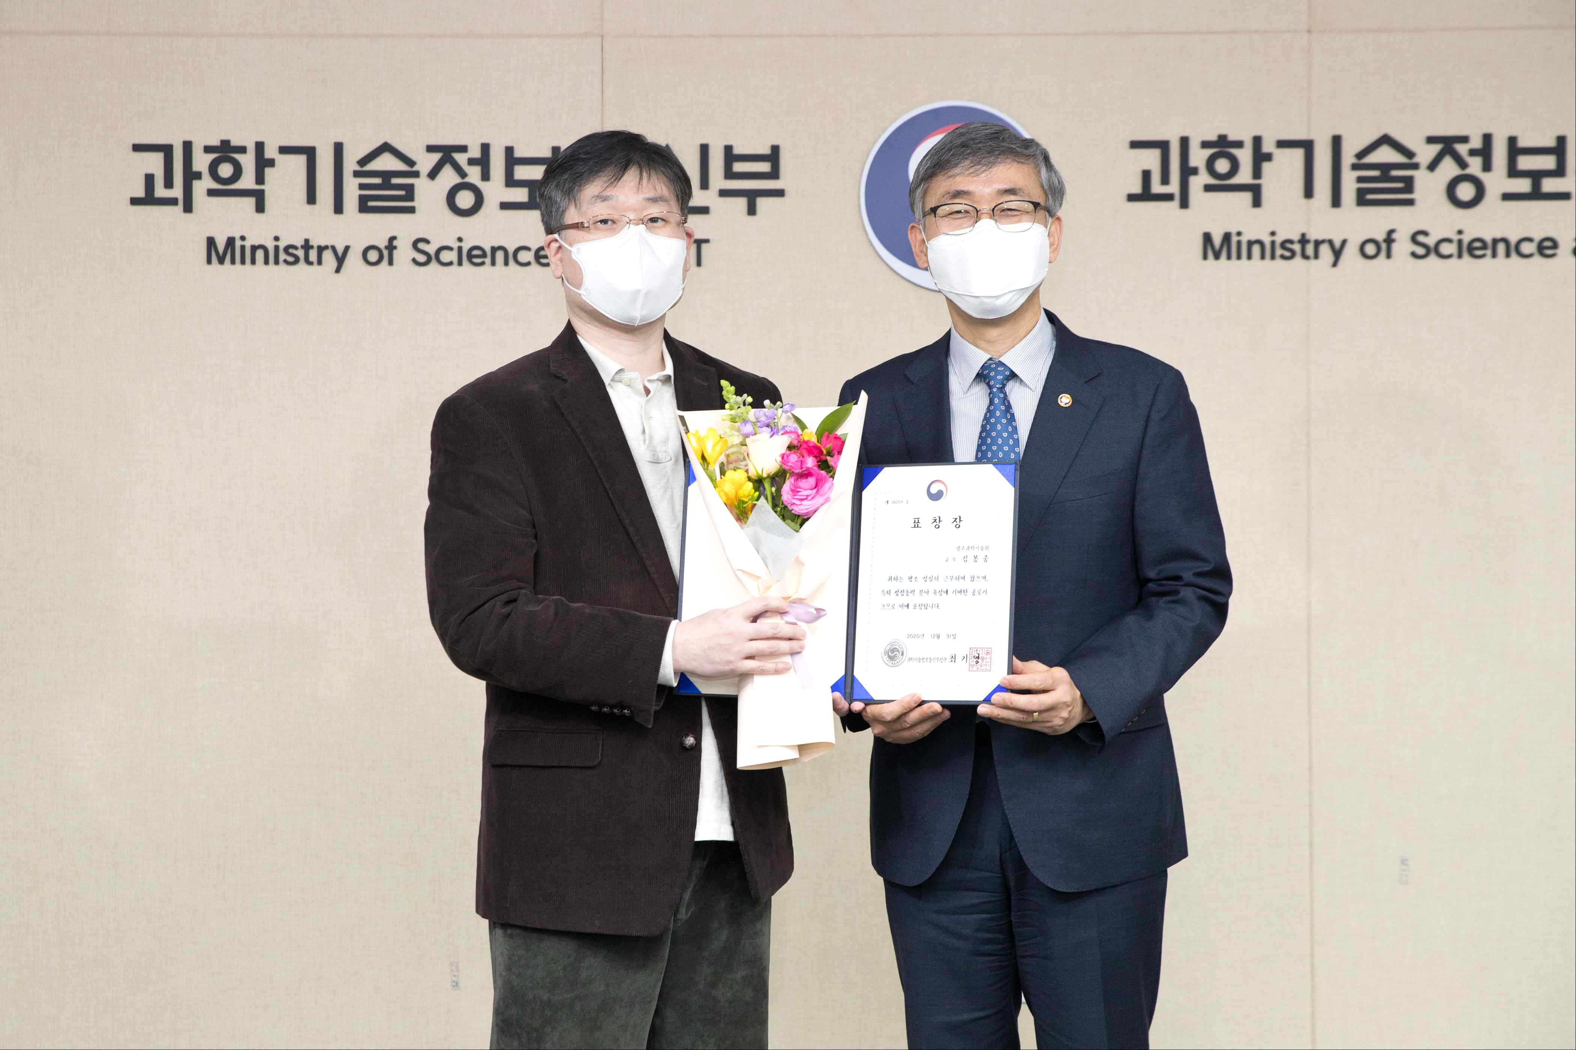
▲ Professor Bong Joong Kim receives a commendation from
the Ministry of Science and ICT for promoting growth engines



