
Gwangju Institute of Science and Technology
Official Press Release — https://www.gist.ac.kr

Section of Dongsun Cho Nayeong Lee
Public Relations Section Chief Senior Administrator
062-715-2061 062-715-2062

Contact Person Professor SeungJun Kim
for this Article School of Integrated Technology
062-715-5352

Release Date 2021.03.03

Professor SeungJun Kim's team won the best thesis award by establishing a platform to analyze driver interaction
with self-driving cars

□ GIST (Gwangju Institute of Science and Technology, President Kiseon Kim) School of Integrated Technology Professor SeungJun Kim's research team was awarded the Best Paper Award at the '2021 Korean HCI Conference' hosted by the Korean Human Computer Interaction (HCI) Society.



∘ The research team proposed a meaningful method for determining driver status by analyzing interaction demands, unlike the existing method of measuring the cognitive load of autonomous vehicle drivers, and it was selected as one of the final 5 papers (within the top 2.5%) out of the 200 papers submitted.

□ Professor SeungJun Kim (corresponding author), Eunki Jeon (first author) in the integrated master's and doctoral program, Ph.D. student Dohyeon Yeo, and Jungseok Oh in the master's program authored (thesis title: “Demand Timing for Driver Situation Awareness in Autonomous Vehicles: An Empirical Study with Wizard-of-Oz Autonomous Driving in the wild”). By constructing a real vehicle-based autonomous driving platform, the timing of requesting the autonomous driving vehicle driver's voluntary situation was analyzed.

∘ From this research, it is possible to know in which driving situation the driver wants to transmit information from the autonomous vehicle through the voluntary situation or the time of request. This is one of the important factors in the design of an autonomous vehicle-driver interaction system.

□ Professor SeungJun Kim said, "With the advent of the autonomous vehicle era, discussions and research on drivers in autonomous vehicles are becoming more and more important. Because the driver's situational awareness request point can be used in various autonomous vehicle interaction studies, this study's method of analyzing the voluntary situational request point of view is very meaningful.

∘ Eunki Jeon, the first-author of the paper, said, "It seems that our proposal for a method of analyzing the request point of a voluntary situation in order to determine the driver's condition in an autonomous vehicle, which has been actively studied recently, has been awarded a big prize in line with the interests of this conference. In the future, we plan to continue research on the development of an autonomous vehicle driver interaction system."

□ The Korean HCI conference, which marks its 19th this year, held oral and poster presentations on human-computer interaction including artificial intelligence, autonomous driving, IoT, virtual reality/augmented reality, and robotics technology, which are core applications for a future technological industrial society.

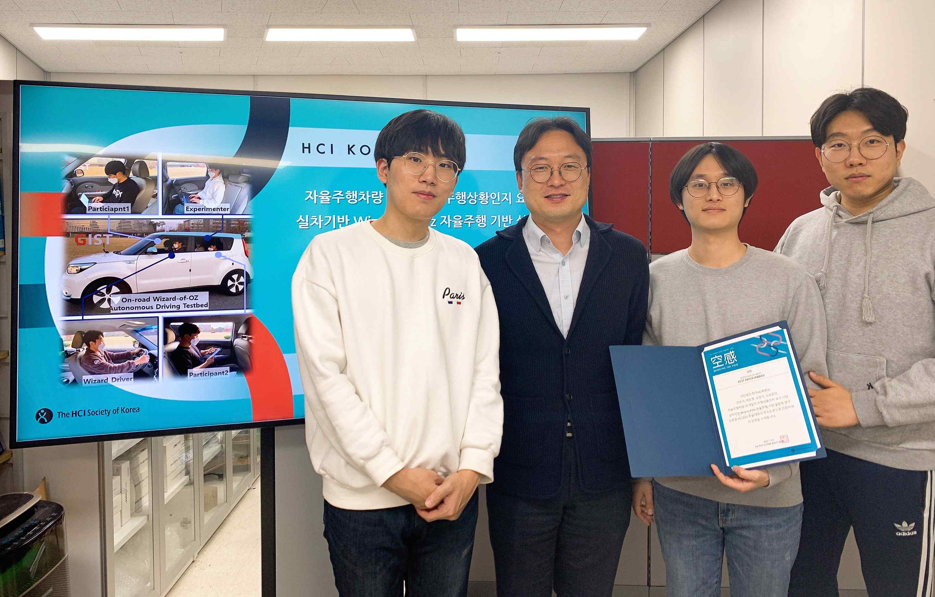
▲ GIST Human-Centered Intelligent System Lab (from left): Jungseok Oh,
Professor SeungJun Kim, Eunki Jeon (first author), and Dohyeon Yeo



