
Gwangju Institute of Science and Technology
Official Press Release — https://www.gist.ac.kr

Section of Dongsun Cho Nayeong Lee
Public Relations Section Chief Senior Administrator
062-715-2061 062-715-2062

Contact Person Dohyeon Yeo
for this Article Institute of Integrated Technology
062-715-5352

Release Date 2021.02.23

Institute of Integrated Technology: Dohyeon Yeo's student team launches a VR-based walking simulation platform for urban forest immersion



□ GIST (Gwangju Institute of Science and Technology, President Kiseon Kim) Institute of Integrated Technology Ph.D. student Dohyeon Yeo's (advisor: Professor SeungJun Kim) team was selected as the organizer for the "Development of Virtual Reality-Based 4D Simulators for Urban Forest Immersion and Physiological Effects Research" by the Korea Forestry Promotion Agency's Forest Convergence Professional Training Project (R&D).

∘ They plan to develop a virtual reality-based 4D walking simulation platform with 20 million won support for the next year and will develop technology to support forest immersion in urban areas through physiological comparison and analysis with actual forest immersion.

□ Dohyeon Yeo's student team plans to establish a VR-based multimodal 4D walking simulation platform for urban forest bathing with PhD students Gwangbin Kim, Jieun Lee, and Jungseok Oh in the integrated course and will verify the physiological effects through comparison and analysis with actual forest immersion.

∘ Although forest immersion has an emotional stability effect to reduce depression and stress and increased immunity caused by phytoncides, accessibility is low due to insufficient green space in cities, making it difficult for modern people to comfortably enjoy forest healing and recreation in daily life.

∘ In response, Dohyeon Yeo's student team tried to increase accessibility to forest healing/recreation activities by enabling forest bathing in the city center through virtual reality technology and will verify its physiological effects.

∘ For this purpose, they will ▲ develop urban forest bathing scenarios including each situation and environmental factors through prior research and analysis of actual environmental factors ▲ establish a virtual reality platoform to increase the sense of immersion and reality with motion tangible 4D multi-modal (view, hearing, touch, smell) experience ▲ develop a sensor-mixed analysis tool to verify the physiological effects of virtual reality-based forest immersion through comparison and analysis with actual forest immersion.

□ Student research director Dohyeon Yeo said, "A study on forest experience technology and its physiological effects in the city through a VR-based multi-modal 4D forest immersion platform indoors is an original study that has never been attempted. It is expected that this will contribute to relieving stress among modern people by increasing access to forest immersion and creating an environment that can be easily enjoyed in daily spaces in the city, such as living rooms and offices."

∘ Student Dohyeon Yeo conducts research in the field of virtual reality and human-computer interaction in the 'Human-Centered Intelligent Systems Lab' led by Professor SeungJun Kim and has received high evaluation of excellent research capabilities, including publication of first-author papers at the International Society of Human-Computer Interactions (ACM CHI), thesis publication by "International Mixed Augmented Reality Symposium (IEEE ISMAR)," and by applying for domestic and international patents related to mixed reality technologies.

□ In this year's Korea Forestry Promotion Agency's Forest Convergence Professional Training Project (R&D), an open contest was held for the project "Support for Research on Creative Challenge Ideas for Undergraduate Students" to select 20 teams. The majority of forest industry and ICT technologies were selected in recognition of their uniqueness and city quality, and agreements was completed on Tuesday, February 9, 2021.

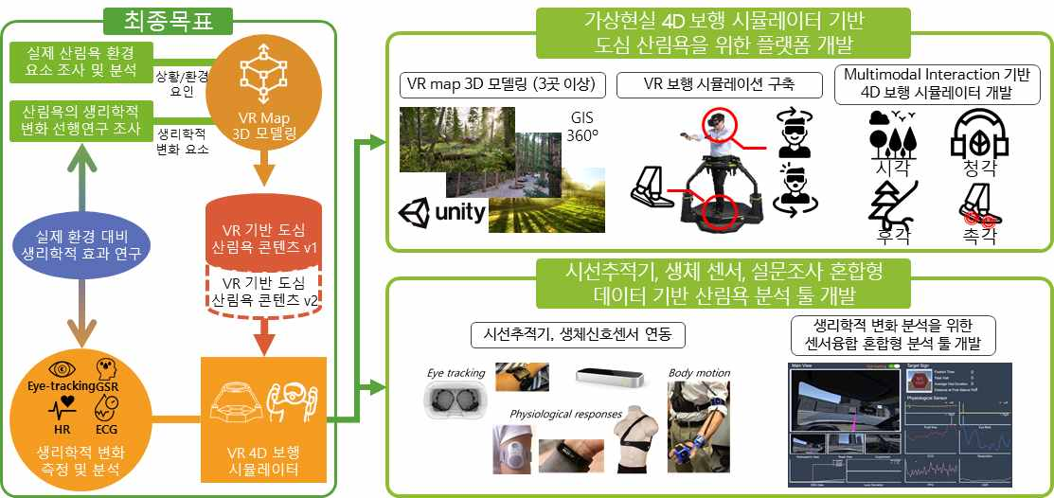
[Figure 1] A conceptual diagram of a virtual reality-based 4D simulator development and physiological effect research for urban forest immersion

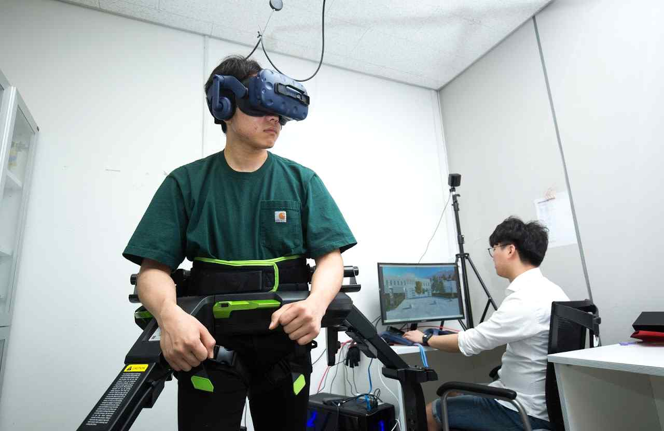
[Picture 1] Example of a virtual reality 4D walking simulator

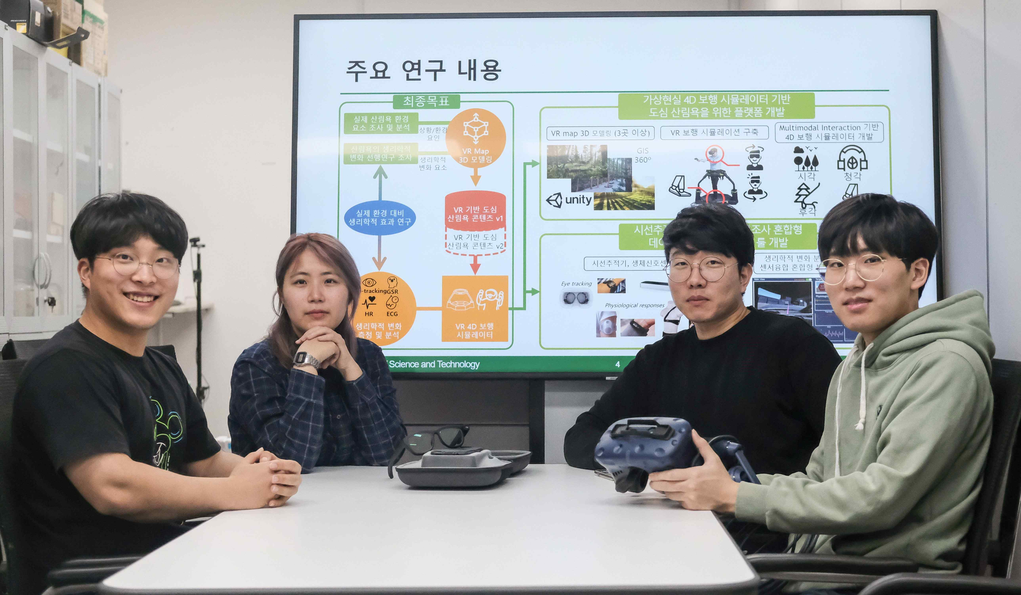
[Photo 2] Dohyeon Yeo Student Team_ From the far left, Gwangbin Kim, Jieun Lee, Dohyeon Yeo (Research Director), Jungseok Oh



