
Gwangju Institute of Science and Technology
Official Press Release — https://www.gist.ac.kr

Section of Dongsun Cho Nayeong Lee
Public Relations Section Chief Senior Administrator
062-715-2061 062-715-2062

Contact Person Section of Public Relations
for this Article 062-715-2061~2063

Release Date 2021.02.10

4 GIST teams win at the 27th HumanTech
Paper Award, including gold

□ GIST (Gwangju Institute of Science and Technology, President Kiseon Kim) produced a total of four teams of award winners, including the Gold Award, the Bronze Award, and the Encouragement Award at the 27th HumanTech Research Papers Awards hosted by Samsung Electronics.



∘ The winners were Electrical Engineering and Computer Science doctorate students Min-seok Kim and Gil-ju Lee (faculty advisor Young Min Song) for the Gold Award, EE&CS master’s student In-hwan Bae (faculty advisor Hae-Gon Jeon) for the Bronze, master’s student Min-Hyeong Kang and doctorate students Gil-ju Lee, Jung-hun Lee, and Min-seok Kim (faculty advisor Young Min Song), along with Materials Science and Engineering doctorate student Hae-sol Kim (faculty advisor Chang Hyuck Choi) for two Encouragement Awards.

□ Gold Award winners Min-seok Kim and Gil-ju Lee, in their study “Optics-Physical Replication-Proof System that Utilizes Fiber Materials Instead of Lenses,” proposed a new optics-physical replication-proof system that operates without optical materials such as lenses. This new system utilizes the diffraction and interference phenomenon of light, and shows great potential as a next-generation security device. Their faculty advisor Yeong-min Song also had received the same award in the same division (Physical Devices) at the 17th HumanTech Paper Awards, back when he was a student of the same graduate school.

∘ Bronze Award winner In-hwan Bae, in his study “Pedestrian Path Prediction System: Utilizing Multi-relationship Graphs,” materialized and expressed all social interaction of the pedestrians of a scene through a space-time graph. His research proposes a new method in restoring a path to the original destination. This new method shows superior accuracy in predicting long-term paths of pedestrians compared to existing iterative models.

∘ The Encouragement Award-winning team of Min-hyeong Kang, Gil-ju Lee, Jung-hun Lee, and Min-seok Kim, in their study “Biometric Signal Sensors that Are Patch-type Wearable and Thermally Stable,” proposed a wearable device with integrated radiant-energy cooling material that solves heat problems experienced indoors and outdoors. Their research successfully demonstrated a wearable oxygen-saturation device that can accurately measure the oxygen saturation level of muscle even under intense sunlight. The proposed technology is a completely new and innovative cooling system and is expected to be applied to various wearable devices in the future.

∘ Another Encouragement Award-winner, Hae-sol Kim, in his study “A Close Examination of Active Points of Mono-atomic Nickel Catalysts for Electro-chemical Carbon Dioxide Conversion,” was able to determine the active points of mono-atomic metallic catalysts suitable for electro-chemical CO2 conversion by utilizing a physical structure precisely controlled at the atomic level. He also demonstrated that efficient CO2 conversion is possible and proposed new approaches in developing highly efficient CO2 conversion catalysts.

□ The HumanTech Research Paper Awards is an annual awards event held by Samsung Electronics since 1994 with a commitment to discovering new scientists, among domestic and international universities, graduate schools, and high schools, who may lay the future foundation for a scientifically developed nation.

∘ In the university category, Gold, Silver, Bronze, and Encouragement Awards are awarded in a total of ten disciplinary divisions with one Grand Prize winner. Prize money is also awarded to the winners: 10 million won for Gold, 5 million won for Bronze, and 2 million won for Encouragement Awards.

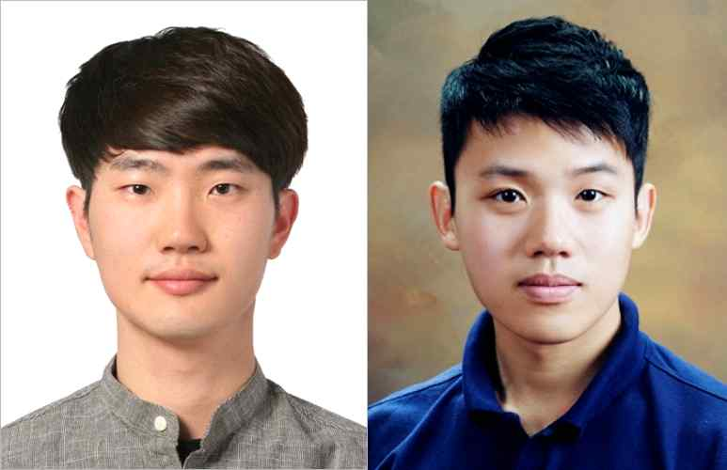
▲ The Gold Award: Min-seok Kim (left) and Gil-ju Lee

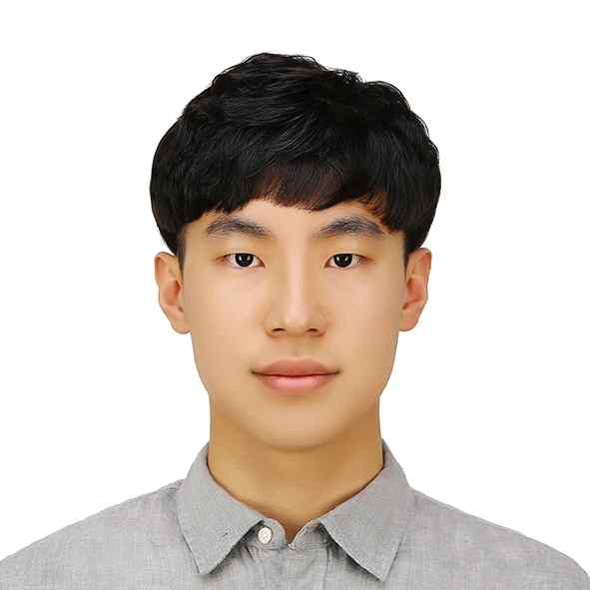
▲ The Bronze Award: In-hwan Bae

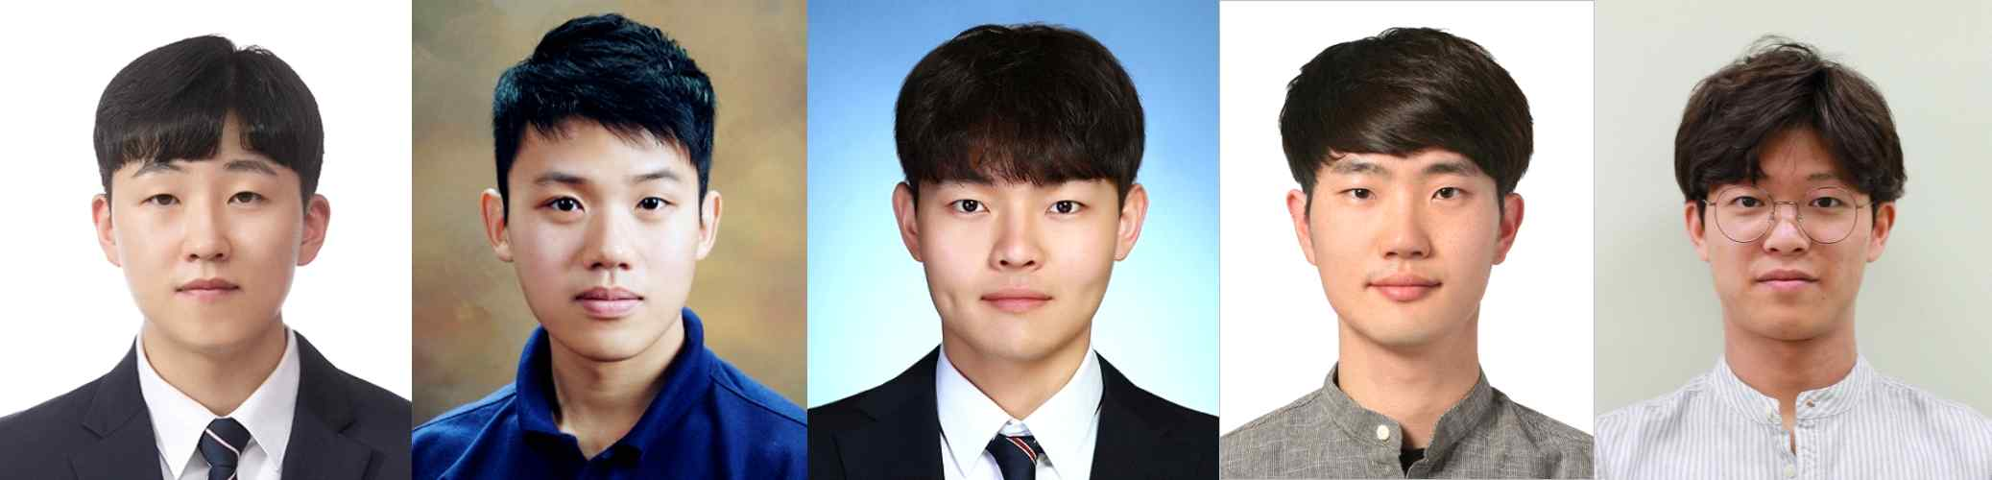
▲ The Encouragement Award (from left): Min-Hyeong Kang, Gil-ju Lee, Jung-hun Lee, Min-seok Kim, Hae-sol Kim



